**CNV Coordinate Determination by Chromosome**

**Chromosome 1:**

Primary CNV 1: 1p36.33 (ATAD3 Cluster) 5

Primary CNV 2: 1p35 5

Primary CNV 3: 1p32.2-p31.3 6

Primary CNV 4: 1p21.3 7

Primary CNV 5: 1q21.1 TAR, Neuro 8

Primary CNV 6: 1q24-q25 Proximal, Intermediate, Distal 10

Primary CNV 7: 1q41-q42 11

Primary CNV 8: 1q43-q44 12

**Chromosome 2:**

Primary CNV 9: 2p25.3 (MYTIL) 13

Primary CNV 10: 2p16.3 (NRXN1) 14

Primary CNV 11: 2p15-p14 15

Primary CNV 12: 2p16-p15 15

Primary CNV 13: 2p12-p11.2 16

Primary CNV 14: 2q11.2 17

Primary CNV 15: 2q13 17

Primary CNV 16: 2q22.3 (Mowat-Wilson) 18

Primary CNV 17: 2q23.1 (MBD5) 19

Primary CNV 18: 2q31.1 20

Primary CNV 19: 2q31.2-q32.3 21

Primary CNV 20: 2q33.1 22

Primary CNV 21: 2q35 (IHH) 22

Primary CNV 22: 2q37 23

**Chromosome 3:**

Primary CNV 23: 3p25.3 Proximal, Distal 23

Primary CNV 24: 3p21.31 24

Primary CNV 25: 3q13.31 25

Primary CNV 26: 3q22.1-q25.2 26

Primary CNV 27: 3q27.3-q28 26

**Chromosome 4:**

Primary CNV 28: 4p16.3 (Wolf-Hirschorn) 28

Primary CNV 29: 4q21 29

**Chromosome 5:**

Primary CNV 30: 5p13 30

Primary CNV 31: 5q11.2 31

Primary CNV 32: 5q12 31

Primary CNV 33: 5q14.3-q15 Proximal, Distal 32

Primary CNV 34: 5q31.3 33

**Chromosome 6:**

Primary CNV 35: 6p25 34

Primary CNV 36: 6p25.1-p24.3 34

Primary CNV 37: 6q12-q14.1 35

Primary CNV 38: 6q13-q14.2 35

Primary CNV 39: 6q14.1-q14.3 35

Primary CNV 40: 6q14.1-q15 35

Primary CNV 41: 6q14.3-q16.3 35

Primary CNV 42: 6q24-q25 36

Primary CNV 43: 6q25 36

**Chromosome 7:**

Primary CNV 44: 7p22.1 37

Primary CNV 45: 7q11.23 (WBS) 38

Primary CNV 46: 7q11.23 (WBS Distal) 38

Primary CNV 47: 7q21.3 (SHFM1) 40

**Chromosome 8:**

Primary CNV 48: 8q12 40

Primary CNV 49: 8q13 41

Primary CNV 50: 8q21.11 41

Primary CNV 51: 8q22.1 42

Primary CNV 52: 8q22.2-q22.3 43

Primary CNV 53: 8q23.1-q24.12 43

Primary CNV 54: 8q24.3 44

Primary CNV 55: 9p24.3 (SRXY4) 44

**Chromosome 9:**

Primary CNV 56: 9p Terminal 45

Primary CNV 57: 9p13.3-p13.1 46

Primary CNV 58: 9q22.3 46

Primary CNV 59: 9q31.1-q31.3 47

**Chromosome 10:**

Primary CNV 60: 10p Terminal 48

Primary CNV 61: 10p15.3 49

Primary CNV 62: 10p14-p12 49

Primary CNV 63: 10p14 (HDR, DGS2) 50

Primary CNV 64: 10q22-q23 Syndrome 51

Primary CNV 65: 10p24 (SHFM3) 52

Primary CNV 66: 10q26 Interstitial 53

Primary CNV 67: 10q26 Terminal 53

**Chromosome 11:**

Primary CNV 68: 11p15.5 (BWS/RS) 54

Primary CNV 69: 11p13 (ELP4) 54

Primary CNV 70: 11p13 (WAGR, WAGRO) 54

Primary CNV 71: 11p11.2 (Potocki-Shaffer) 55

Primary CNV 72: 11q13 55

Primary CNV 73: 11q23-q25 (Jacobsen) 56

**Chromosome 12:**

Primary CNV 74: 12p13.33 58

Primary CNV 75: 12q14 59

Primary CNV 76: 12q21.33 60

Primary CNV 77: 12q24.3 61

**Chromosome 13:**

Primary CNV 78: 13q12.11-q12.13 61

Primary CNV 79: 13q12.3 62

Primary CNV 80: 13q14 62

Primary CNV 81: 13q31.3 (Feingold Syndrome 2) 63

Primary CNV 82: 13q32.1 63

Primary CNV 83: 13q33-q34 64

**Chromosome 14:**

Primary CNV 84: 14q11-q22 64

Primary CNV 85: 14q22-q23 (Frias Syndrome) 65

**Chromosome 15:**

Primary CNV 86: 15q11-q13 (Temple/ Kagami-Ogata) 65

Primary CNV 87: 15q11-q13 (Angleman/Prader-Willi) 66

Primary CNV 88: 15q14 (MEIS2) 66

Primary CNV 89: 15q15.3 67

Primary CNV 90: 15q21.1 (FBN1) 67

Primary CNV 91: 15q24 (Witteveen-Kolk) 68

Primary CNV 92: 15q25 69

Primary CNV 93: 15q26 70

**Chromosome 16:**

Primary CNV 94: 16p13.3 70

Primary CNV 95: 16p13.2 (Hao-Fountain Syndrome) 71

Primary CNV 96: 16p13.11 72

Primary CNV 97: 16p12.2-p11.2 73

Primary CNV 98: 16p11.2 (220kb; 593kb) 73

Primary CNV 99: 16q22 75

Primary CNV 100: 16q24.1 75

**Chromosome 17:**

Primary CNV 101: 17p13.3 (Miller-Dieker Syndrome) 76

Primary CNV 102: 17p13.3 (SHFLD3) 77

Primary CNV 103: 17p13.1 78

Primary CNV 104: 17p11.2 (CMT1A/HNPP) 78

Primary CNV 105: 17p11.2 (PTLS/SMS) 79

Primary CNV 106: 17p11.2 (Yuan-Harel-Lupski) 80

Primary CNV 107: 17q11.2 (NF1) 82

Primary CNV 108: 17q23.1-q23.2 82

Primary CNV 109: 17q24.2-q24.3 83

Primary CNV 110: 17q24.3 (SRXY10; SRXX2) 83

**Chromosome 18:**

Primary CNV 111: 18p 84

Primary CNV 112: 18q Proximal 85

Primary CNV 113: 18q Terminal 85

**Chromosome 19:**

Primary CNV 114: 19p13.3 86

Primary CNV 115: 19p13.2 87

Primary CNV 116: 19p13.12 87

Primary CNV 117: 19q13.11 Proximal, Distal 88

Primary CNV 118: 19q13.2 89

**Chromosome 20:**

Primary CNV 119: 20p13 90

Primary CNV 120: 20p12.3 90

Primary CNV 121: 20q13.33 91

**Chromosome 21:**

Primary CNV 122: 21q22 91

**Chromosome 22:**

Primary CNV 123: 22q11 (Cat-eye syndrome) 92

Primary CNV 124: 22q11.2 (DGS/VCFS) 93

Primary CNV 125: 22q13.33 (Phelan-McDermid) 93

**Chromosome X:**

Primary CNV 126: Xp22.31 (STS) 94

Primary CNV 130: Xp21 94

Primary CNV 127: Xp11.3 95

Primary CNV 128: Xp11.23-p11.22 95

Primary CNV 129: Xp11.22 95

Primary CNV 131: Xq21 96

Primary CNV 132: Xq22 (DL-ATS, DL-MR) 97

Primary CNV 133: Xq25 97

Primary CNV 134: Xq26.3 (XLAG) 98

Primary CNV 135: Xq27.1 99

Primary CNV 136: Xq27.3-q28 99

Primary CNV 137: Xq28 (MECP2) 100

Primary CNV 138: Xq28 (GD1) 100

Primary CNV 139: Xq28 (RAB39B) 100

Primary CNV 140: Xq28 (BRCC3) 100

# Primary CNV 1: 1p36.33 (ATAD3 Cluster)

*Figure S1 of Gunning 2020[1]:*

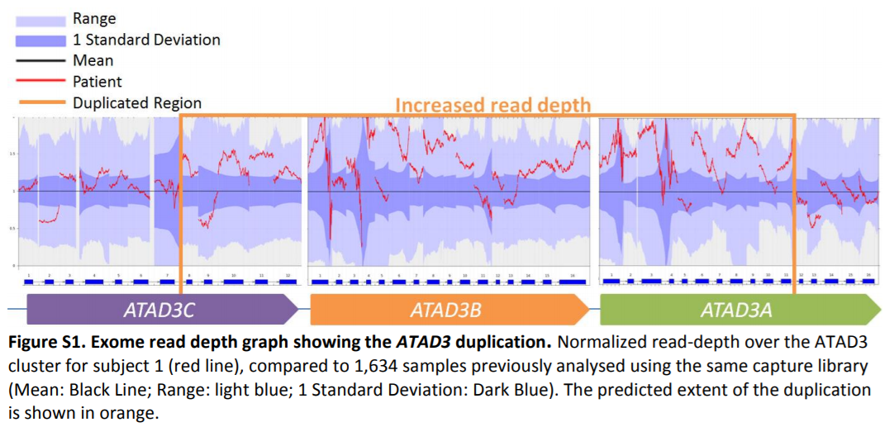

*Figure 2C of Desai 2017[2]:*

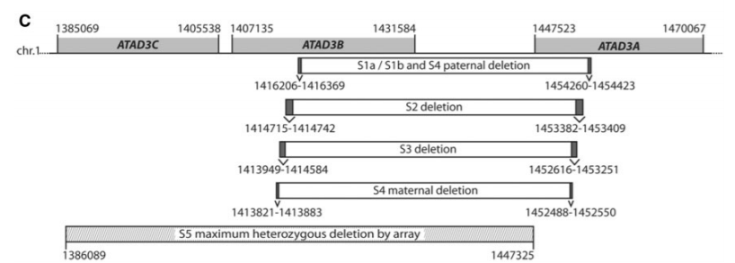

**Whole Region (ATAD3 Cluster):** chr1:1385069-1470067 (hg19)

* ATAD3C (hg19): chr1:1385069-1405538
* ATAD3B (hg19): chr1:1407164-1431582
* ATAD3A (hg19): chr1:1447523-1470067

# Primary CNV 2: 1p35

*Figure 1A of Gennarino 2018[3]:*

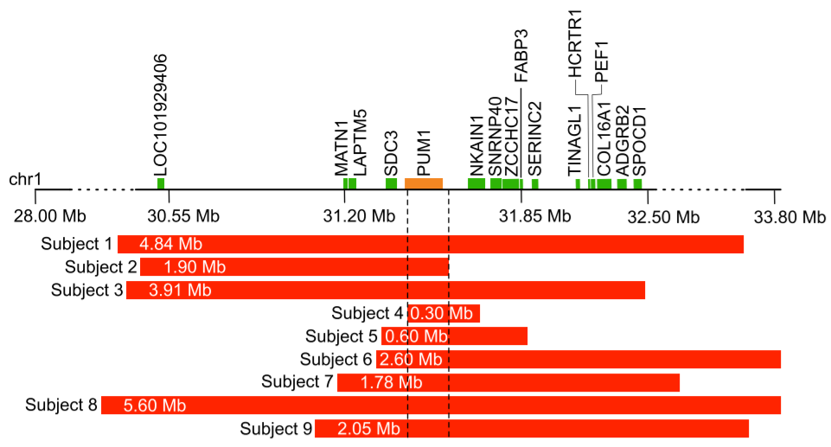

**PUM1 Gene**: chr1:31404353-31538564 (hg19)

**Whole Region**: chr1:28751378-33588455 (hg19); Subject 1

# Primary CNV 3: 1p32.2-p31.3

*Figure 2 of Labonne 2016[4]:*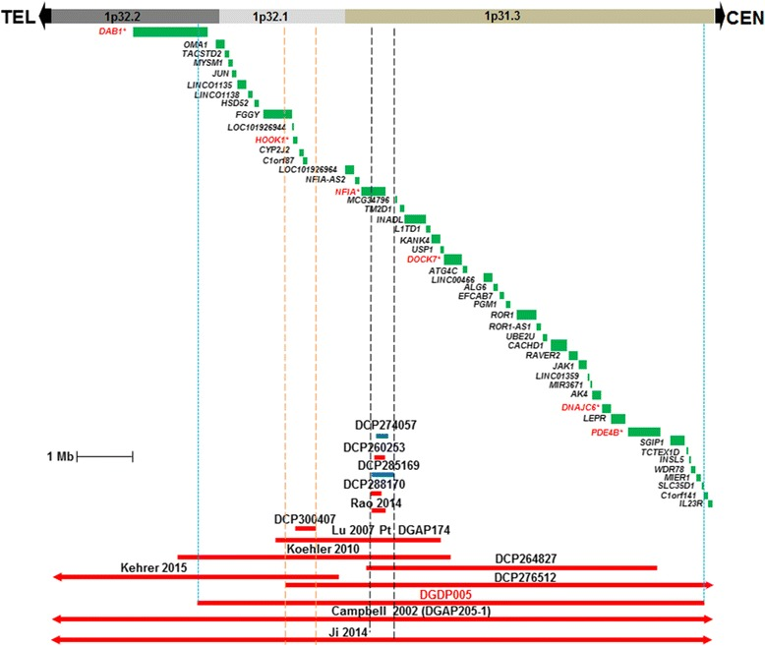

*UCSC Genome Browser View of Reported CNVs:*

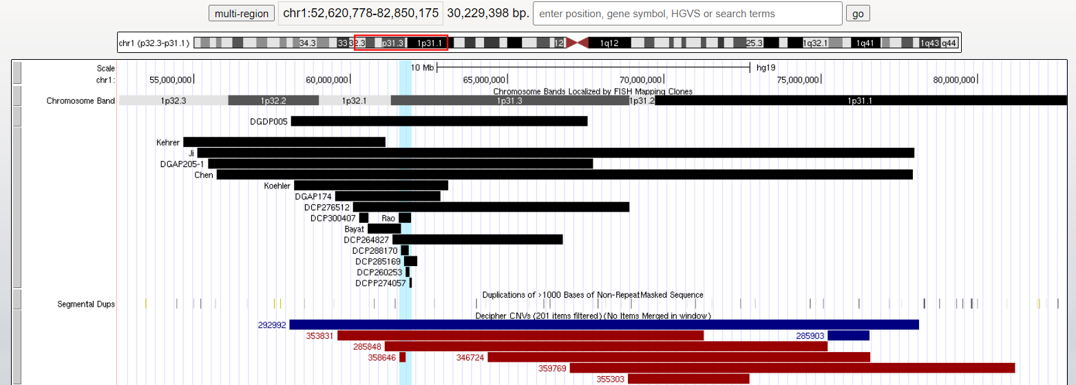

**SRO = DCP285169 (hg19)**: chr1:61700460-62119733

**Whole Region = DGDP005 (GRCh38)**: chr1:57633718-67087056

# Primary CNV 4: 1p21.3

*Figure 2 of Willemsen 2011[5]:*

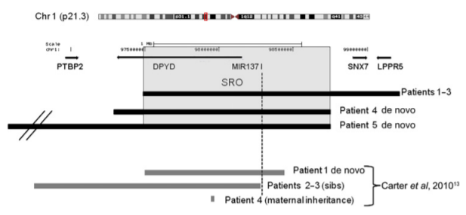

*UCSC Genome Browser View of Reported 1p21.3 deletions:*

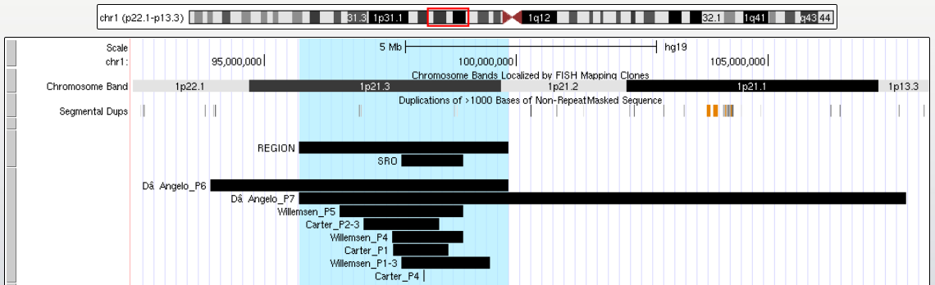

**Whole Region (D’Angelo P7 – D’Angelo P6):** chr1:95696444-99846176 (hg19)

* **D’Angelo P6:** chr1:93919217-99846176 (hg19)
* **D’Angelo P7:** chr1:95696444-107755879 (hg19)

**Willemsen SRO (hg18)**: chr1:97,500,000-98,720,000 (hg18)

# Primary CNV 5: 1q21.1 TAR, Neuro

*Figure 4 of Klopocki 2007[6]:*

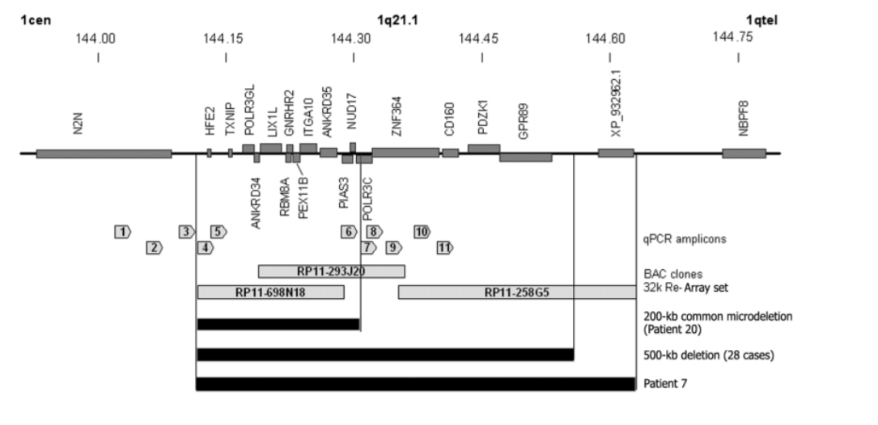

**Klopocki 200-kb Common (hg19):**

* HFE2: chr1:145,413,191-145,417,545 (hg19)
* POLR3C: chr1:145,592,605-145,610,627 (hg19)

**Klopocki 500-kb Common (hg19):**

* HFE2: chr1:145,413,191-145,417,545 (hg19)
* GPR89A: chr1:145,764,595-145,826,450 (hg19)

*Figure 1 of Mefford 2008[7]:*

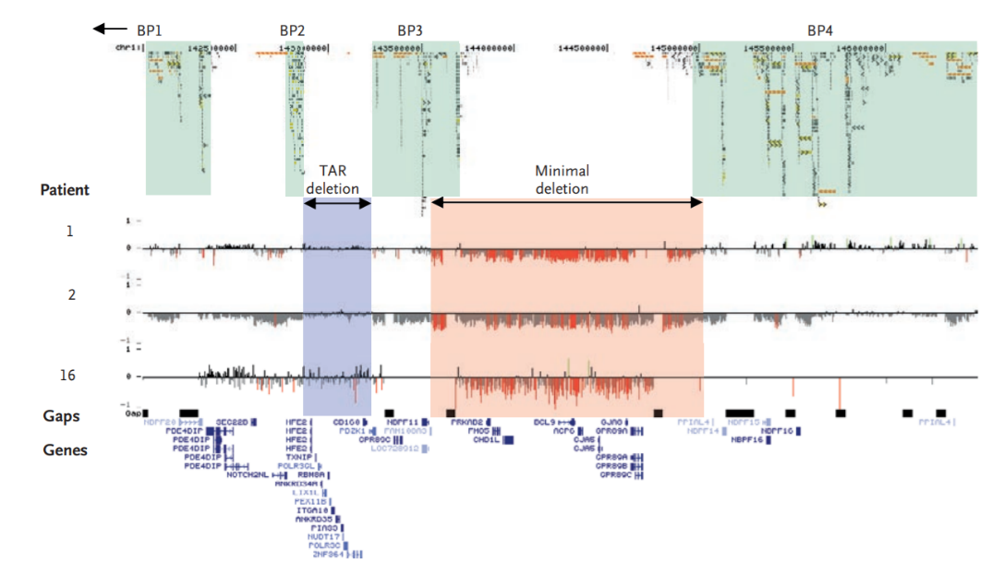

**Mefford TAR (hg19):**

* HFE2: chr1:145,413,191-145,417,545 (hg19)
* CD160: chr1:145,695,798-145,715,565 (hg19)

**Mefford Neuro (hg19):**

* PRKAB2: chr1:146,626,685-146,644,129 (hg19)
* GPR89C: chr1:147,425,567-147,465,755 (hg19)

*Figure 1 of Brunetti-Pierri 2008[8]:*

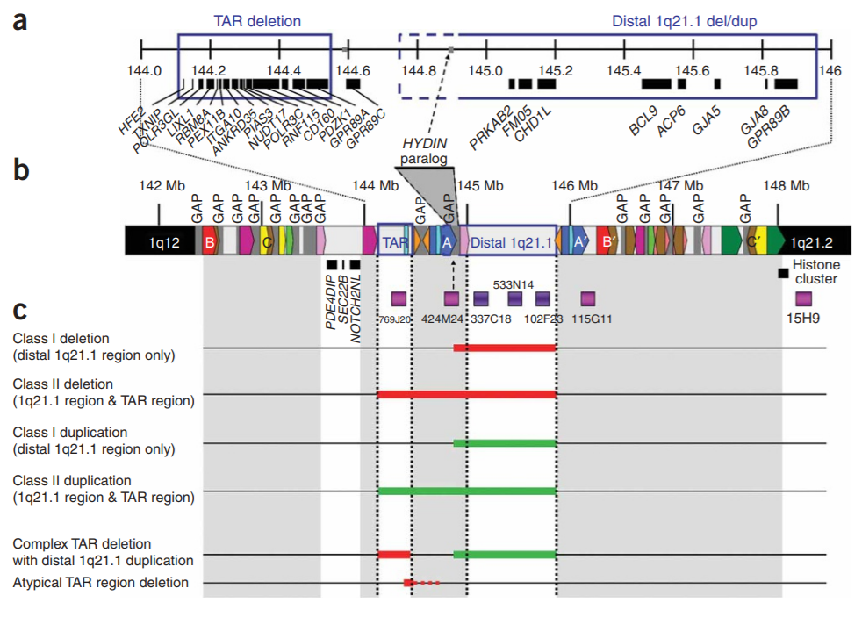

**Brunetti-Pierri TAR (hg19)**:

* HFE2: chr1:145,413,191-145,417,545 (hg19)
* GPR89A: chr1:145,764,595-145,826,450 (hg19)

**Brunetti-Pierri Neuro (hg19)**:

* PRKAB2: chr1:146,626,685-146,644,129 (hg19)
* GPR89B: chr1:147,400,506-147,465,755 (hg19)

*Figure 1 of Rosenfeld 2012[9]:*

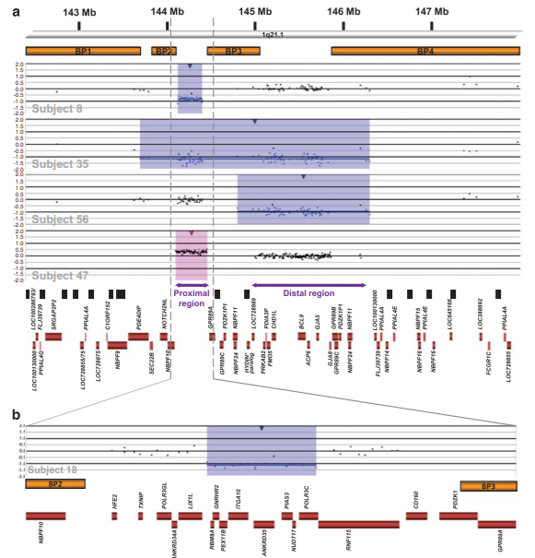

**Rosenfeld Proximal (hg19):**

* RBM8A: chr1:145,507,557-145,513,535 (hg19)
* POLR3C: chr1:145,592,605-145,610,884 (hg19)

**Rosenfeld Distal (hg19)**:

* LOC728989: chr1:146,490,895-146,514,599 (hg19)
* FLJ39739: chr1:147,835,127-147,931,980 (hg19)

*Figure 1 of Pang 2020[10]:*

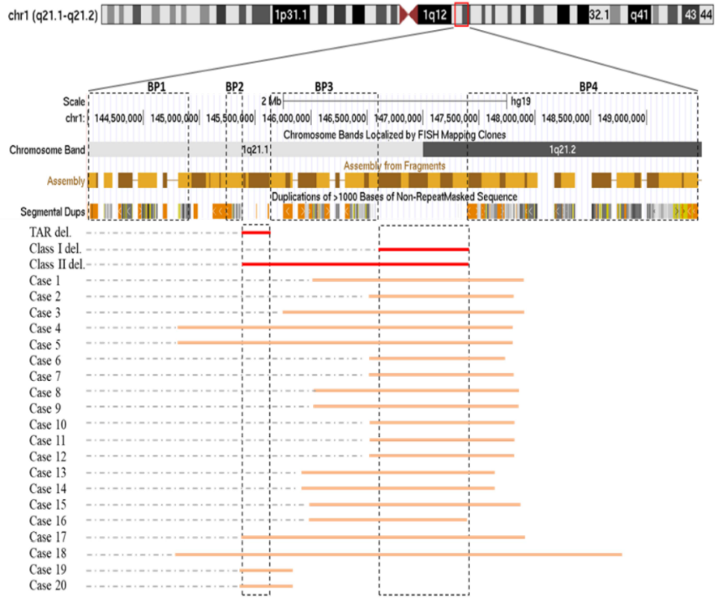

**Pang TAR (Case 19; hg19):** chr1:145388977-145746649

**Pang Class I (Case 2; hg19):** chr1:146507710-147828089

**Pang Class II (Case 19-Case 2):** chr1:145388977-147828089

*UCSC Genome Browser View of 1q21.1 TAR/Neuro Regions:*

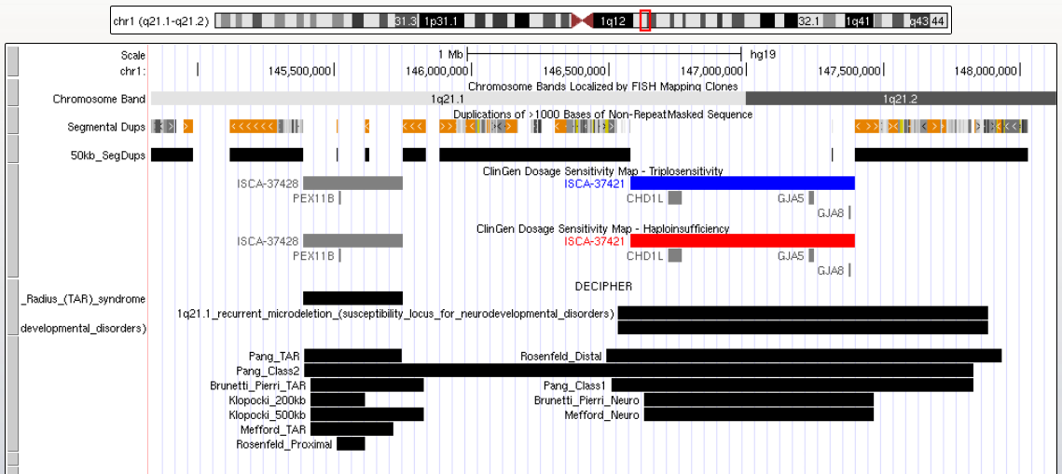

**FINAL REGIONS:**

**1q21.1 TAR:**

* **Klopocki 200kb:** chr1:145413192-145610627 (hg19)
* **Klopocki 500kb:** chr1:145413192-145826450 (hg19)

**1q21.1 Neuro:**

* **ClinGen:** chr1:146577486-147394506 (hg19)
* **DECIPHER:** chr1:147061832-148411223 (GRCh38)

**1q21.1 TAR Neuro:**

* **Pang Class II:** chr1:145388978-147828089 (hg19)
* **Proximal SegDup to Distal SegDup:** chr1:145118354-148026038 (hg19)

# Primary CNV 6: 1q24-q25 Proximal, Intermediate, Distal

*UCSC Genome Browser View of 1q24-q25 Events, Genes of Interest, and Delineated SRO(s):*

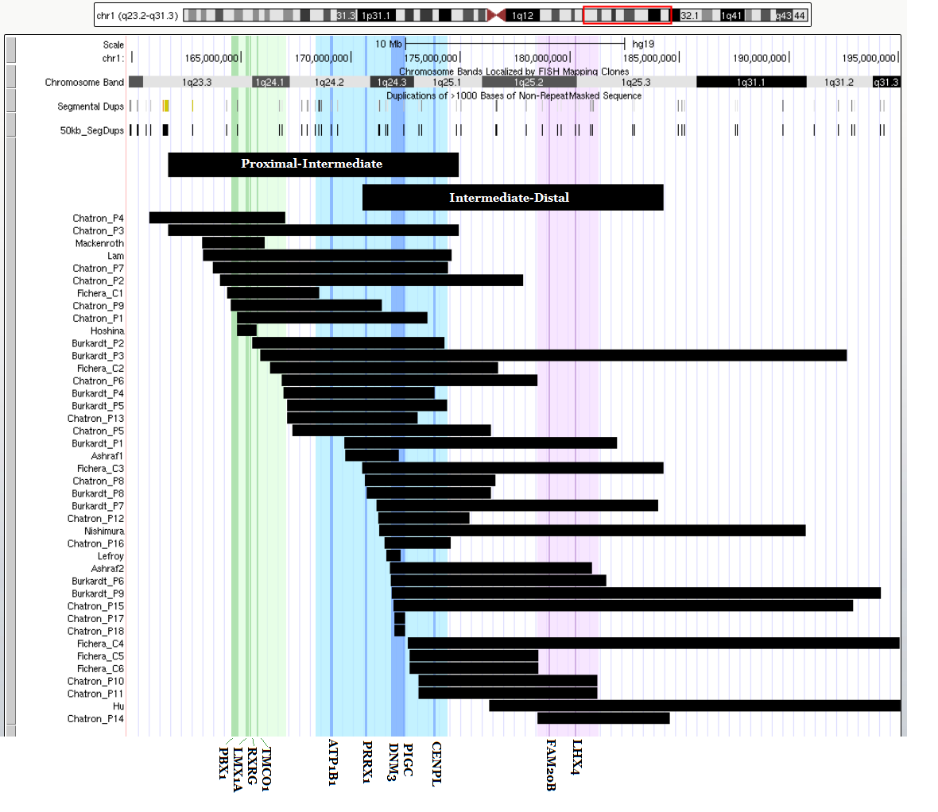

**Proximal-Intermediate (Chatron P3):** chr1:161650414-174926542 (hg19)

**Intermediate-Distal (Fichera C3):** chr1:170500104-184283033 (hg19)

**Green (Chatron Proximal SRO):** chr1:164501003-167022133 (hg19)

**Blue (End Fichera C1 to End Chatron P7):** chr1:168556004-174427602 (hg19)

**Purple (Chatron Distal SRO):** chr1:178514910-181269712 (hg19)

# Primary CNV 7: 1q41-q42

*Figure 4 of Rosenfeld 2011[11]:*

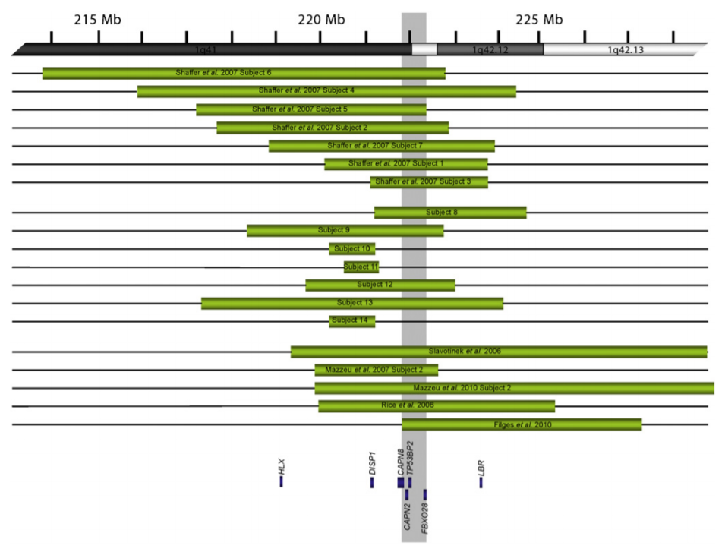

*UCSC Genome Browser View of Reported CNVs:*

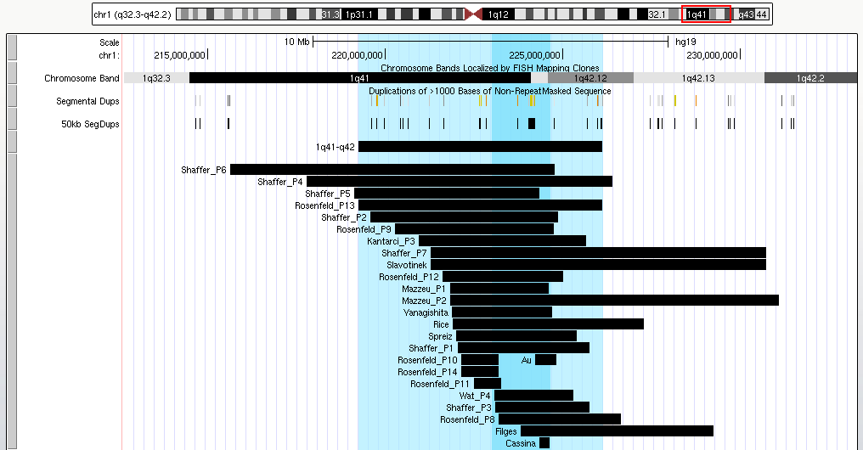

**Subject 13:** chr1:217,316,327-224,182,462 (hg18)

**SRO (DISP1 to WDR26)**: chr1:222988431-224622001 (hg19)

* DISP1: chr1:222,988,431-223,179,337 (hg19)
* WDR26: chr1:224,572,845-224,622,001 (hg19)

# Primary CNV 8: 1q43-q44

*Figures 2-4 of Ballif 2012[12]:*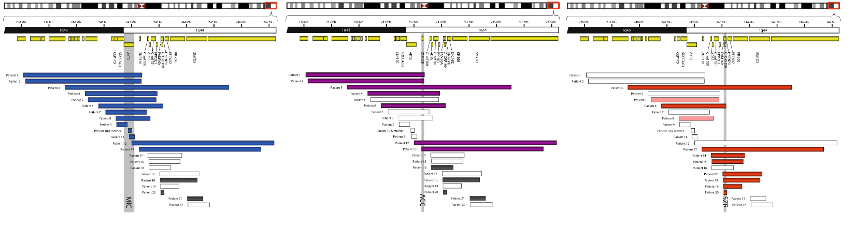

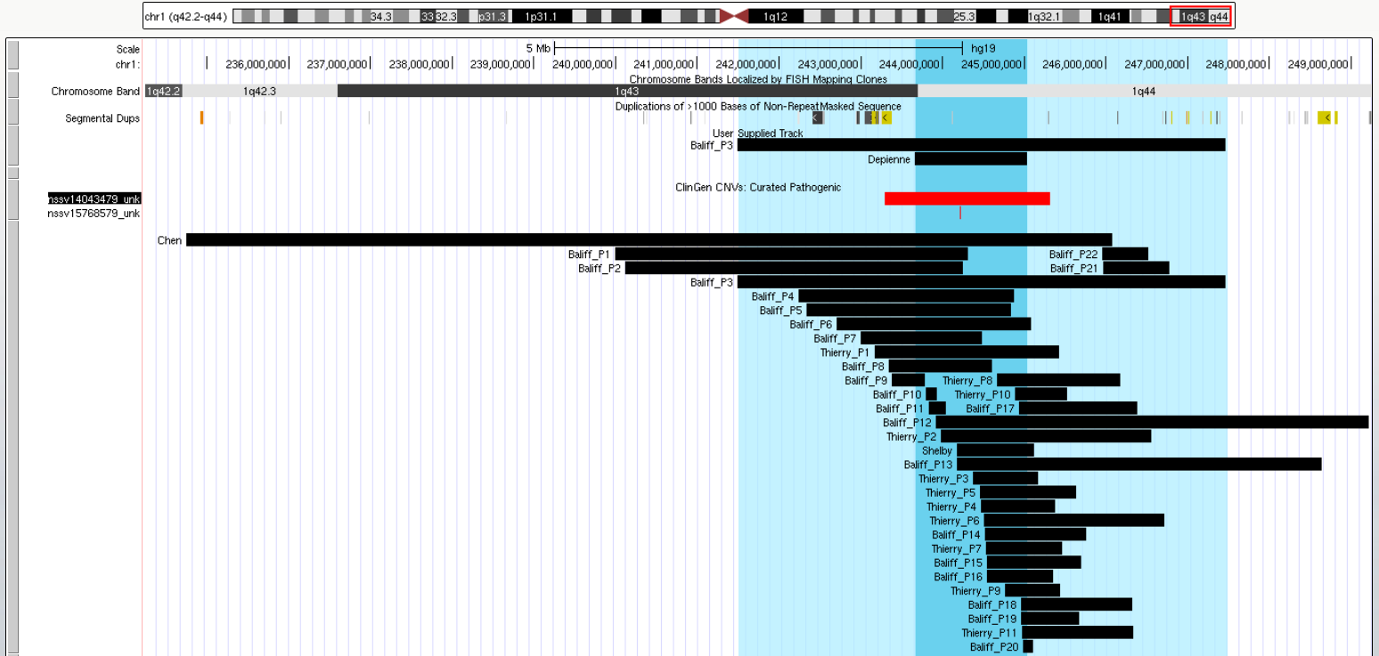

**Whole Region = Baliff Patient 3**: chr1: 239559031-245532863 (hg18)

**ClinGen Coordinates**: chr1:243287730-245318287 (hg19)

# Primary CNV 9: 2p25.3 (MYTIL)

*Figure 2 of De Rocker 2015[13]:*

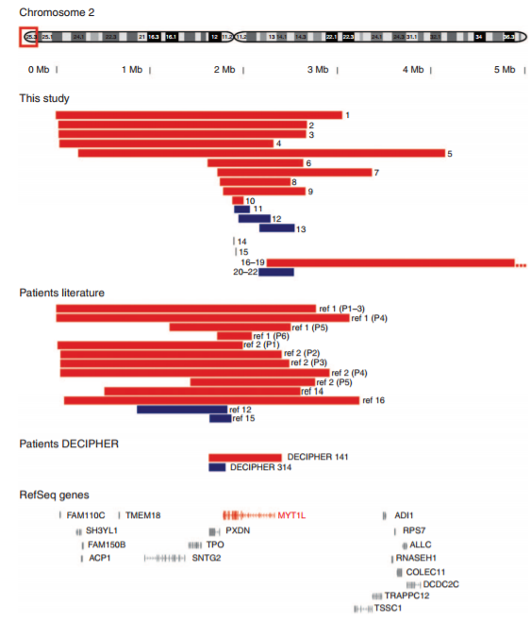

**De Rocker Patient 1:** chr2:1-3014104 (hg19)

**MYTIL Coordinates**: chr2:1,792,885-2,335,045 (hg19)

# Primary CNV 10: 2p16.3 (NRXN1)

*Figure 1 of Lowther 2017[14]:*

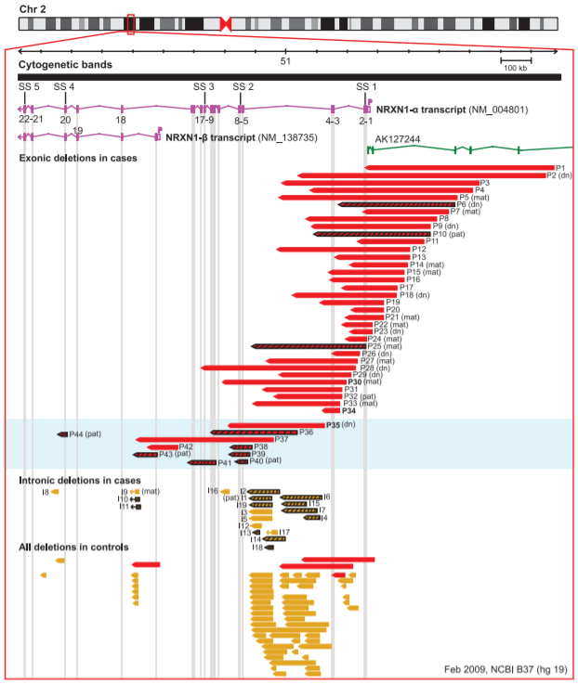

*UCSC Genome Browser View of Reported CNVs:*

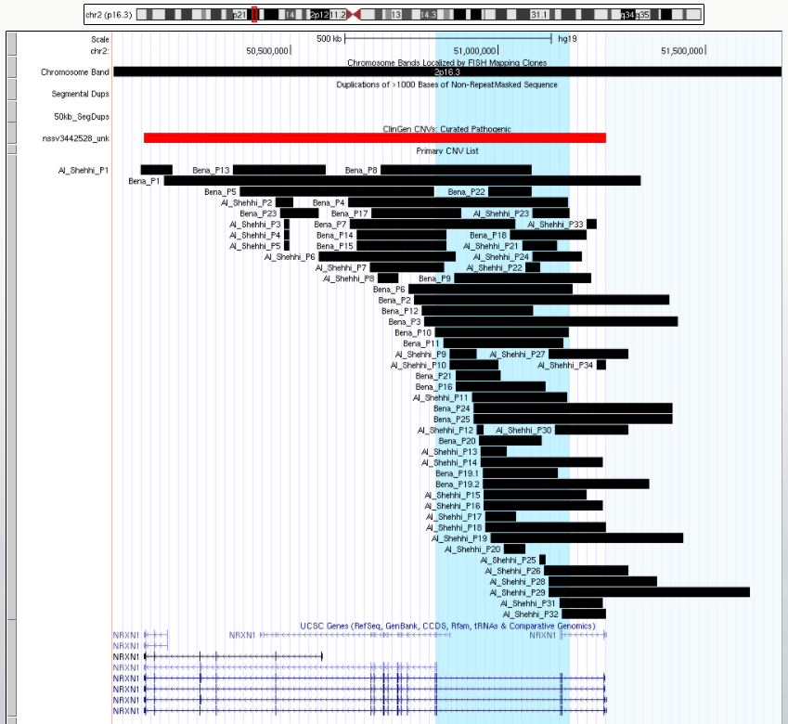

**Whole Region = NRXN1**

* chr2:50145643-51259674 (hg19)

**Blue Region = Bena P10**

* chr2:50847740-51170975 (hg18)

# Primary CNV 11: 2p15-p14

# Primary CNV 12: 2p16-p15

*Figure 2 of Hancarova 2013[15]:*

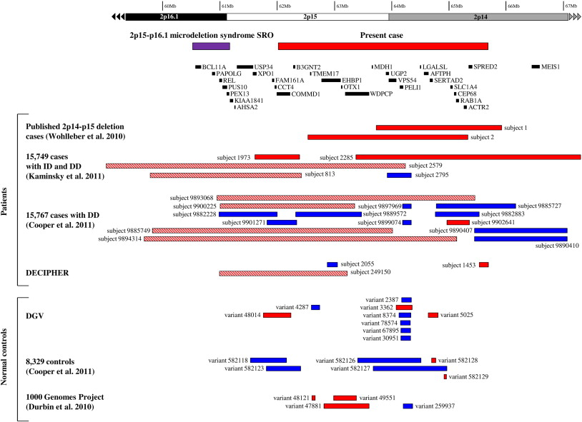

*UCSC Genome Browser View of Reported CNVs:*

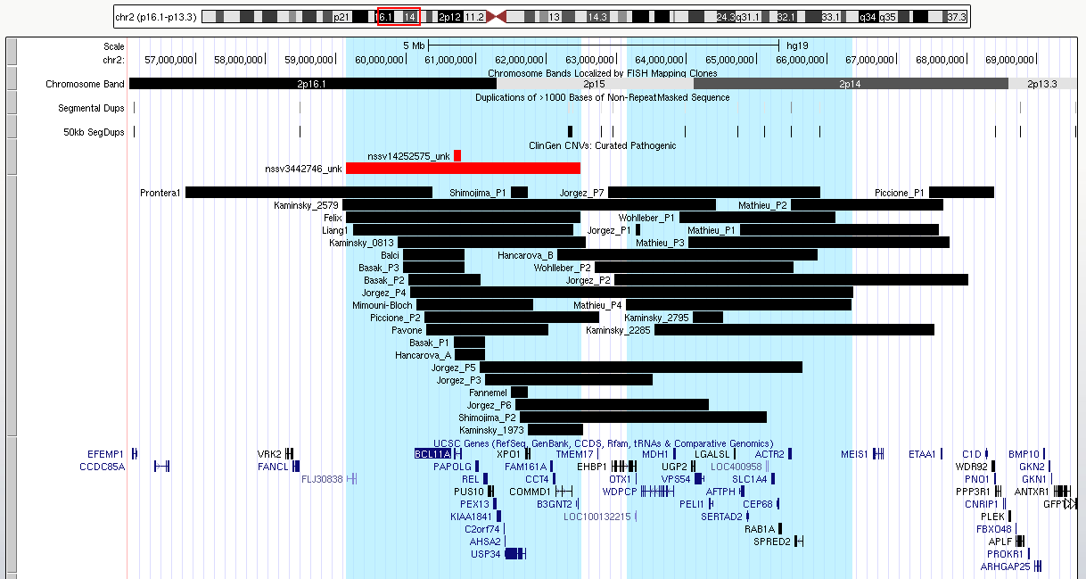

**2p16-p15.1 (ClinGen):** chr2:59139200-62488871 (hg19)

**Matthieu P2:** chr2:65490660-67666133 (hg19)

# Primary CNV 13: 2p12-p11.2

*Figure 3 of Writzl 2009[16]:*

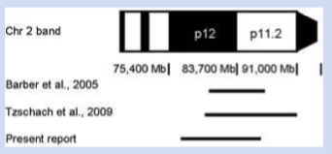

*Figure 5 of Barber 2005[17]:*

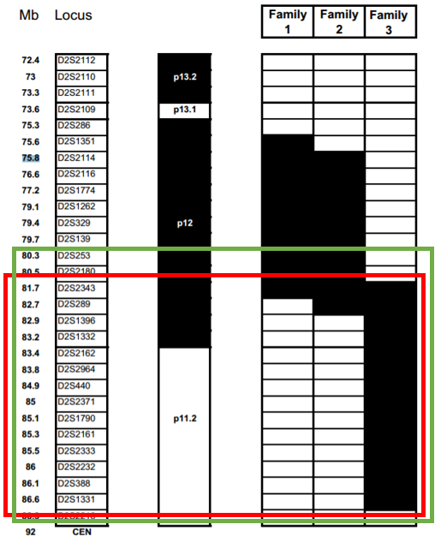

Green: Tzschach et al. (2009)

*UCSC Genome Browser View of Reported CNVs:*

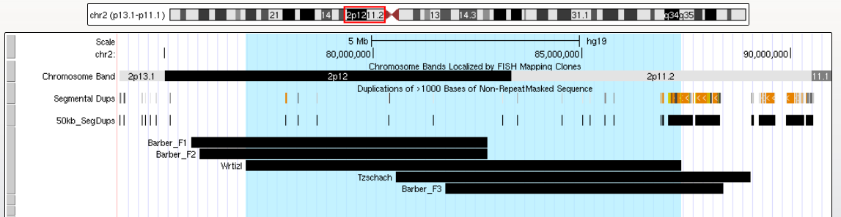

**Region = Wrtizl =** chr2:76854464-87287935 (hg17)

# Primary CNV 14: 2q11.2

*Figure 2 of Riley 2015[18]:*

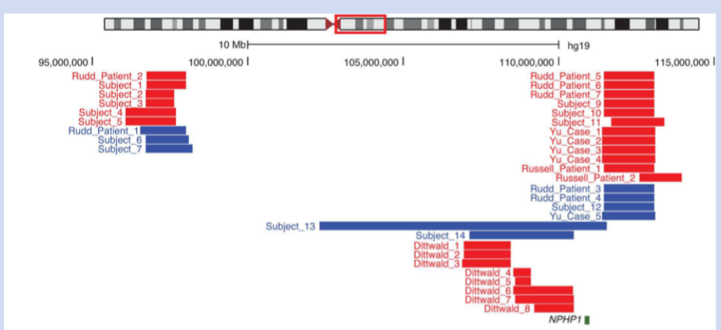

**Subject 3**: chr2: 96,739,309–97,652,262 (hg19)

***UCSC Genome Browser View of Reported CNVs in 2q11.2 and 2q13:***

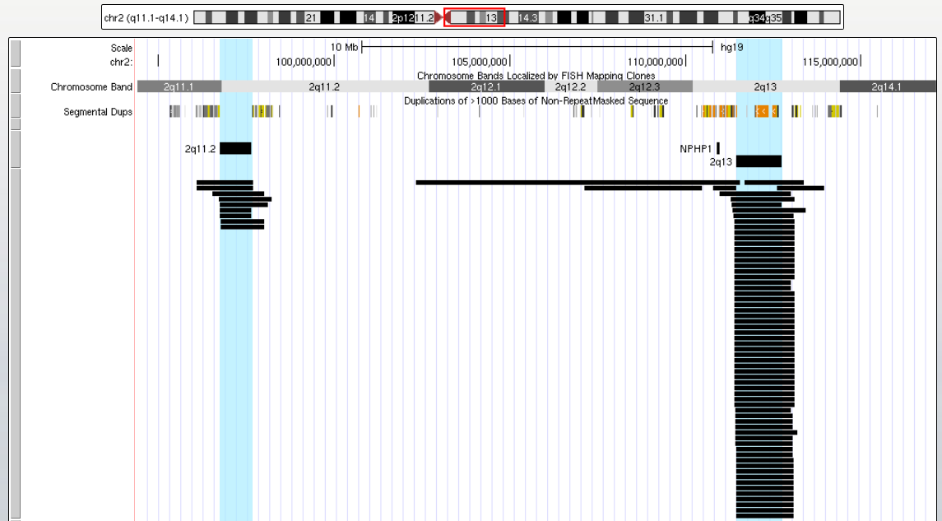

# Primary CNV 15: 2q13

*Figure 1 of Wolfe 2018[19]:*

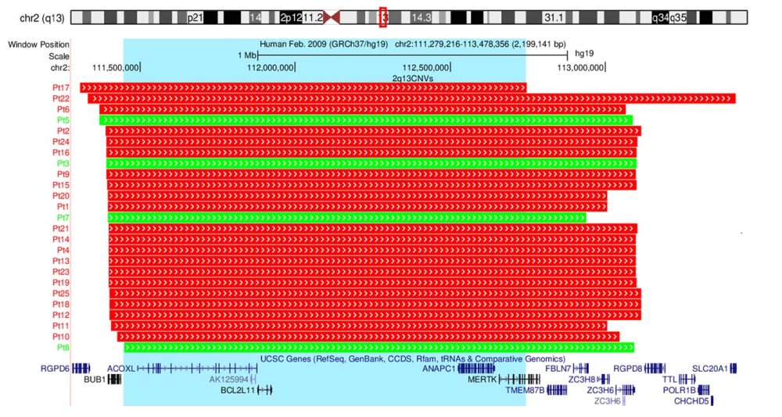

**Wolfe (2018) SRO:** chr2:111449141–112746937 (hg19)

# Primary CNV 16: 2q22.3 (Mowat-Wilson)

*Figure 3 of Ishihara 2004[20]:*

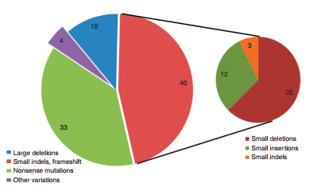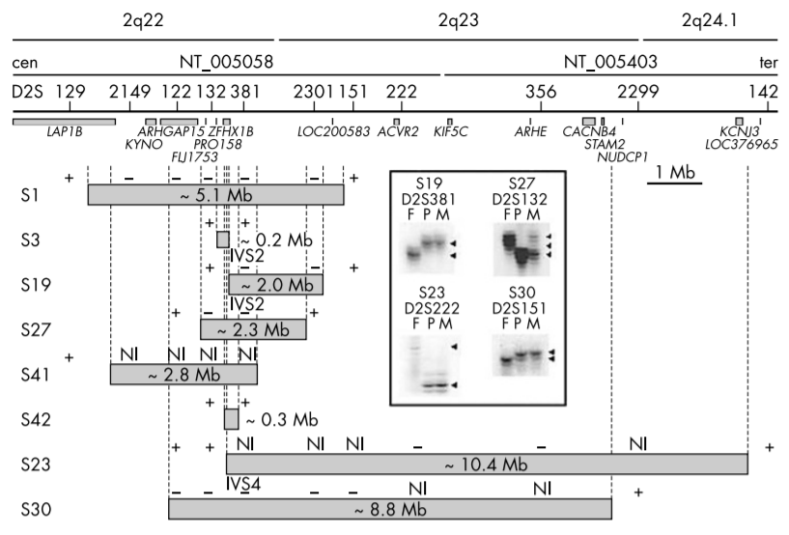

*Figure 3B and 3C of Ivanovksi 2008[21]: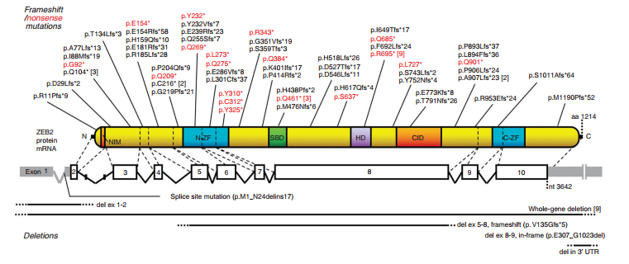*

# Primary CNV 17: 2q23.1 (MBD5)

*Figure 1 of Talkowski 2011[22]:*

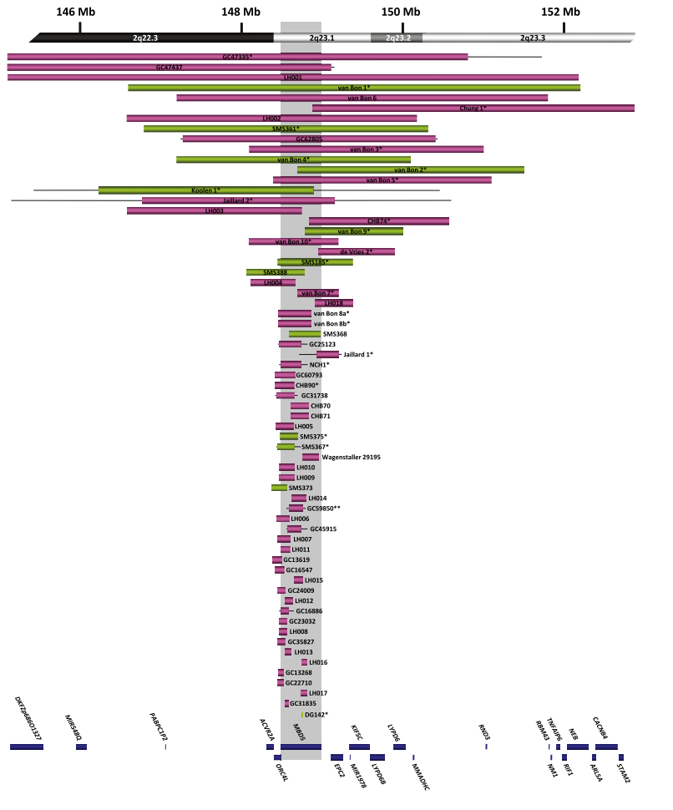

**Whole Region = van Bon P4** = chr2:147200000-150100000 (hg18)

**SRO = MBD5** = chr2:148778580-149271046 (hg19)

# Primary CNV 18: 2q31.1

*Figure 1 of Theisen 2011[23]:*

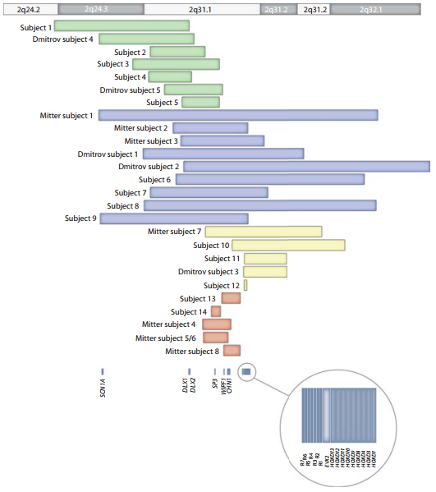

**Pink Region = Mitter Patient 4** No Facial or Limb abnormalities

*UCSC Genome Browser View of Reported CNVs:*

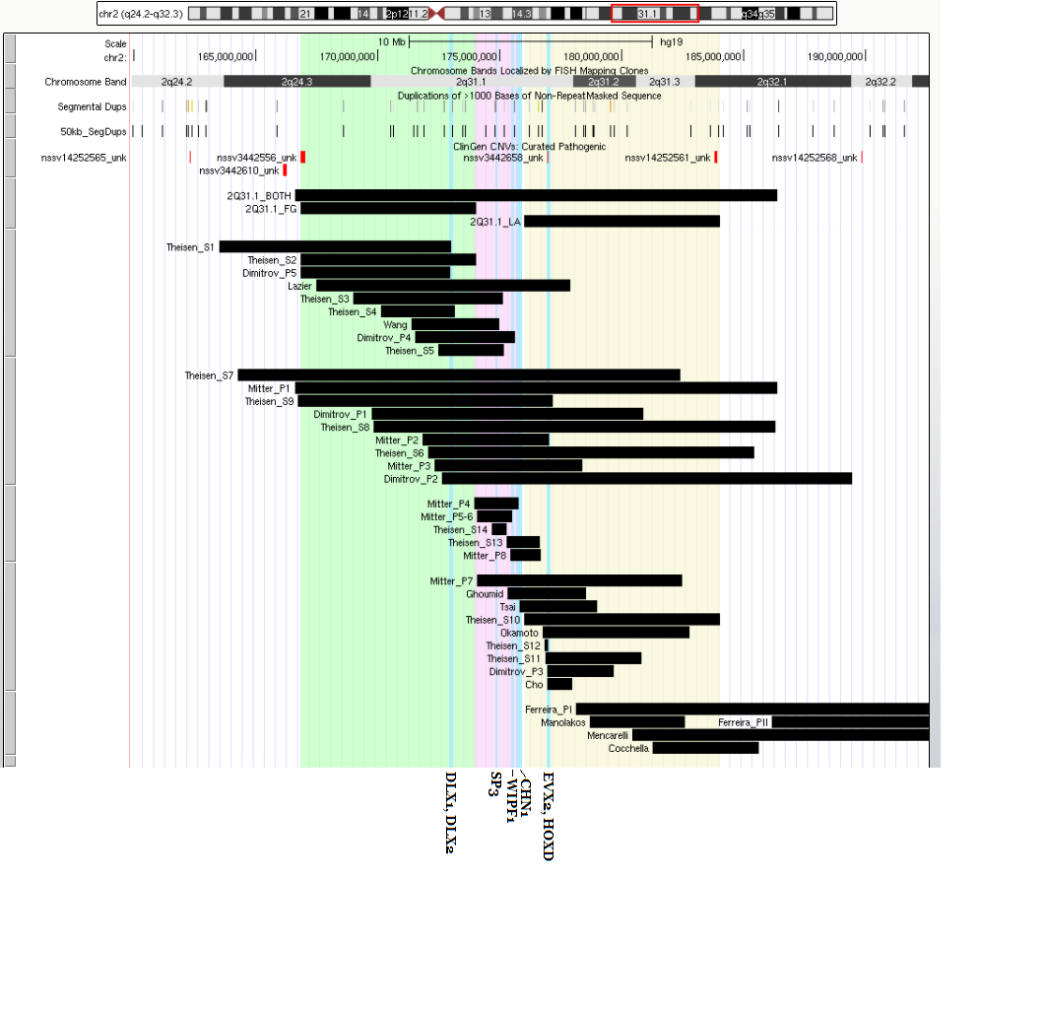

**Whole Region = Mitter Patient 1 =** chr2:166293773-186068927 (hg18)

**Green Region (FG) = Thiesen Subject 2** **=** chr2:166519354-173745491 (hg18)

**Yellow Region (LA) = Thiesen Subject 10** **=** chr2:175712131-183736599 (hg18)

**HOXD Cluster** **=** chr2:176957533-177055635 (hg19)

# Primary CNV 19: 2q31.2-q32.3

*Figure 3 of Ferreira 2012[24]:*

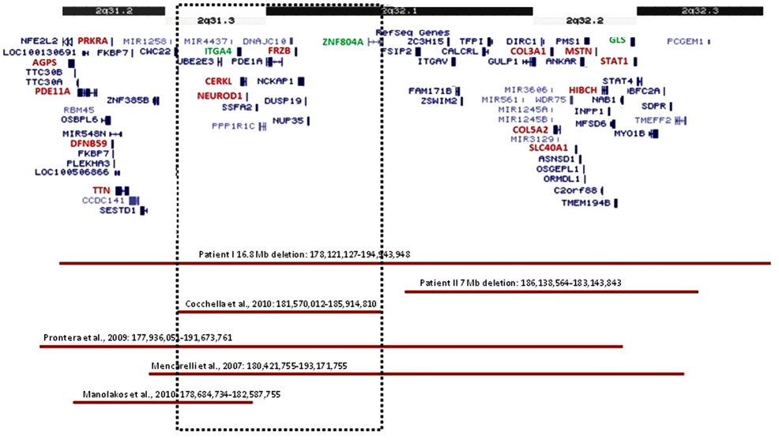

*UCSC Genome Browser View of Reported CNVs:*

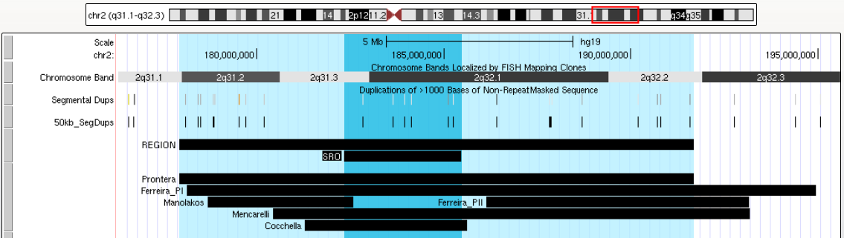

**“Present Case” [Prontera 2009]:** chr2:177,644,267-191,382,006 (hg18)

**Ferreira SRO (ITGA4 to ZNF804A):** chr2:182,321,619-185,804,214 (hg19)

* **ITGA4:** chr2:182,321,619-182,402,468 (hg19)
* **ZNF804A:** chr2:185,463,093-185,804,214 (hg19)

# Primary CNV 20: 2q33.1

*Figure 1 of Zarate 2017[25]:*

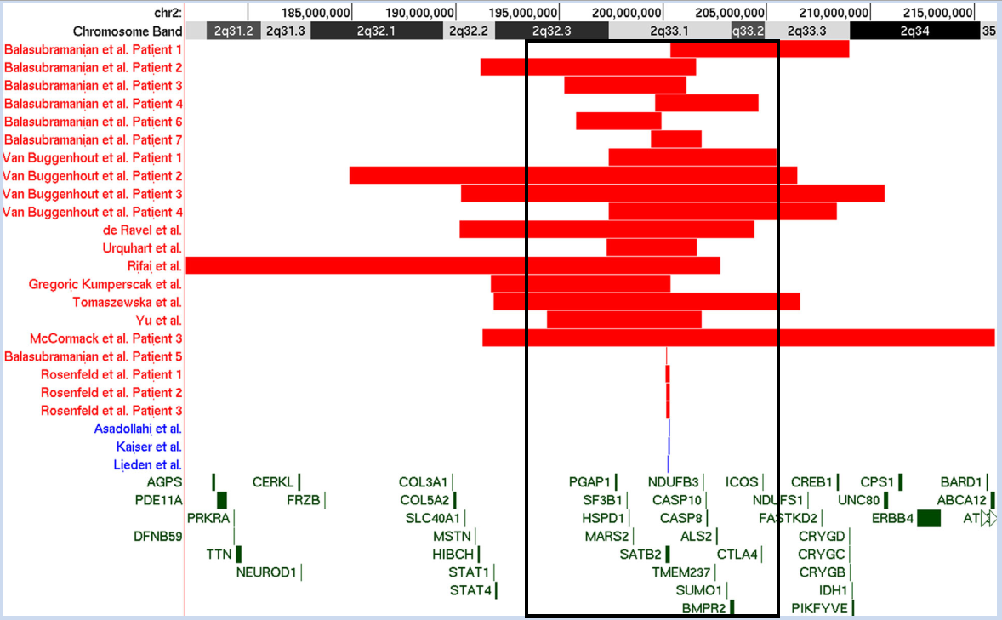

*NOTE: Black box is approximation of DECIPHER Coordinates based on gene inclusion/exclusion.*

**DECIPHER Coordinates**: chr2:196060397-204342216 (GRCh38)

**SATB2**: chr2:200134223-200329831 (hg19)

# Primary CNV 21: 2q35 (IHH)

*Figure 3 of Barroso 2014[26]:*

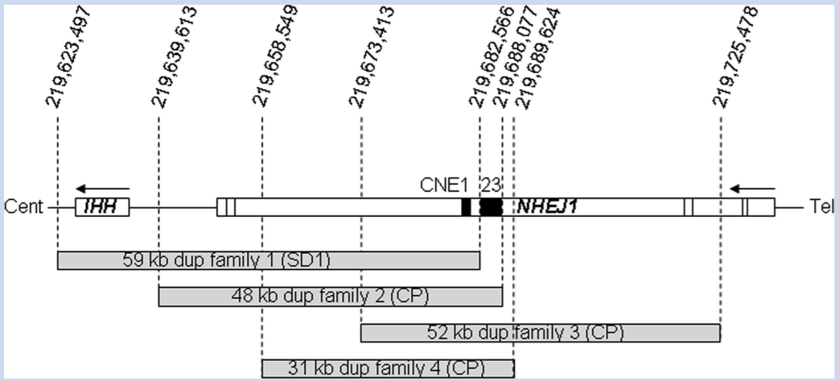

**Whole Region (IHH to NHEJ1):** chr2:219,919,142-220,025,587 (hg19)

* IHH: chr2:219,919,142-219,925,238 (hg19)
* NHEJ1: chr2:219,940,046-220,025,587 (hg19)

# Primary CNV 22: 2q37

*Figure 2 of Le 2019[27]:*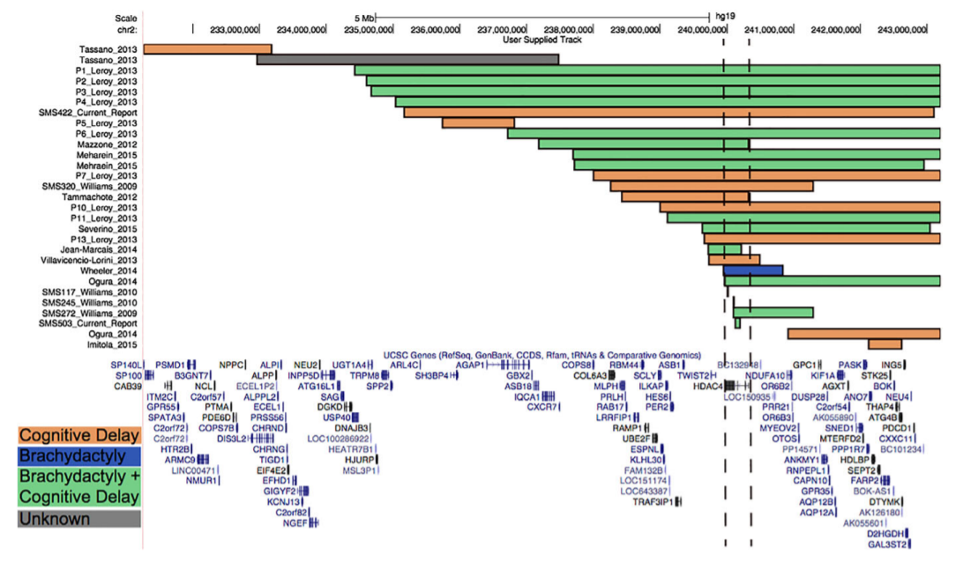**ClinGen:** chr2:239954693-242930600 (hg19)

**AGAP1 to qter**: chr2:236402733-243199373 (hg19)

**HDAC:** chr2:239969864-240322643 (hg19)

# Primary CNV 23: 3p25.3 Proximal, Distal

*UCSC Genome Browser View of Reported CNVs:*

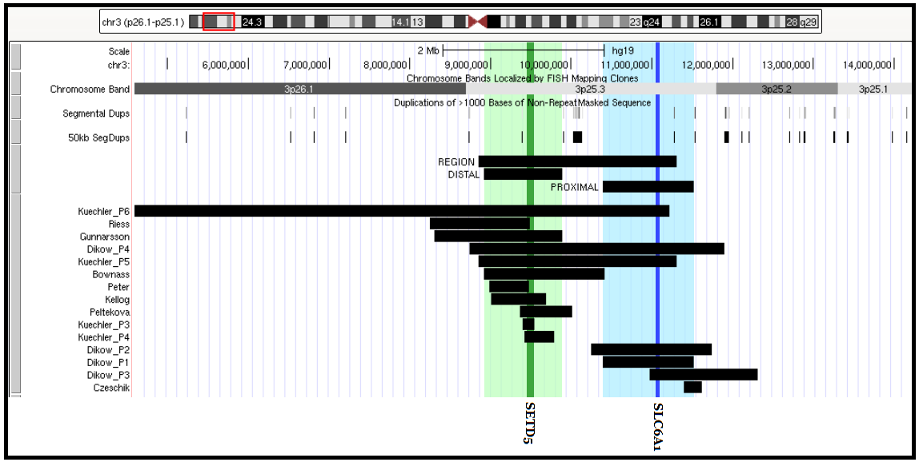

**Whole Region [ Bownass – Gunnarsson ]:** chr3:8922192-9885334

* **Bownass:** chr3:8922192-10413378 (hg19)
* **Gunnarrson:** chr3:8305426-9885334 (hg19)

**Distal SRO [ Patient #5; Kuchler ]:** chr3:8856000-11305600 (hg19)

**Proximal [ Dikow P1 ]:** chr3:10391284-11516688 (hg19)

# Primary CNV 24: 3p21.31

*Figure 1 of Eto 2013[28]:*

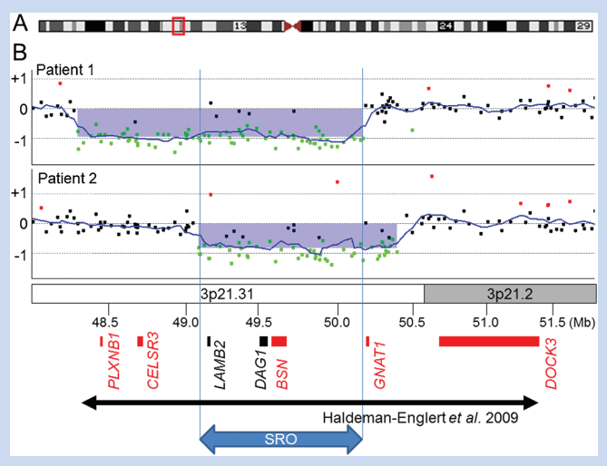

*Figure 2B of Lovrecic 2016[29]:*

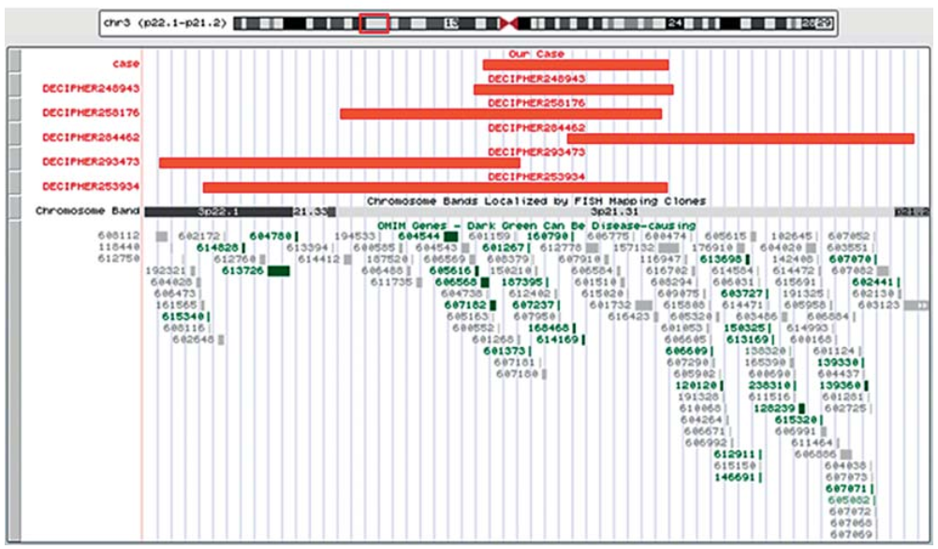

*UCSC Genome Browser View of Reported CNVs:*

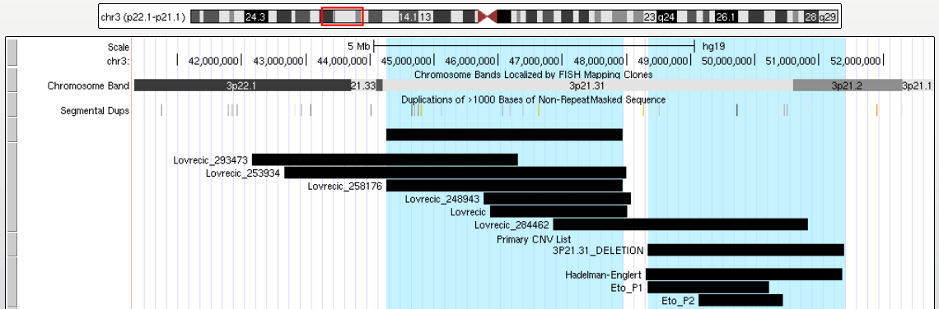

**Hadelman-Englert (2009):** chr3:48,301,437-51,364,610 (hg18)

**DECIPHER #258176 from Lovrecic (2016)***:* chr3:44251270-47936671 (hg18)

# Primary CNV 25: 3q13.31

*Figure 4 of Herve 2016[30]:*

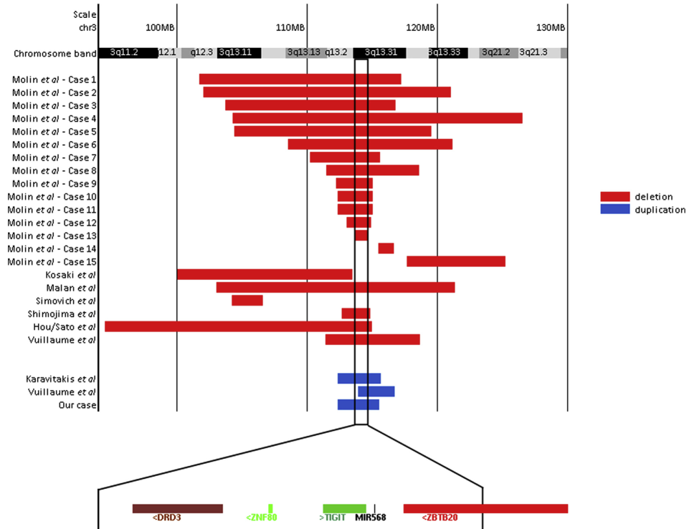

*UCSC Genome Browser View of Reported CNVs:*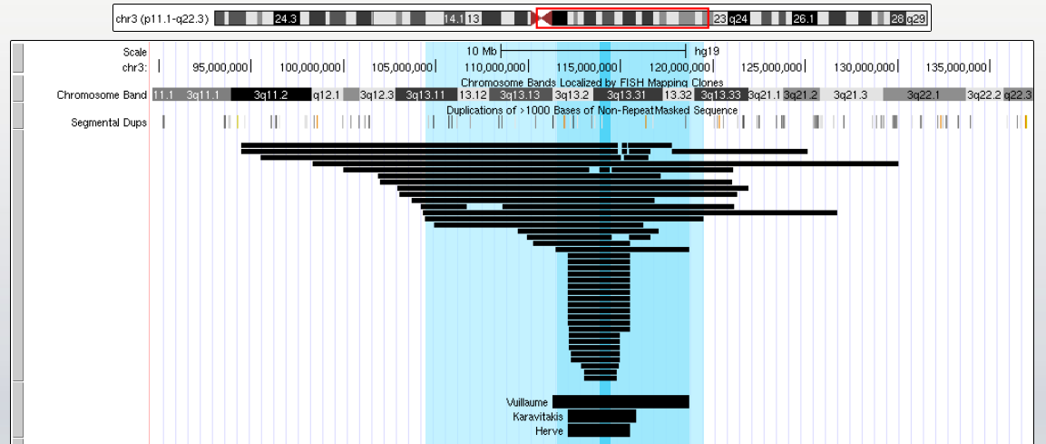 **Molin Regions:**

* **Case 5:** chr3:105911706-120983616 (hg18)
* **Case 8:** chr3:112976429 -120183473 (hg18)
* **Case 13:** chr3:115335356-115916848 (hg18)

# Primary CNV 26: 3q22.1-q25.2

*UCSC Genome Browser View of Reported CNVs:*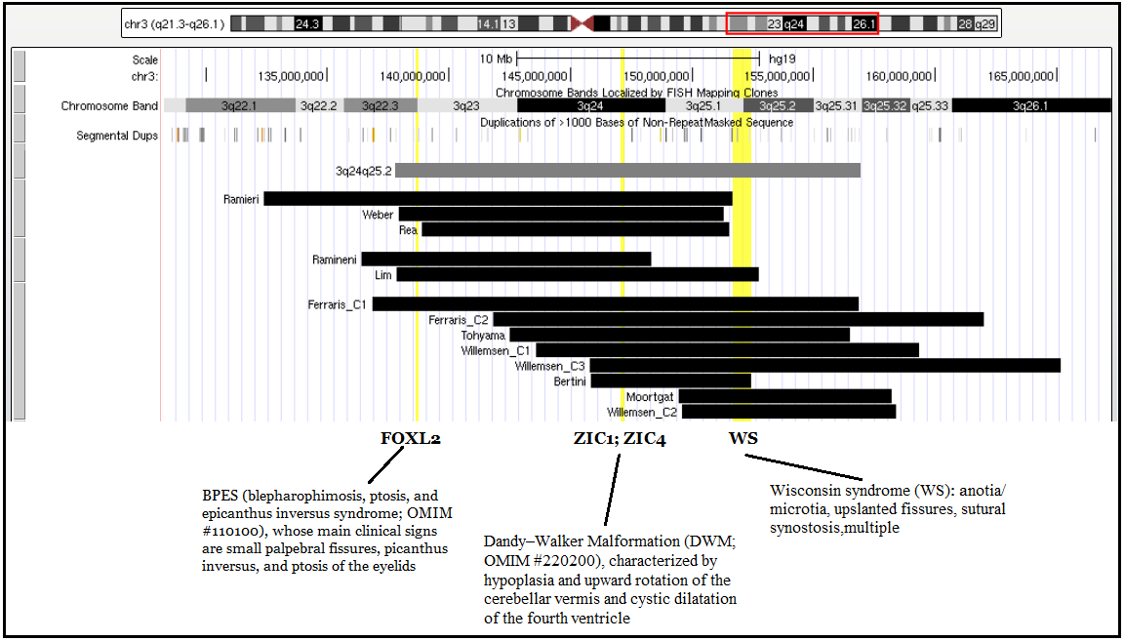

**Whole Region (Grey)**: chr3:137845310-156872233 (hg19)

* **Lim (2011):** chr3:139328000-154254416 (hg18) // chr3:137845310-152771726 (hg19)
* **Bertini (2016) :: Bertini P6 / Ferraris C1:** chr3:136842221-156872233 (hg19)

# Primary CNV 27: 3q27.3-q28

*Figure 2 of Ponzi 2015[31]:*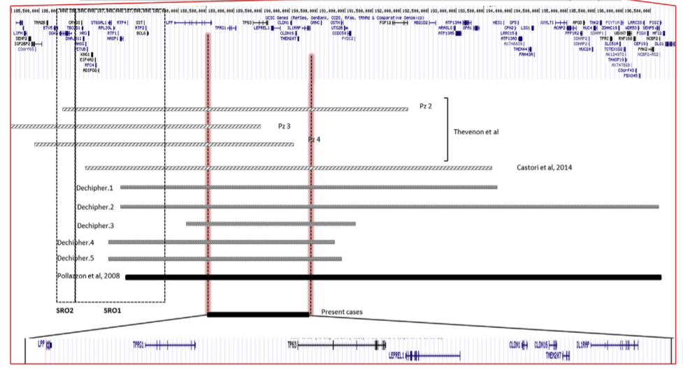

*UCSC Genome Browser View of Reported CNVs:***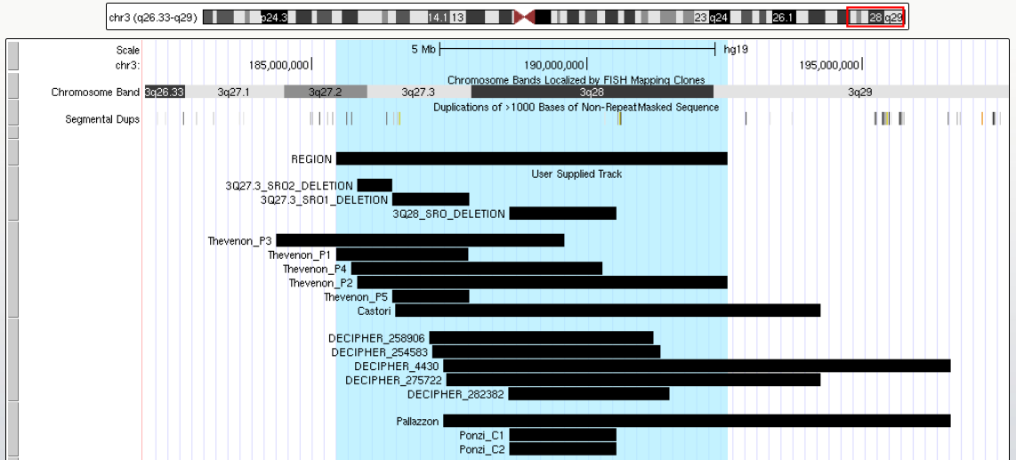**

**Thevenon (2014) Regions:**

* **SRO1 [ Start P5; End P1 ] ::** chr3:186461680-187832449 (hg19)
* **SRO2 [ Start P2; Start P5 ] ::** chr3:185816939-186461680 (hg19)
* **Whole Region [ Start P1; End P2 ] ::** chr3:185445864-192541120 (hg19)

**Ponzi (2015) SRO Region:** chr3:188592241-190521638 (hg19)

# Primary CNV 28: 4p16.3 (Wolf-Hirschorn)

*UCSC Genome Browser View of Reported CNVs:*

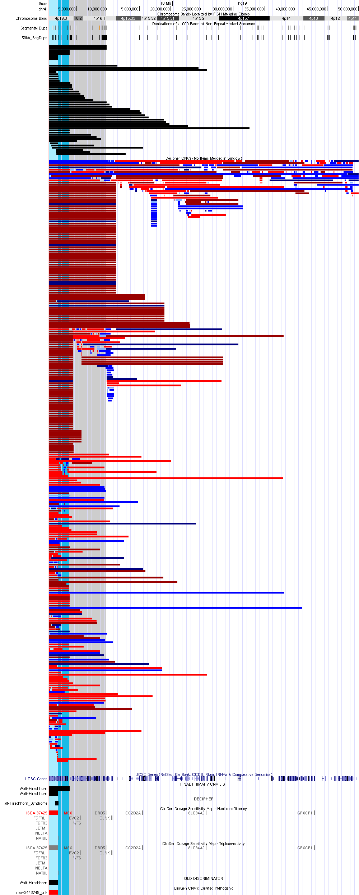

**Grey Region = Ho P15 =** chr4:68345-9785068 (hg19)

**Dark Blue Region = Correa C1 =** chr4:71552-3845097 (GRCh38)

**Light Blue Region = ClinGen Coordinates =** chr4:331568-2010962 (hg19)

# Primary CNV 29: 4q21

*Figure 1E of Harada 2002[32]:*

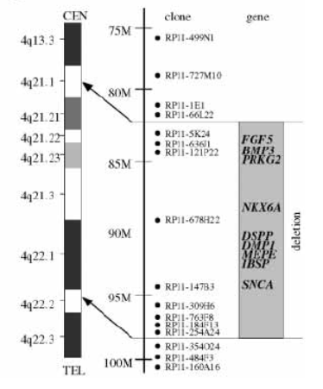

**Harada (2002):** chr4:79144454-92526443 (hg19)

* RP11-5K24: chr4:79144454-79291868 (hg19)
* RP11-254A24:
  + chr4:91603275-91605292 (GRCh38)
  + chr4:92524426-92526443 (hg19)

*Figure S1 of Hu 2017[33]:*

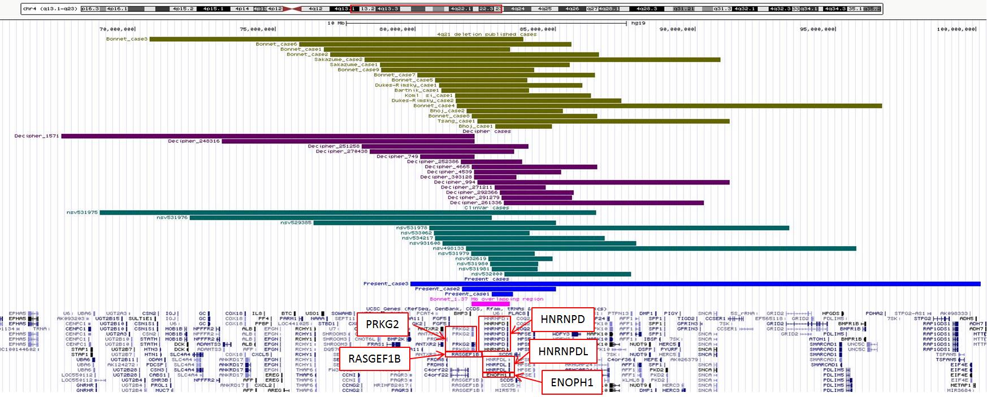

*UCSC Genome Browser View of Reported CNVs:*

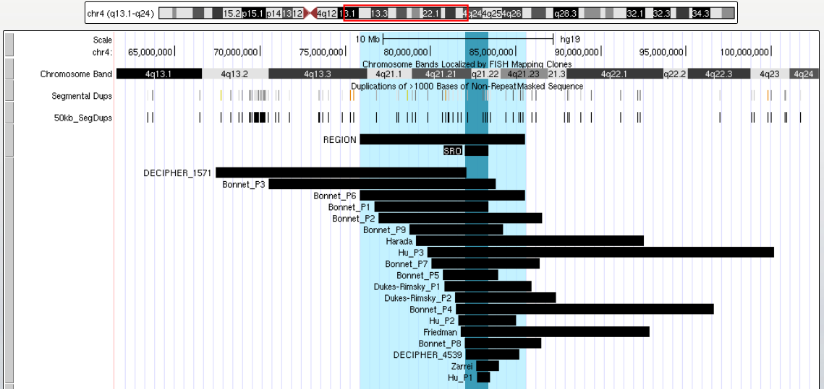

**Whole Region (Bonnet Patient 6):** chr4:76077557-85788996 (hg18)

**Bonnet SRO (Start Patient 8 – End Patient 1):** chr4:82228875-83601083 (hg18)

* **Patient 1**: chr4:76949115-83601083 (hg18)
* **Patient 8**: chr4:82228875-86711060 (hg18)

# Primary CNV 30: 5p13

*UCSC Genome Browser View of Reported CNVs: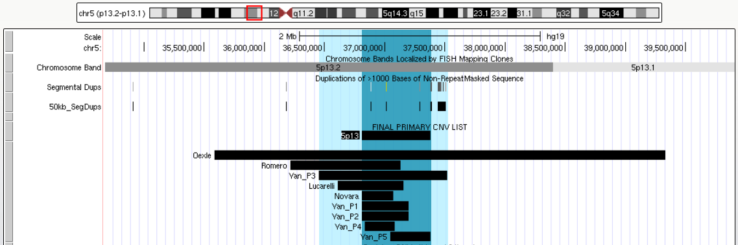*

**Whole Region (Yan P3)**: chr5:36487985-37556112 (hg18)

**SRO (Yan P1 to Yan P5)**: chr5:36845462-37417228 (hg18)

# Primary CNV 31: 5q11.2

# Primary CNV 32: 5q12

*Figure 2 of Snijders Blok 2014[34]:*

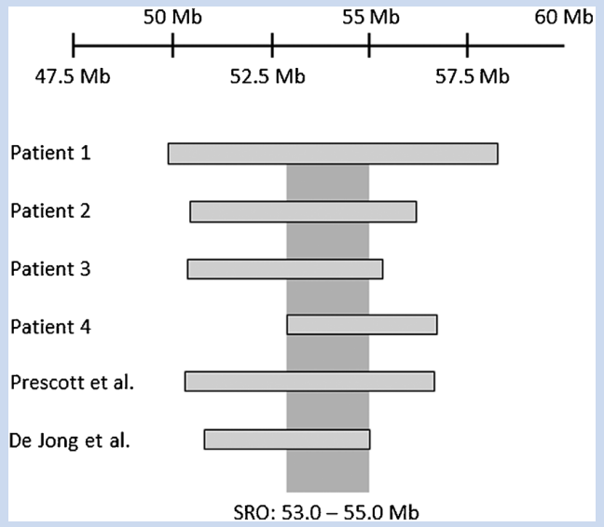

*Figure 3 of Cellamare 2021[35]: 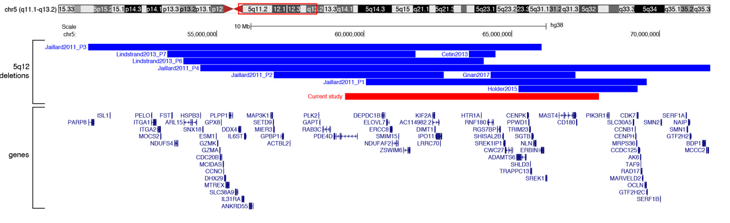*

*UCSC Genome Browser View of Reported CNVs:*

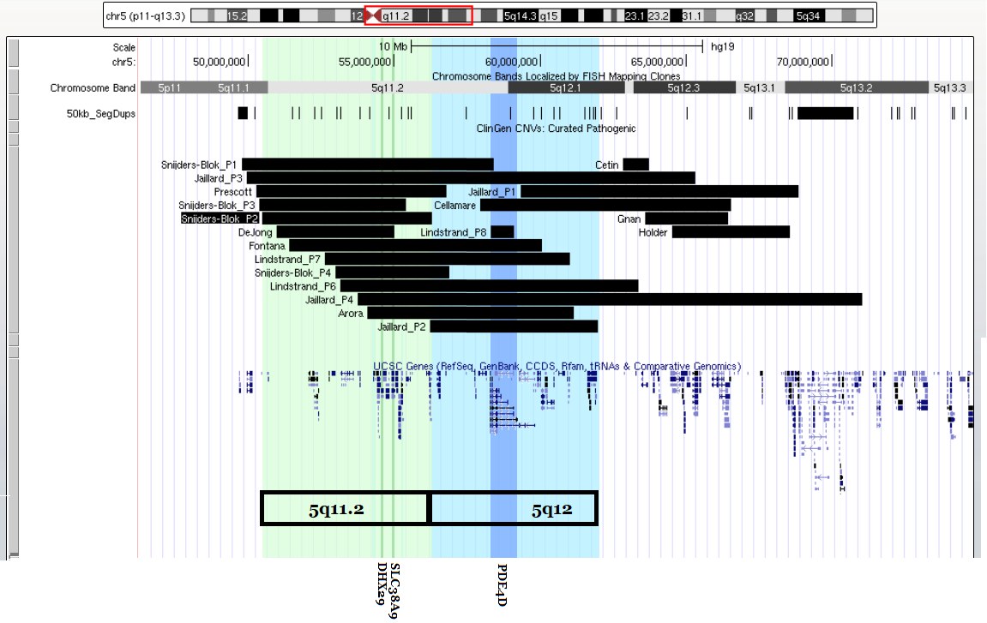

**5q11.2 (Green) = Snijers Blok P2 =** chr5:50500000-56300000 (hg19)

**5q12 (Blue) = Jaillard P2 =** chr5:56264851-62021754 (hg18)

# Primary CNV 33: 5q14.3-q15 Proximal, Distal

*Figure 2 of Hotz 2013[36]:*

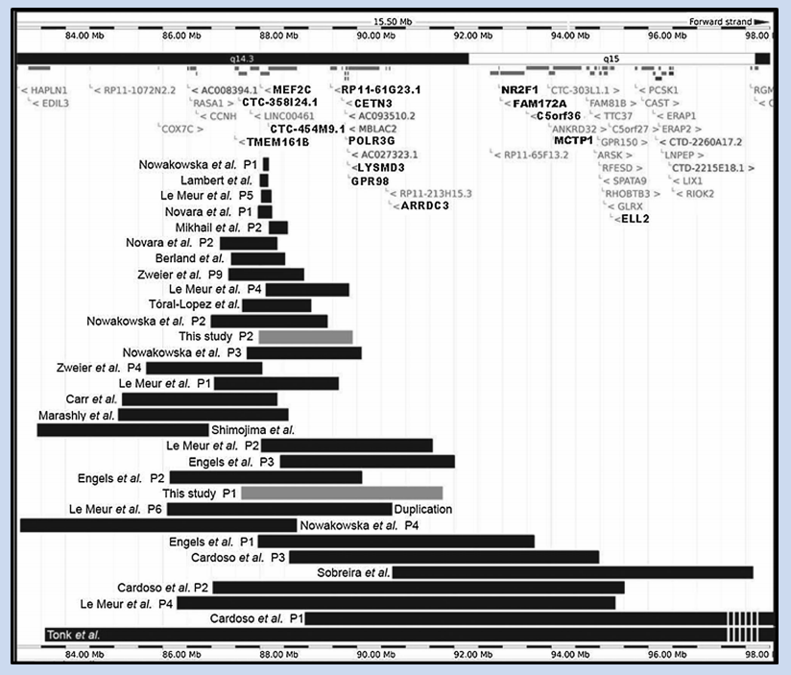

*UCSC Genome Browser View of Reported CNVs:*

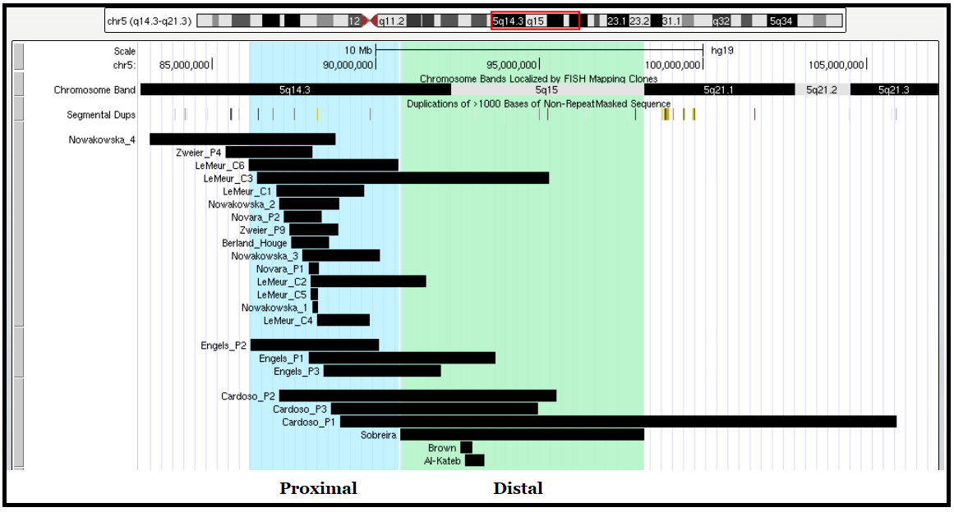

**Proximal Region ( Le Meur P6 ):** chr5:86142512-90712814 (hg18)

**MEF2C (Le Meur C5):** chr5:88014058-88199922 (hg19)

**Distal Region ( Sobreiera ):** chr5:90787099-98232469 (hg18)

**Distal SRO (Al-Kateb to Brown):** chr5:92742875-92972632 (hg18)

# Primary CNV 34: 5q31.3

*Figure 2 of Brown 2013[37]:*

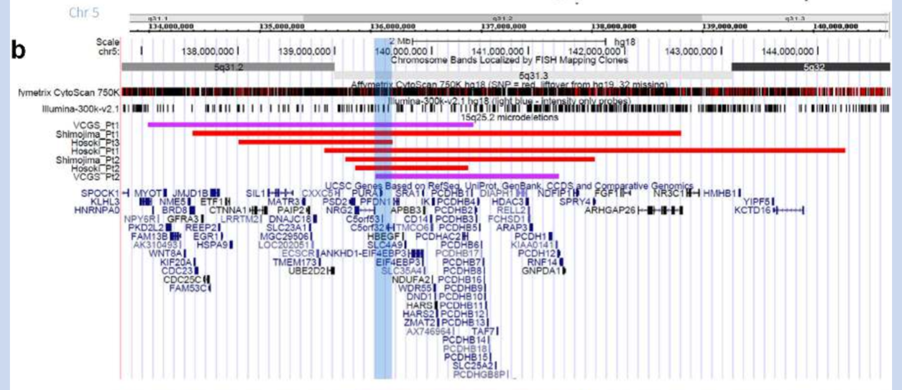

*UCSC Genome Browser View of Reported CNVs:***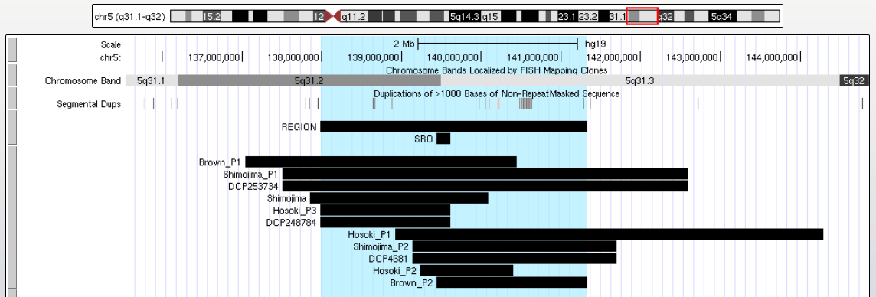**

**Whole Region ( Hosoki P3 – Brown P2 ):** chr5:138011434-141309459 (hg18)

**SRO ( Brown P2 – Hosoki P3 ):** chr5:139422959**-**139592820

* **Hosoki P3:** chr5:138011434-139592820 (hg18)
* **Brown P2:** chr5:139422959-141309459 (hg18)

# Primary CNV 35: 6p25

*Figure 4 of Linhares 2015[38]:*

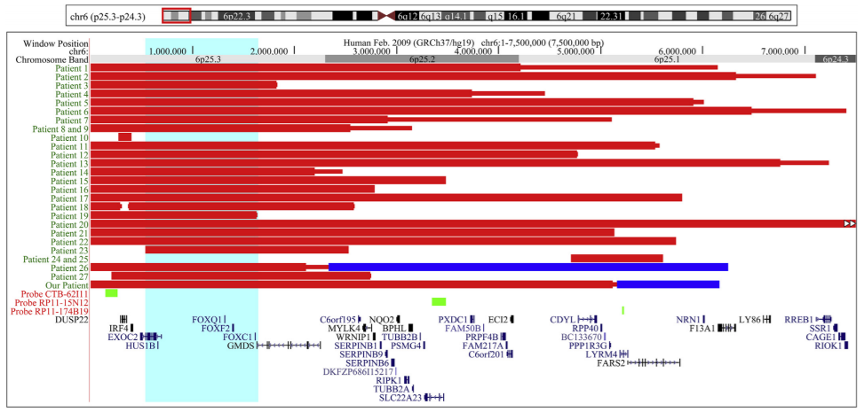

**Whole Region = Patient 27 = Vernon 2013:** chr6:203619-2741187 (hg19)

**SRO (EXOC2 to GMDS):** chr6:485138-2245868 (hg19)

* **EXOC2:** chr6:485,138-693,141 (hg19)
* **GMDS:** chr6:1,624,035-2,245,868 (hg19)

# Primary CNV 36: 6p25.1-p24.3

*Figure 1D of Kent 2020[39]:*

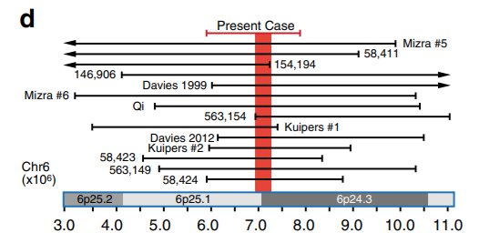

**Whole Region (Qi):** chr6:4745144-10384769 (hg19)

# Primary CNV 37: 6q12-q14.1

# Primary CNV 38: 6q13-q14.2

# Primary CNV 39: 6q14.1-q14.3

# Primary CNV 40: 6q14.1-q15

# Primary CNV 41: 6q14.3-q16.3

*Figure 1 of Engwerda 2018[40]:*

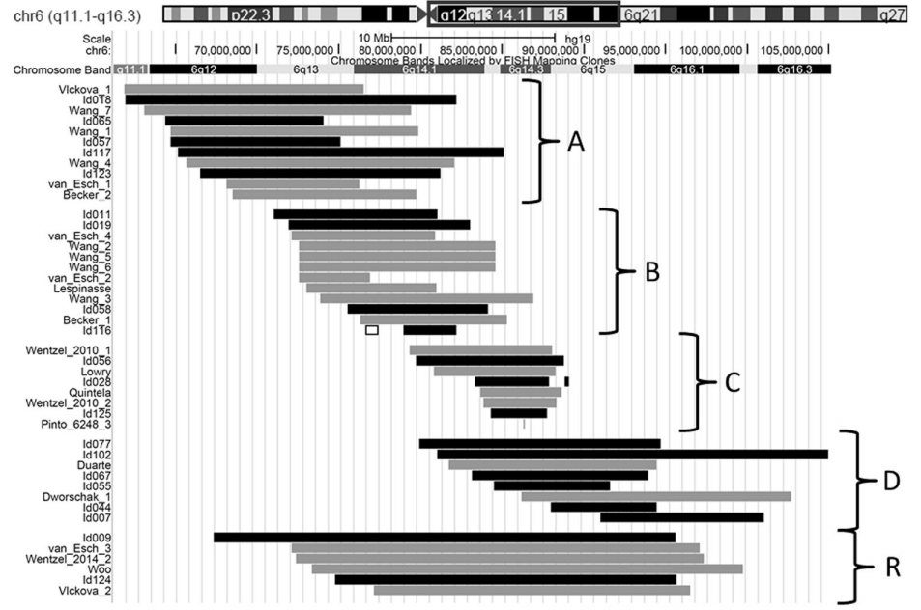

**Regions:**

* **A [ 6q12-q14.1;** **Wang 1 ]:** chr6:64535801-80178353 (hg19)
* **B [ 6q13-q14.2; Wang 2 ]:** chr6:72548959-84576295 (hg19)
* **C [ 6q14.1-q14.3;** **Lowry ]:** chr6:80767339-88299283 (hg19)
* **D [ 6q14.1-q15;** **Dworschak 1 ]:** chr6:86137888-102703574 (hg19)
* **R [ 6q14.3-q16.3;** **van Esch 3 ]:** chr6:72100590-97078142(hg19)

# Primary CNV 42: 6q24-q25

# Primary CNV 43: 6q25

*Figure 1 of Thienpont 2011[41]:*

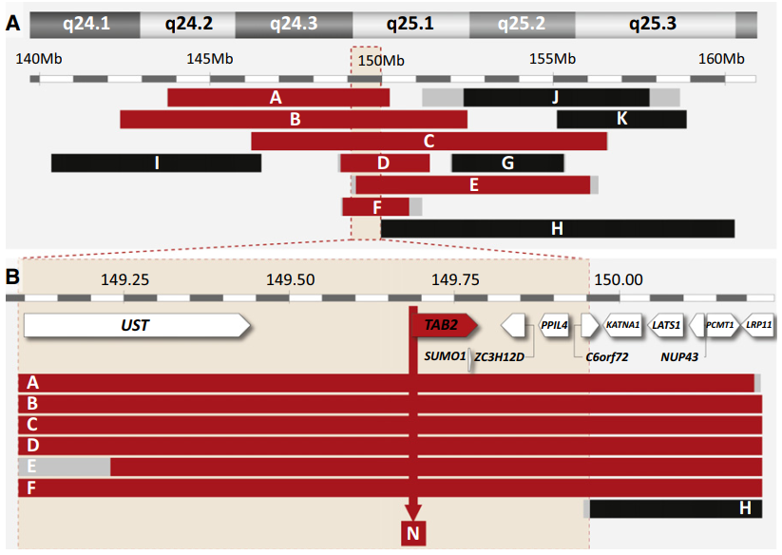

*Figure 1 of Santen 2014[42]:*

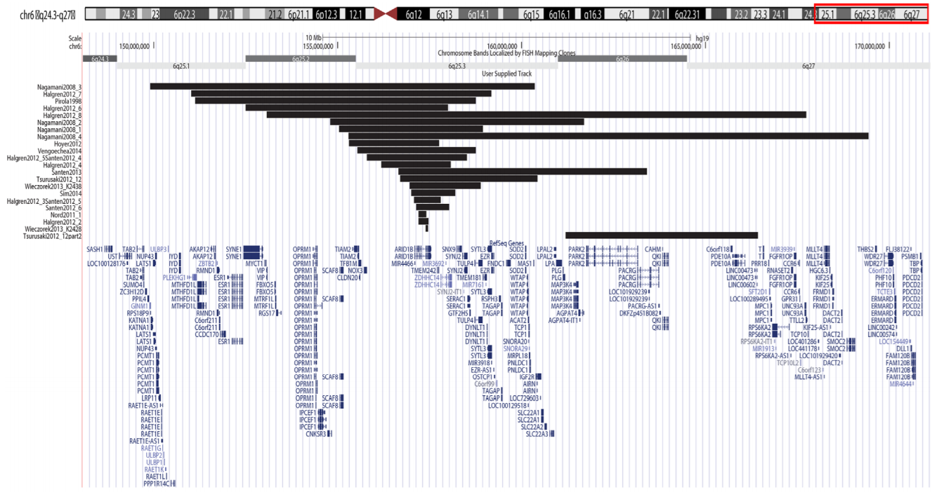

*UCSC Genome Browser View of Reported CNVs: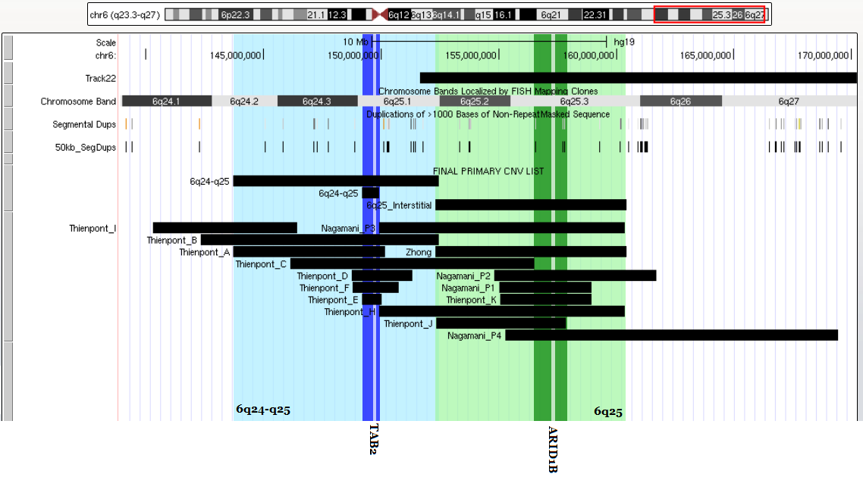*

**6q24-q25 (Blue):**

**Whole Region (Patient A to Patient B of Thienpont):** chr6:143740000-152480000 (hg18)

**SRO (Thienpont):** chr6:149230000-149960000 (hg18)

**6q25 (Green):**

**Whole Region (Zhong):** chr6:152307705-160422834 (hg19)

**SRO (Patient C to Patient J of Thienpont):** chr6:156550000-157790000 (hg18)

# Primary CNV 44: 7p22.1

*Figure 4 of Caselli 2015[43]:*

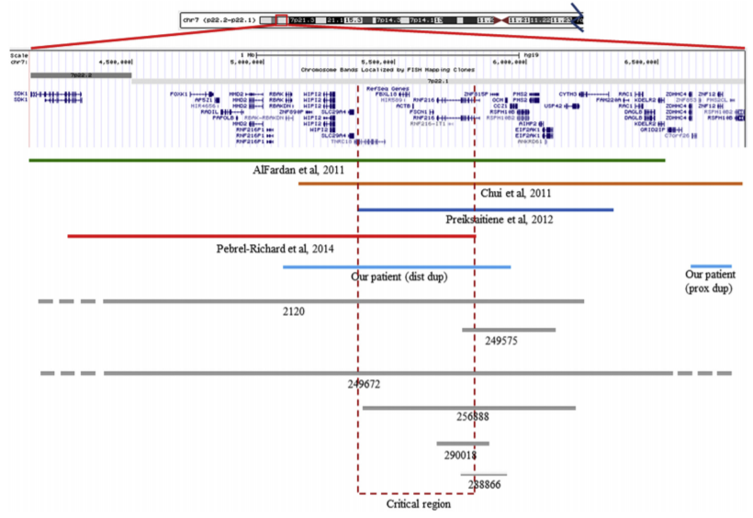

**DECIPHER #249672:** chr7:3483223-7325864 (hg19)

*Figure 2 of Shimojima 2016[44]:*

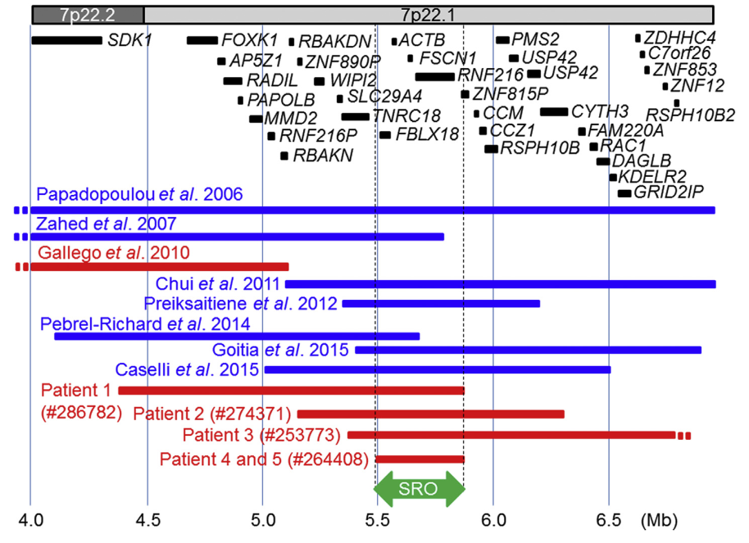

**SRO = Patient 4,5 =** chr7:5492967-5864851 (hg19)

# Primary CNV 45: 7q11.23 (WBS)

# Primary CNV 46: 7q11.23 (WBS Distal)

*Figure 1 of Ramocki 2010[45]:*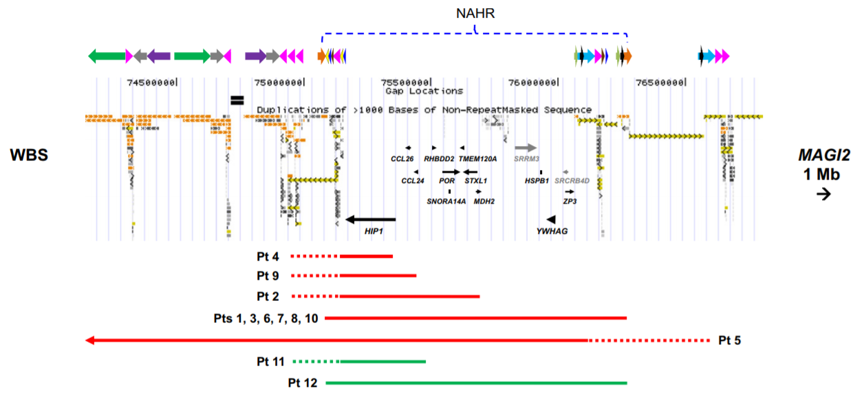

Low copy repeats flanking common deletion (Pts 1,3,6,7,8,10): chr7:75071906-76256141 (hg19)

Left: chr7:75,071,539-**75,071,906**

Right: chr7:**76,256,141**-76,256,508

*Figure 1 of Porter 2012[46]:*

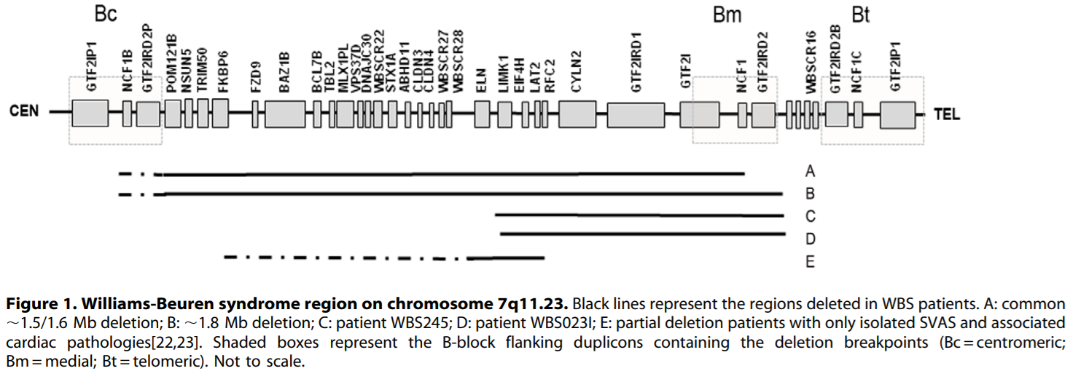

**1.8 Mb Common Region (NSUN5 to GTF2IRD2B):** chr7:72716514-74565623 (hg19)

* **NSUN5:** chr7:72,716,514-72,722,864 (hg19)
* **GTF2IRD2B:** chr7:74,541,458-74,565,623 (hg19)

*UCSC Genome Browser View of Reported CNVs and WBS Regions:*

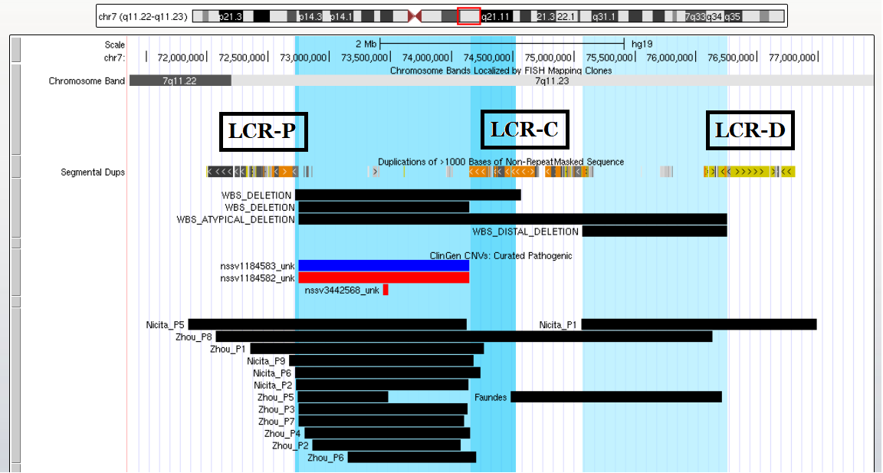

**WBS 1.5 Mb Common Region (ClinGen):** chr7:72744455-74142510 (hg19)

**WBS 1.8 Mb Common Region (NSUN5 to GTF2IRD2B):** chr7:72716514-74565623 (hg19)

**WBS Atypical (LCR-P to LCR-D):** chr7:72716514-76256141 (hg19)

**WBS Distal (ClinGen):** chr7:75158048-76063176 (hg19)

# Primary CNV 47: 7q21.3 (SHFM1)

*Figure 3 from Rasmussen 2016[47]:*

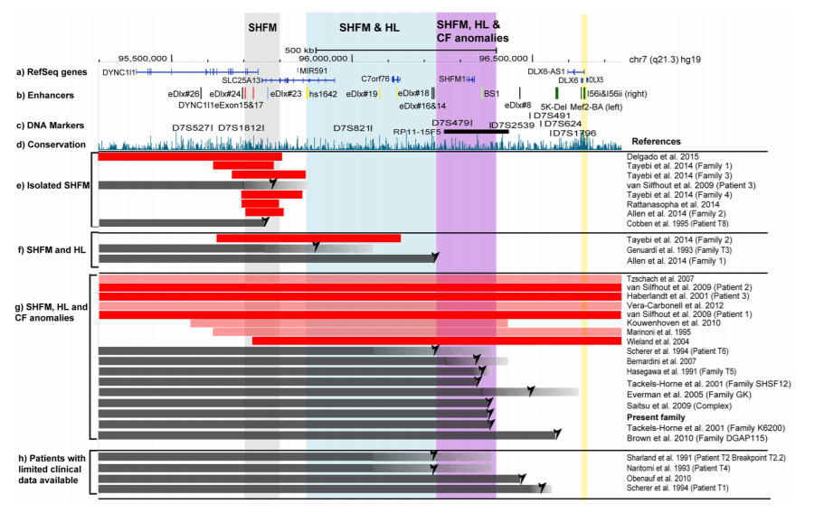

**Region (DYNC1l1 to DLX5)**: chr7:95401818-96654143 (hg19)

* DYNC1l1: chr7:95,401,818-95,727,736 (hg19)
* DLX5: chr7:96,649,702-96,654,143 (hg19)

# Primary CNV 48: 8q12

*Figure 2B of Luo 2012[48]:*

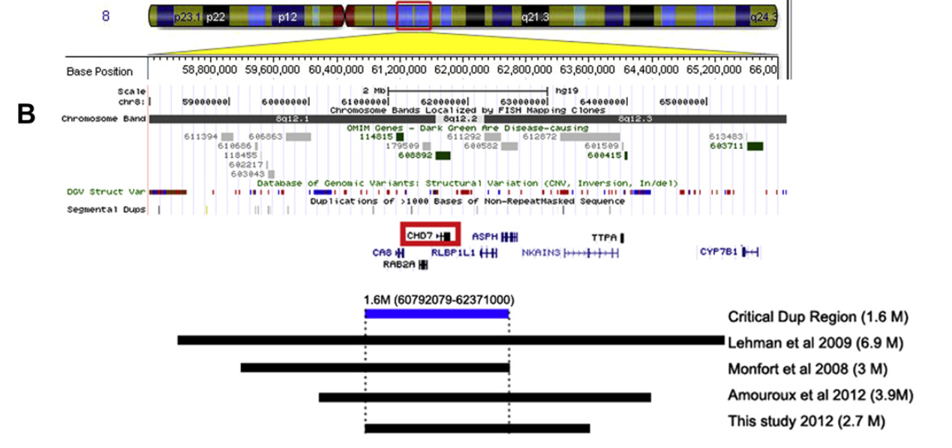

**Region = Amouroux =** chr8:60219746-64072039 (hg19)

# Primary CNV 49: 8q13

*UCSC Genome Browser View of Reported CNVs:*

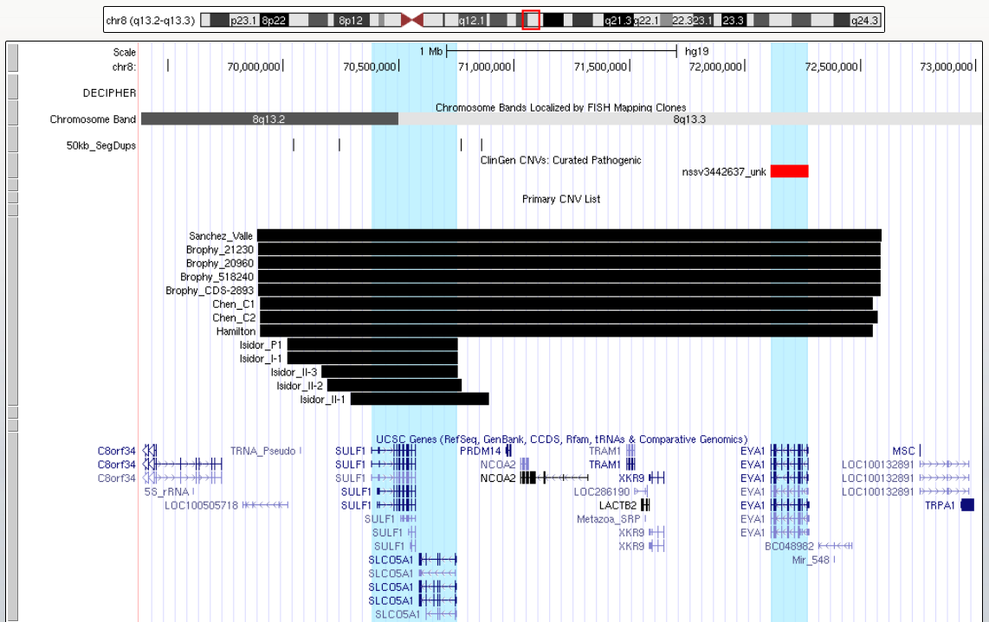

**Whole Region = Hamilton =** chr8:69900100-72552212 (hg19)

**SRO = SULF1 to SLC05A1 =** chr8:70378859-70745404 (hg19)

# Primary CNV 50: 8q21.11

*UCSC Genome Browser View of Reported CNVs:*

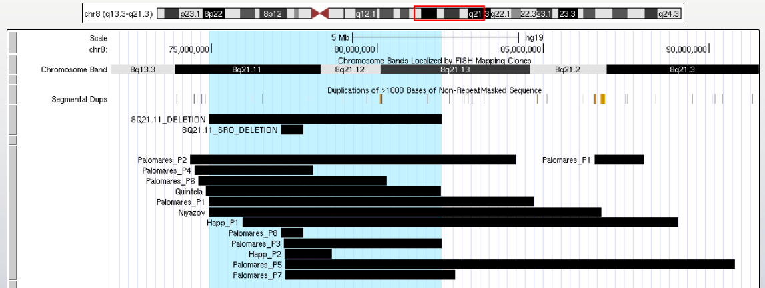

**Whole Region = Quintela:** chr8:74915253-81924253 (hg19)

**SRO = DECIPHER** = chr8:76314229-76854003 (GRCh38)

# Primary CNV 51: 8q22.1

*Figure 1 of Overhoff 2013[49]:*

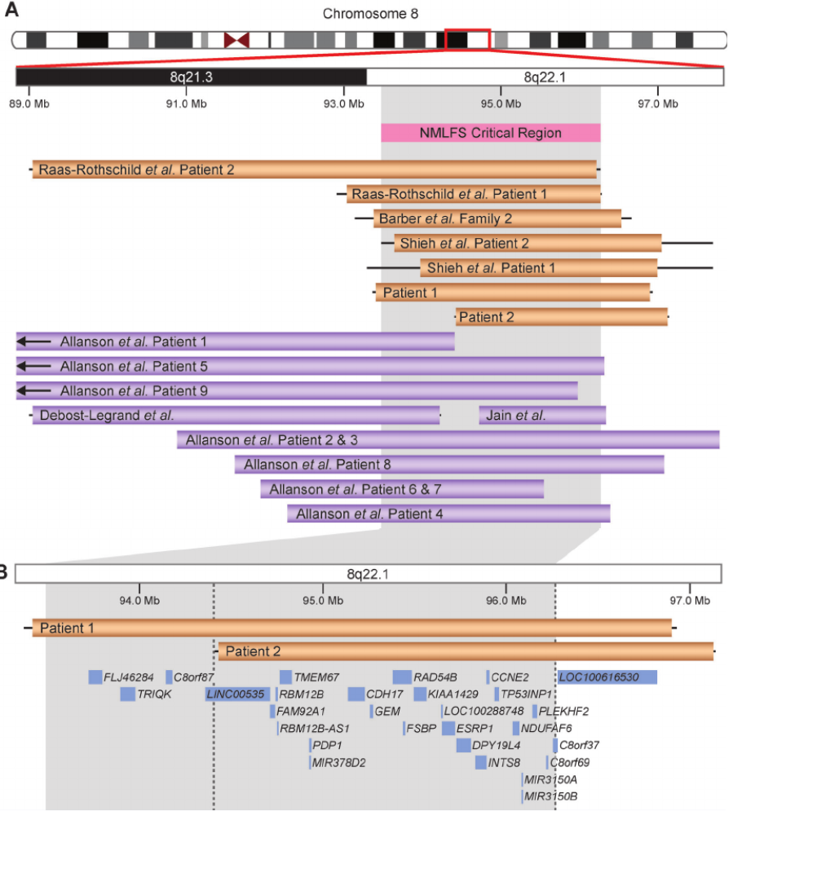

**NMLFS Critical Region:** chr8:94358695-96281462 (hg19)

* **LINC00535:** chr8:94,358,695-94,712,661 (hg19)
* **C8orf37:** chr8:96,257,141-96,281,462 (hg19)

*UCSC Genome Browser View of Reported CNVs:*

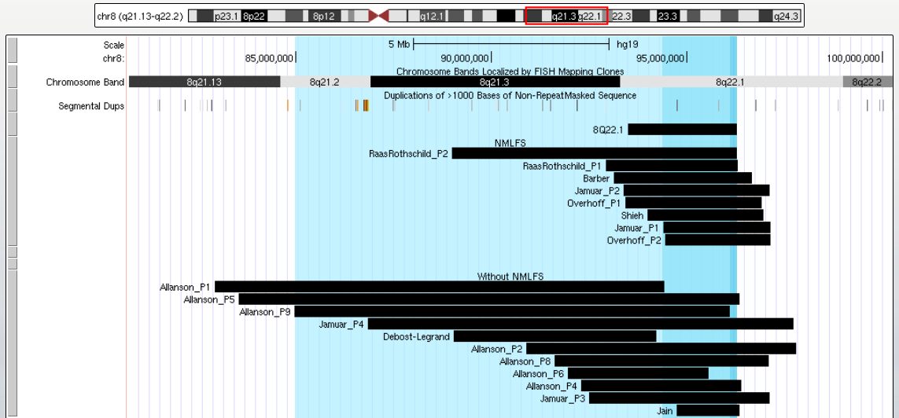

**Whole Region (Allanson P9):** chr8:84974143-96085410 (hg19)

**NMLFS Critical Region:** chr8:94358695-96281462 (hg19)

# Primary CNV 52: 8q22.2-q22.3

*Figure 3 of Sinajon 2015[50]:*

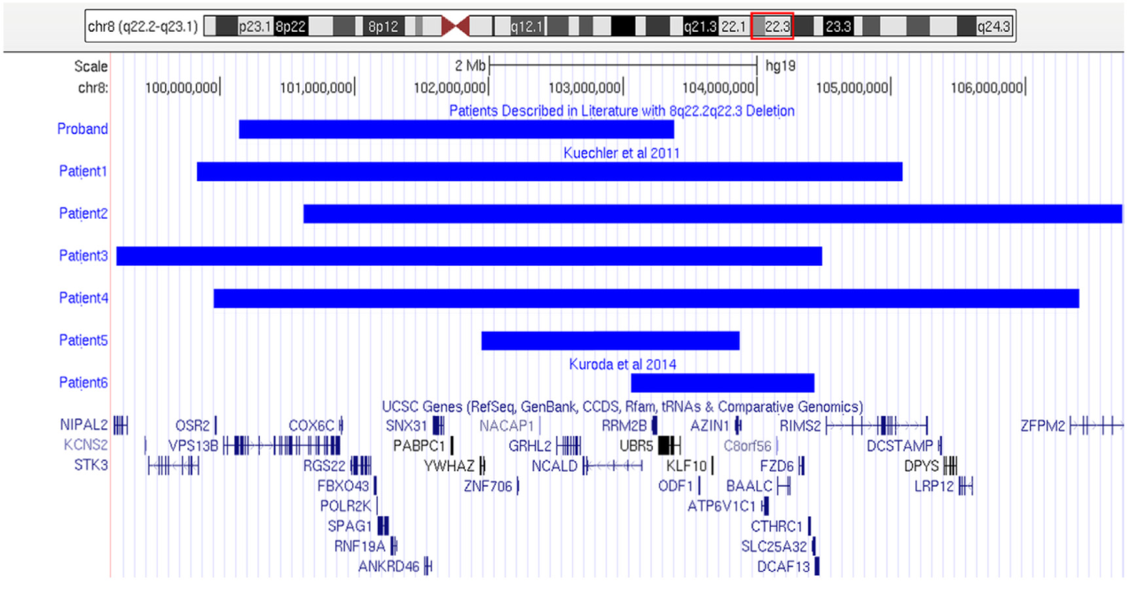

**Whole Region (Kuechler P4):** chr8:100025224-106469347 (hg18)

**SRO (Kuechler P5):** chr8:102017156-103939573 (hg18)

# Primary CNV 53: 8q23.1-q24.12

*UCSC Genome Browser View of Reported CNVs:*

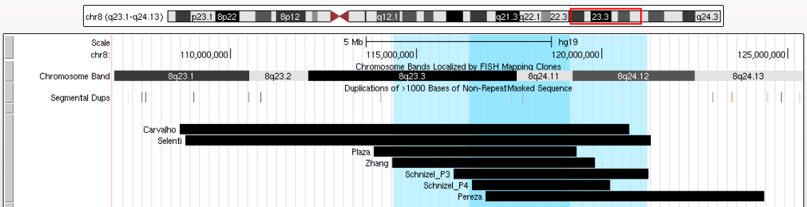

**Whole Region (Li to Schinzel P3):** chr8:114338391-121241253 (hg19)

* **Li:** chr8:114338391-119817276 (hg19)
* **Schinzel P3:** chr8:116002879-121241253 (hg19)

**SRO (TRPS1 to EXT1):** chr8:116420724-119124058 (hg19)

* TRPS1: chr8:116,420,724-116,681,228 (hg19)
* EXT1: chr8:118,811,602-119,124,058 (hg19)

# Primary CNV 54: 8q24.3

*Figure 2 of Wells 2016[51]:*

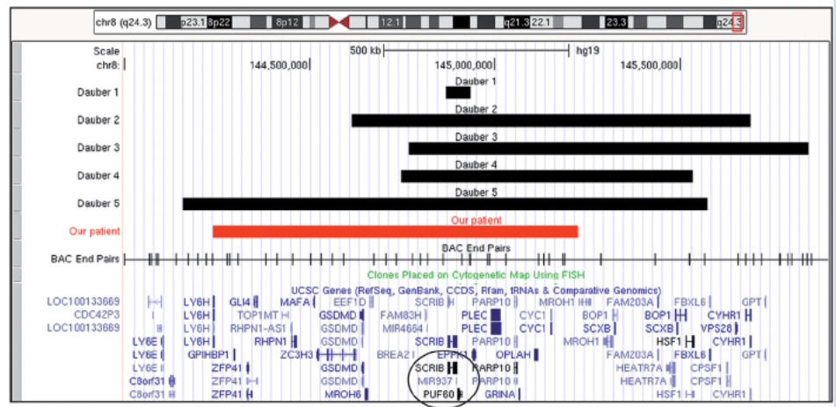

**Whole Region = Dauber P5 =** chr8:144159121-145573790 (hg19)

**Minimal Region (SCRIB to PUF60):** chr8:144873090-144911556 (hg19)

* SCRIB: chr8:144,873,090-144,897,549 (hg19)
* PUF60: chr8:144,898,514-144,911,556 (hg19)

# Primary CNV 55: 9p24.3 (SRXY4)

*UCSC Genome Browser View:*

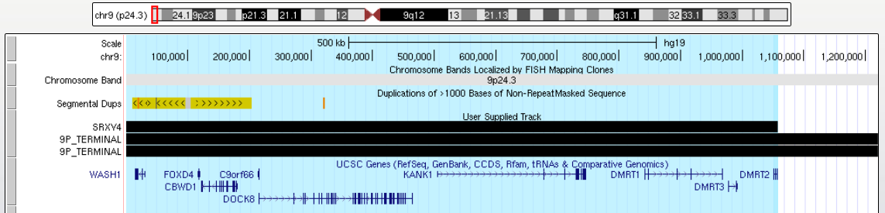

**SRXY4 (pter to DMRT2):** chr9:1-1057554 (hg19)

* **DMRT2:** chr9:1,050,620-1,057,554 (hg19)

# Primary CNV 56: 9p Terminal

*UCSC Genome Browser View of Reported CNVs:*

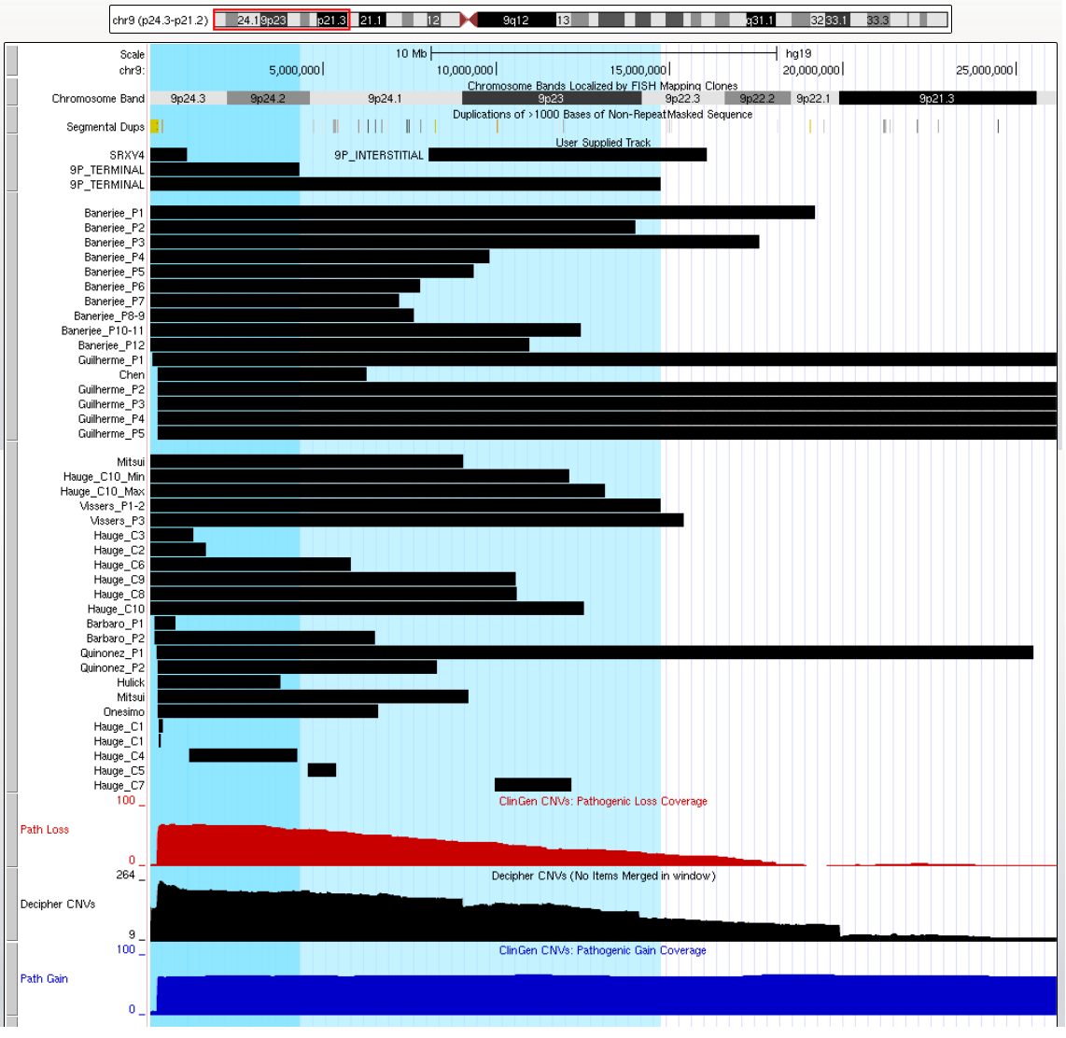

**Dark Blue (pter to GLIS3):** chr9:1-4300035 (hg19)

**Light Blue (Vissers P1-2):** chr9:1-14734664 (hg19)

**Critical Region (Christ):** chr9:8053379-16077945 (hg19)

# Primary CNV 57: 9p13.3-p13.1

*Figure 1C of Ferreira 2020[52]:*

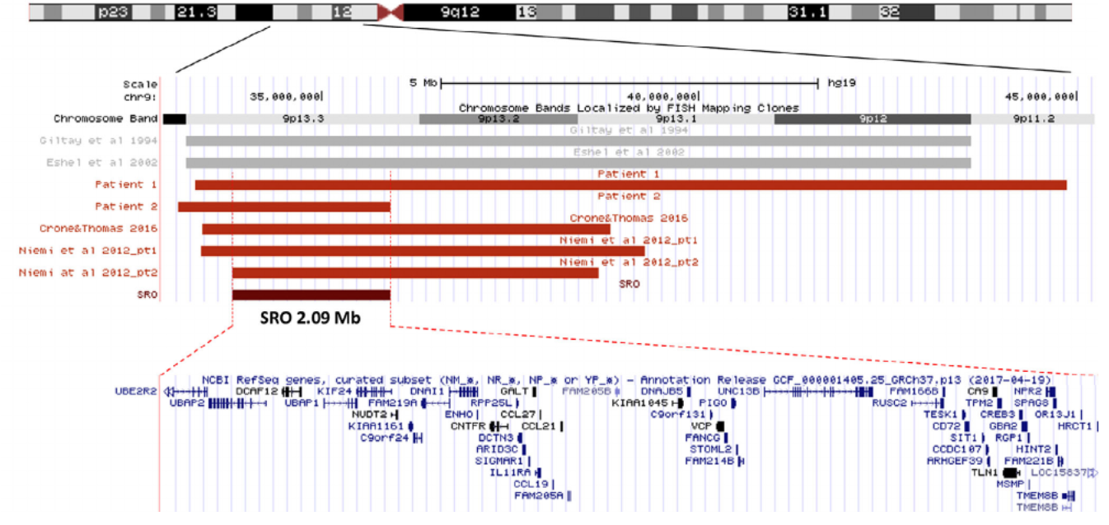

**Whole Region = Niemi P2 =** chr9:33809009-38653271 (hg18)

# Primary CNV 58: 9q22.3

*UCSC Genome Browser View of Reported CNVs:*

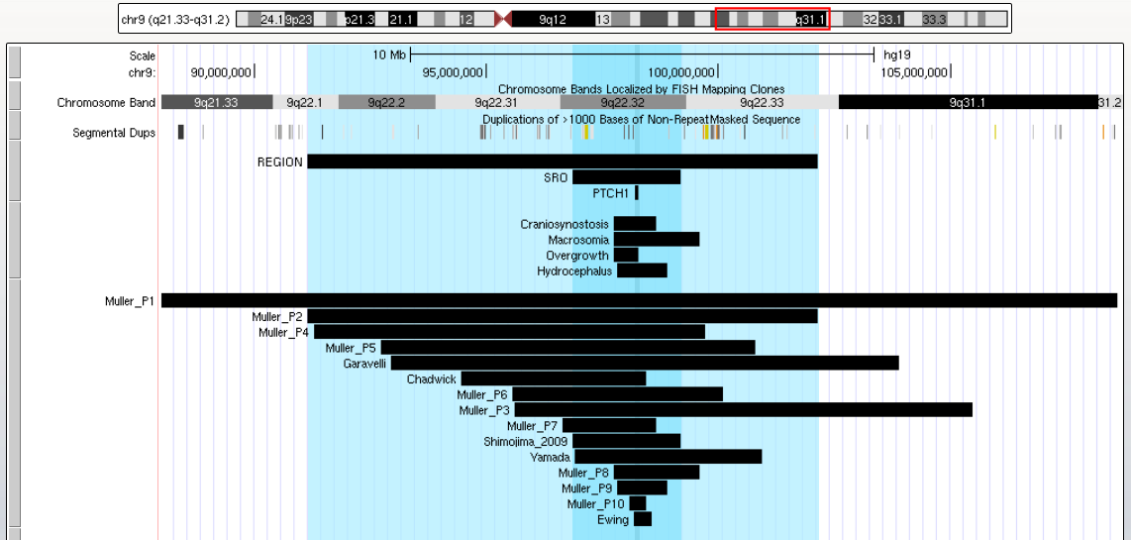

*Craniosynostosis, Hydrocephalus, and Macrosomia CRs from Muller; Overgrowth CR from Yamada*

**Whole Region = Muller P2 =** chr9:90333007-101185240 (hg18)

**SRO = Shimojima =** chr9:95885026-98218797 (hg18)

**PTCH1 = Gene Coordinates =** chr9:98205264-98269699 (hg19)

# Primary CNV 59: 9q31.1-q31.3

*Figure 2 of Mucciolo 2014[53]:*

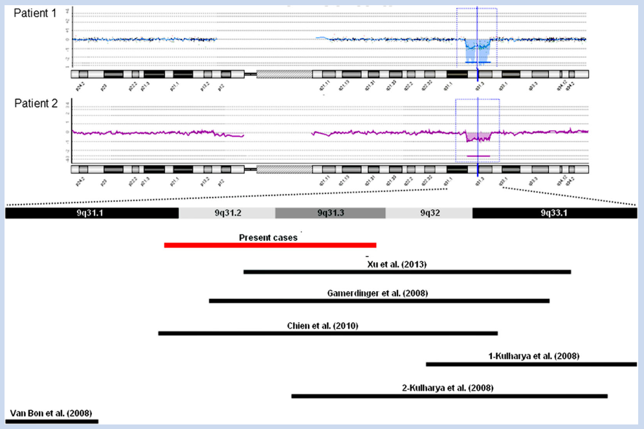

NOTE: Phenotype listed in MMS Review paper by Nevado (2014)[54] matches phenotype of Patients 1,2 of

Mucciolo (2014)[53]. However, other reported CNVs in this region have both overlapping and distinct phenotypic features.

*UCSC Genome Browser View of Reported CNVs:*

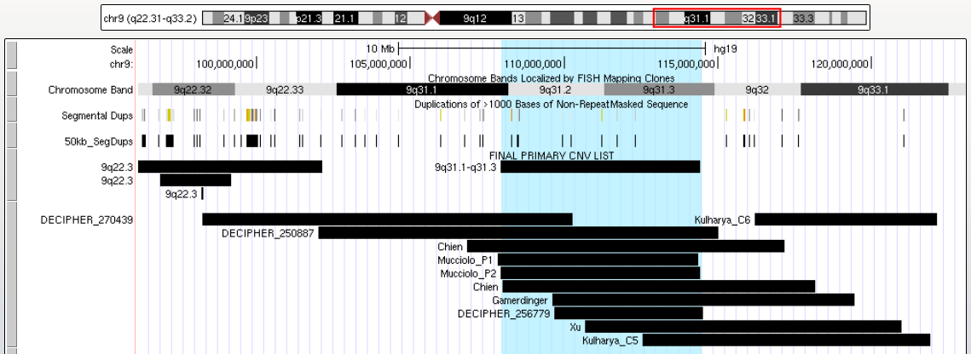

**Whole Region = Mucciolo P2 =** chr9:107945742-114439602 (hg19)

# Primary CNV 60: 10p Terminal

*UCSC Genome Browser View of Reported CNVs:*

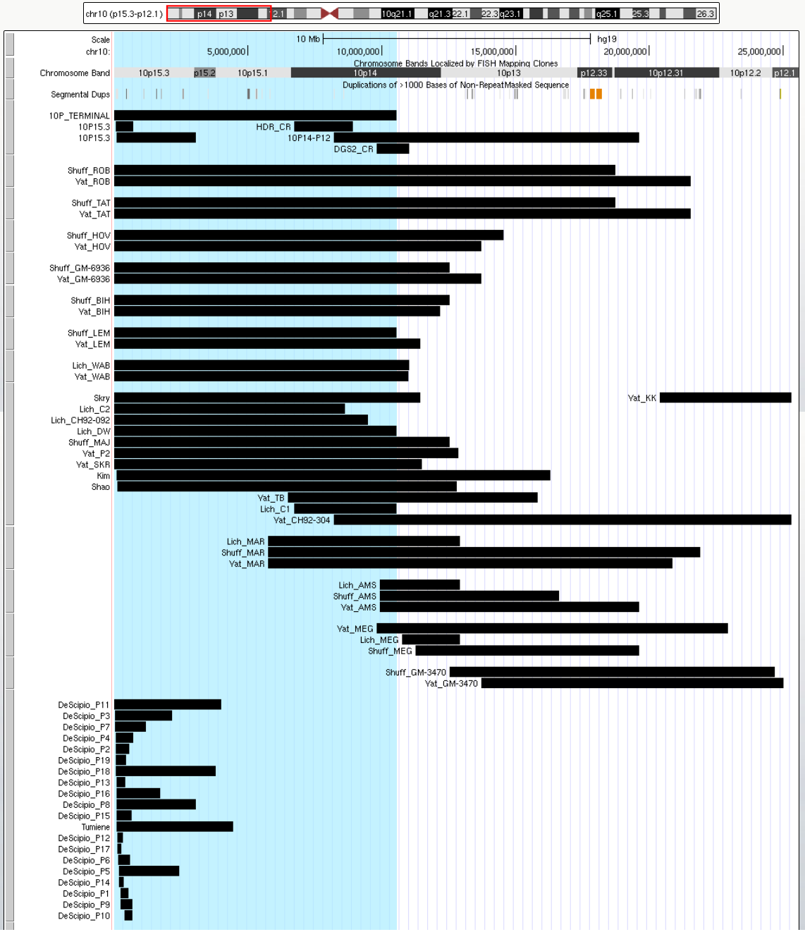

**Whole Region (Patient "DW" in Lichtner 2000):** chr10:0-10550771(hg19)

# Primary CNV 61: 10p15.3

*UCSC Genome Browser View of Reported CNVs:*

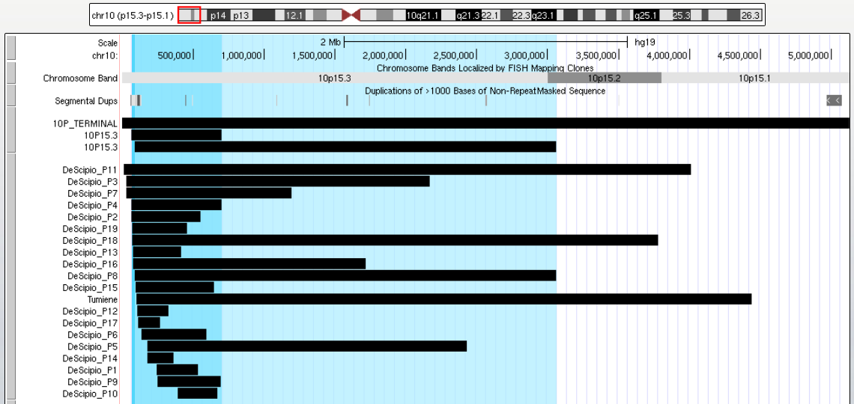

**Whole Region (DeScipio P8):** chr10:126361-3090934 (hg18)

**SRO (DeScipio P4):** chr10:101955-739804 (hg18)

# Primary CNV 62: 10p14-p12

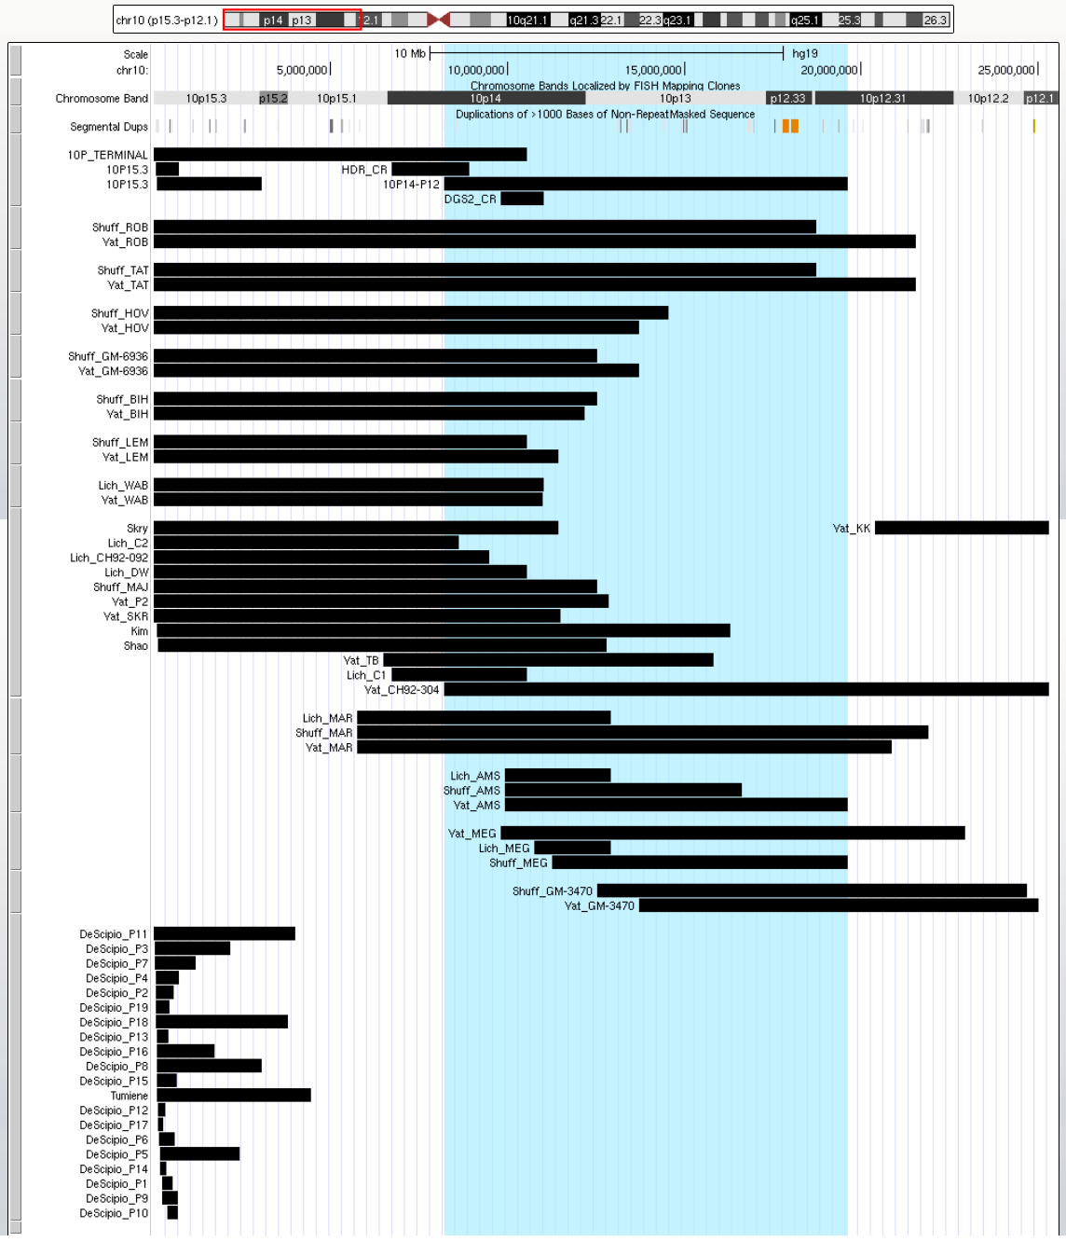

**Whole Region:** chr10:8212176-19608181 (hg19)

* **"CH92-304" in Yatsenko 2004**: chr10:8212176-25315588 (hg19)
* **"AMS" in Yatsenko 2004**: chr10:9922844-19608181 (hg19)

# Primary CNV 63: 10p14 (HDR, DGS2)

*Figure 2 of Lichtner 2000[55]:*

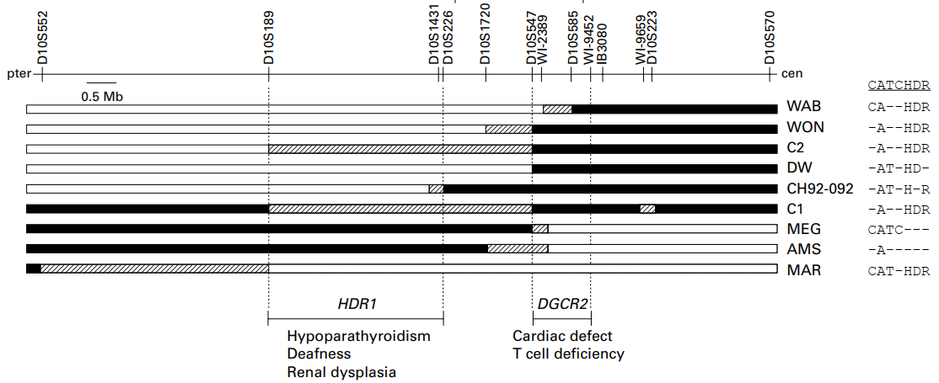

**DGS2 Critical Region (D10S547 to D10S585)**: chr10:10550410-11253972 (hg19)

* **D10S547**: chr10:10550410-10550771 (hg19)
* **D10S585**: chr10: 11253594-11253972 (hg19)

**HDR Critical Region (D10S189 to D10S226):**

chr10:6721874-8919127 (hg19)

* **D10S189**: chr10:6721874-6722254 (hg19)
* **D10S226**: chr10:8918789-8919127 (hg19)

*UCSC Genome Browser View of Reported CNVs and Critical Regions*

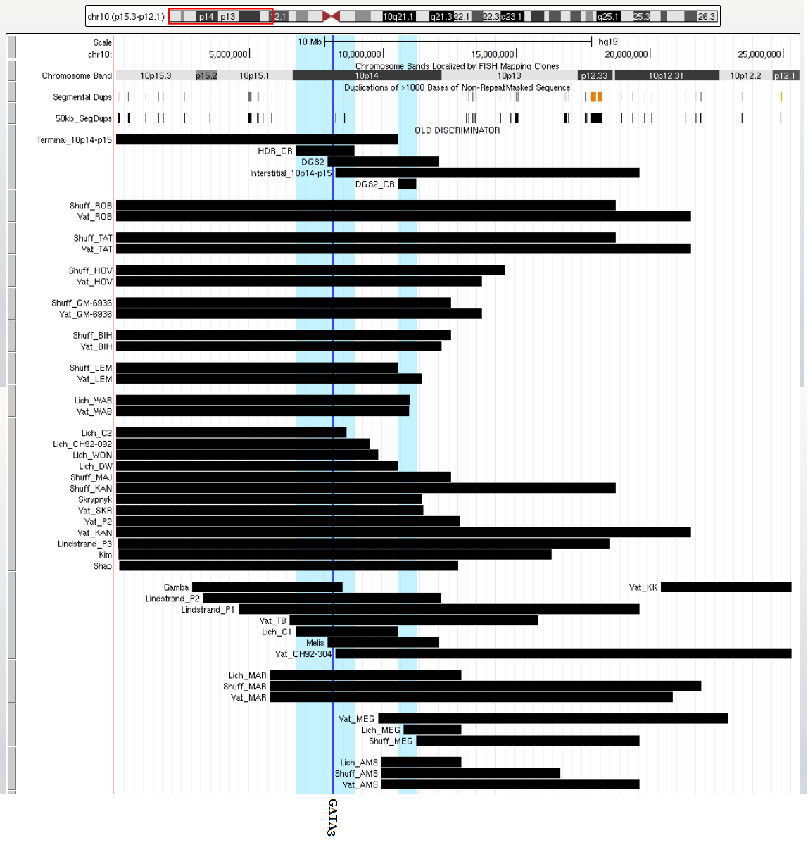

**HDR Critical Region =** chr10:6721874-8919127 (hg19)

**GATA3 =** chr10:8096667-8117164 (hg19)

**DGS2 Critical Region =** chr10:10550410-11253972 (hg19)

# Primary CNV 64: 10q22-q23 Syndrome

*Figure 1 of van Bon 2011[56]:*

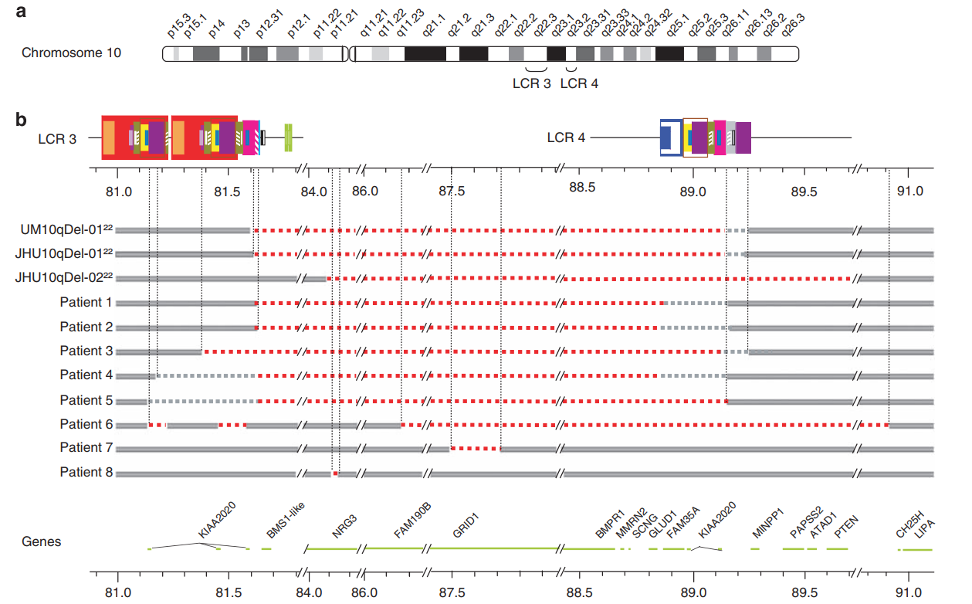

*UCSC Genome Browser View of Reported CNVs:*

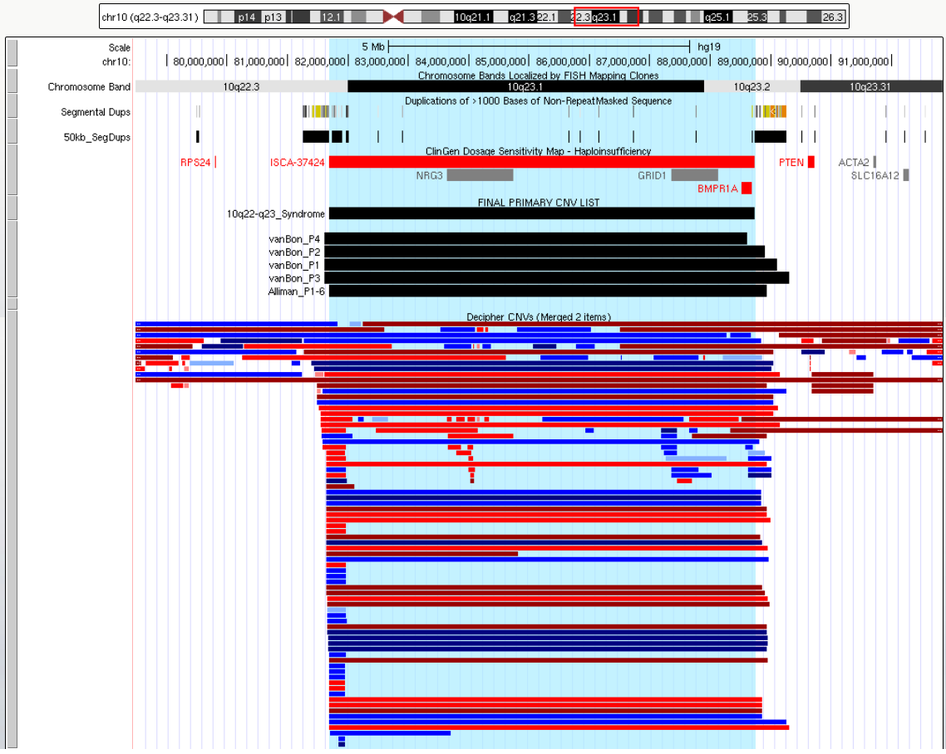

**Region = ClinGen Coordinates =** chr10:81682843-88739388 (hg19)

# Primary CNV 65: 10p24 (SHFM3)

*UCSC Genome Browser View of Reported CNVs:*

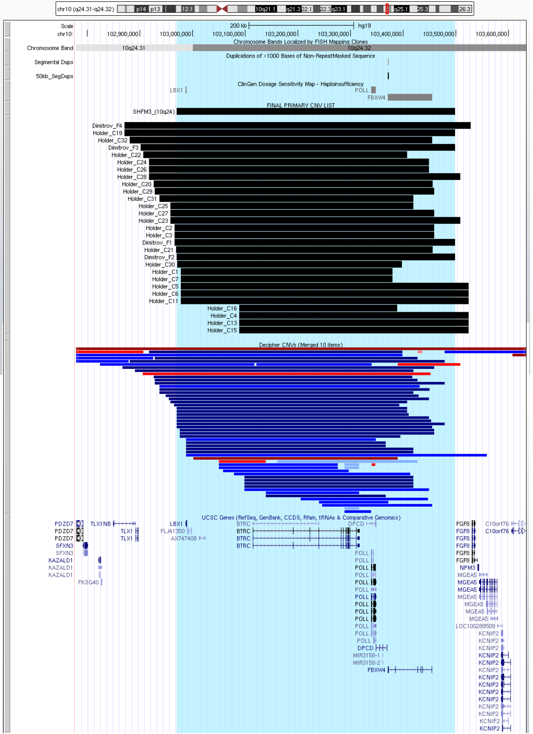

**Whole Region = Dimitrov F2 =** chr10:102969344-103498069 (hg18)

# Primary CNV 66: 10q26 Interstitial

*Figure 3 of Choucair 2015[57]:*

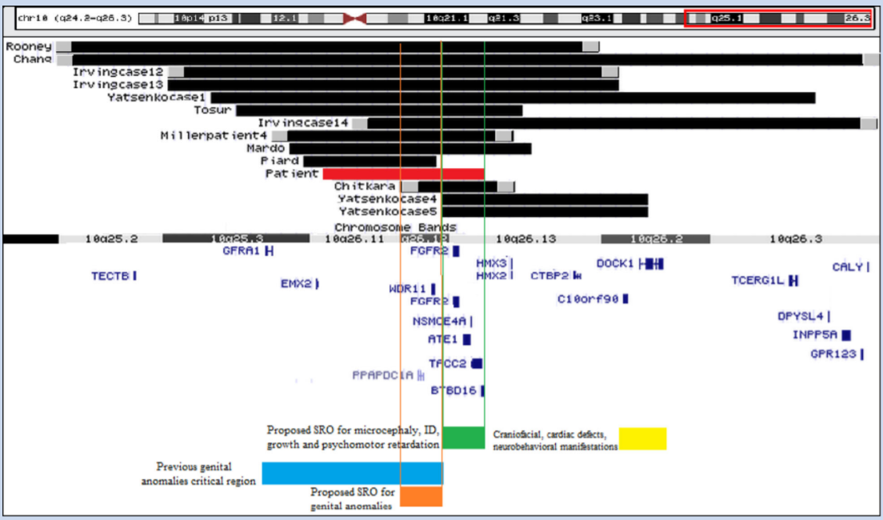

**Region = Miller P4 =** chr10:118506755-125492105 (hg19)

# Primary CNV 67: 10q26 Terminal

*Figure 2 of Lin 2016[58]:*

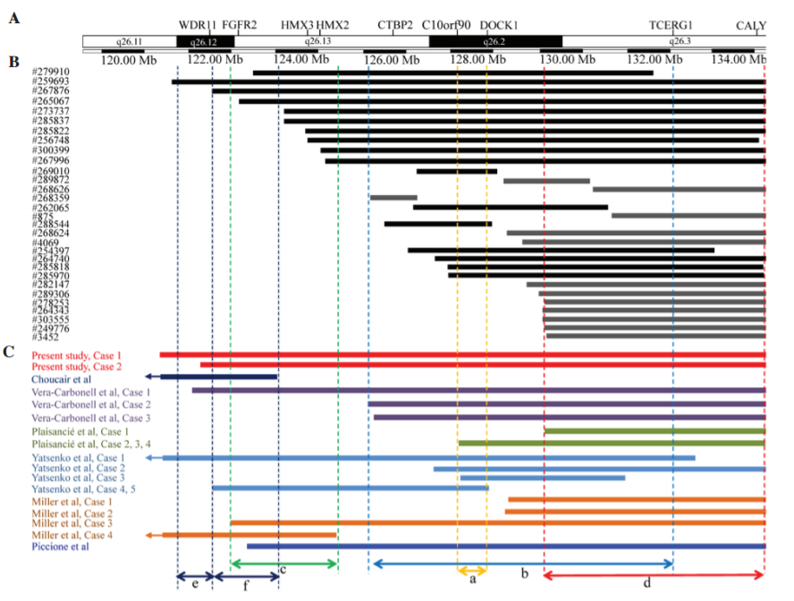

a=the CR proposed by Yatsenko et al (7) for common clinical features of 10q26 deletion syndrome (C10orf90 & DOCK1)

b=the CR proposed by Vera‑Carbonell et al (10) for renal/urinary anomalies

c=the CR proposed by Miller et al (12) for inner ear malformation, vestibular dysfunction and hearing loss

d=the deleted region suggested by the current study as a region that may contribute to common clinical features of 10q26 deletion syndrome

e=the CR proposed by Choucair et al (13) for genital anomalies

f=the CR proposed by Choucair et al (13) for common clinical features

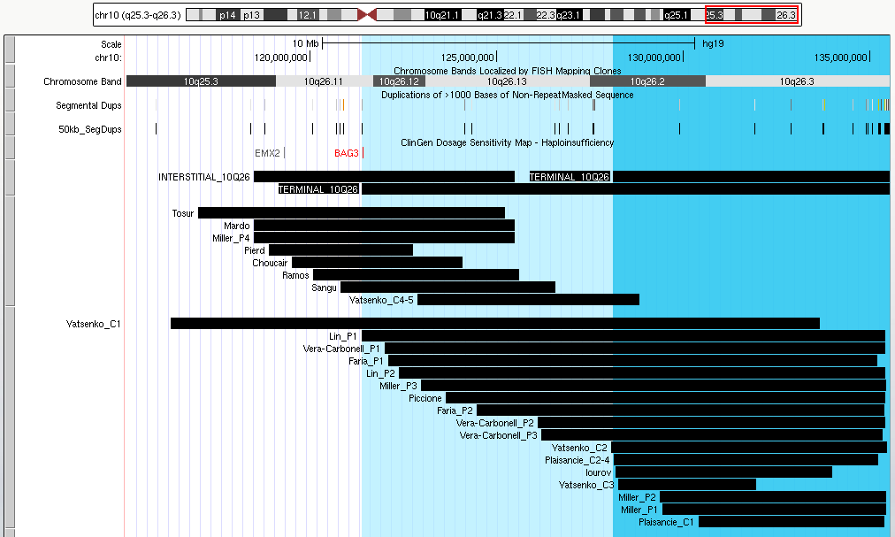

**Light Blue Region (Lin P1):** chr10:121385399-135534747 (hg19)

**Dark Blue Region (C10orf90 to qter):** chr10:128113575-135534747 (hg19)

# Primary CNV 68: 11p15.5 (BWS/RS)

*Figure 8 of Chiesa 2012[59]:*

**Whole Region:** chr11:2016406-2906995 (hg19)

* **H19:** chr11:2016406-2022696 (hg19)
* **CDKN1C:** chr11:2904448-2906995 (hg19)

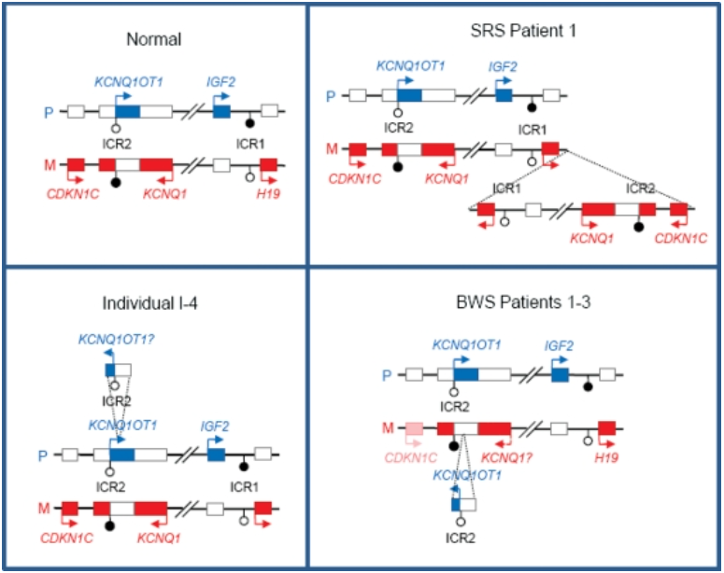

# Primary CNV 69: 11p13 (ELP4)

*Figure 1 of Addis 2015[60]:*

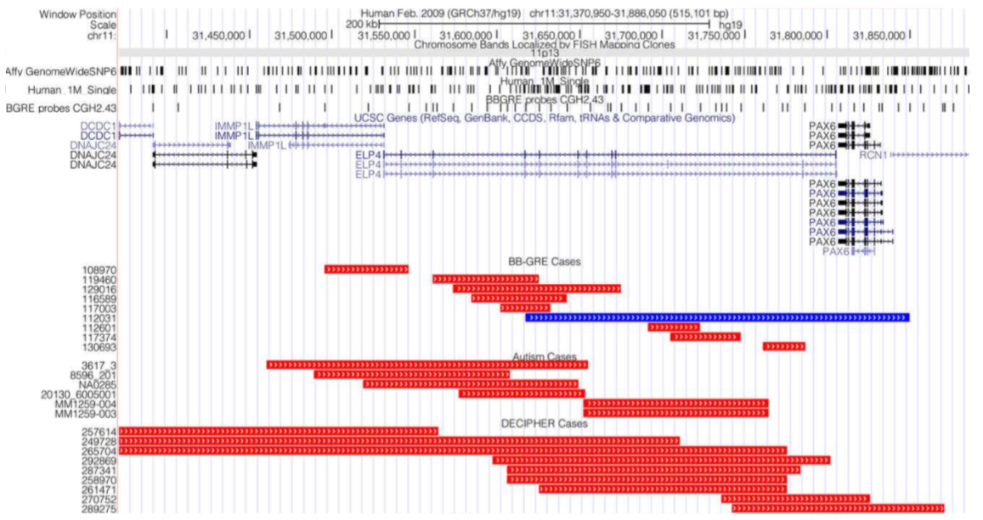

**ELP4 Coordinates:** chr11:31531297-31805329 (hg19)

# Primary CNV 70: 11p13 (WAGR, WAGRO)

*Figure 3 of Han 2008[61]:*

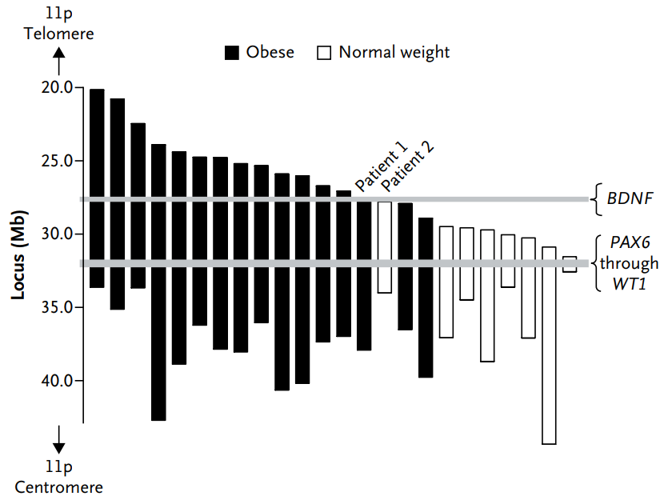

*UCSC Genome Browser View:*

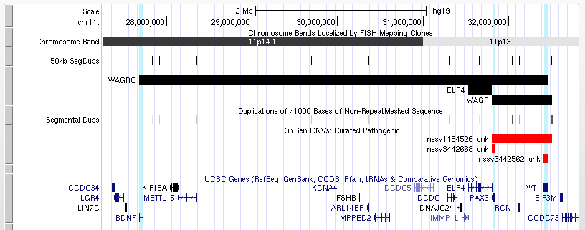

**BDNF:** chr11:27,676,442-27,722,600

**PAX6:** chr11:31,806,340-31,839,509

**WT1:** chr11:32,409,322-32,457,081

**WAGR (ClinGen; PAX6 to WT1):** chr11:31803509-32510988 (hg19)

**WAGRO Region (BDNF to WT1):** chr11:27676442-32457081 (hg19)

# Primary CNV 71: 11p11.2 (Potocki-Shaffer)

*Figure 3 of Trajkova 2020[62]: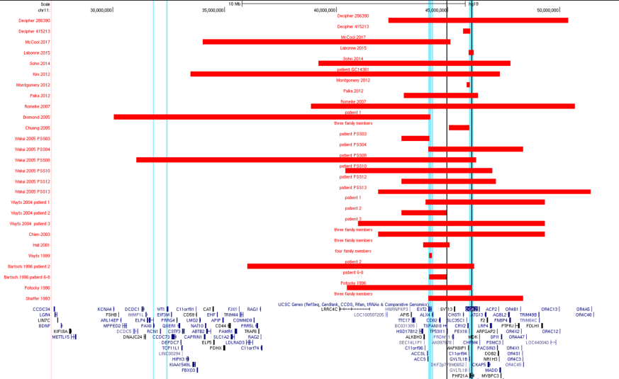*

**ClinGen (EXT2 to PHF21A):** chr11:43894800-46152450 (hg19)

**Whole Region (DECIPHER 286390):** chr11:42312866-50419631 (GRCh38)

# Primary CNV 72: 11q13

*UCSC Genome Browser View of Reported CNVs:*

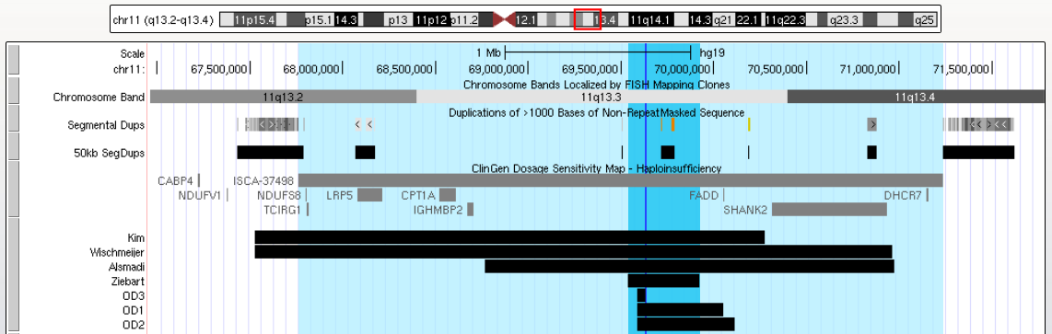

**Whole Region (ClinGen Coordinates):** chr11:67763646-71236931(hg19)

**Ziebart:** chr11:69246102-69600647 (hg18)

**FGF3:** chr11:69,624,736-69,634,192 (hg19)

# Primary CNV 73: 11q23-q25 (Jacobsen)

*Figure 2 of Grossfeld 2004[63]:*

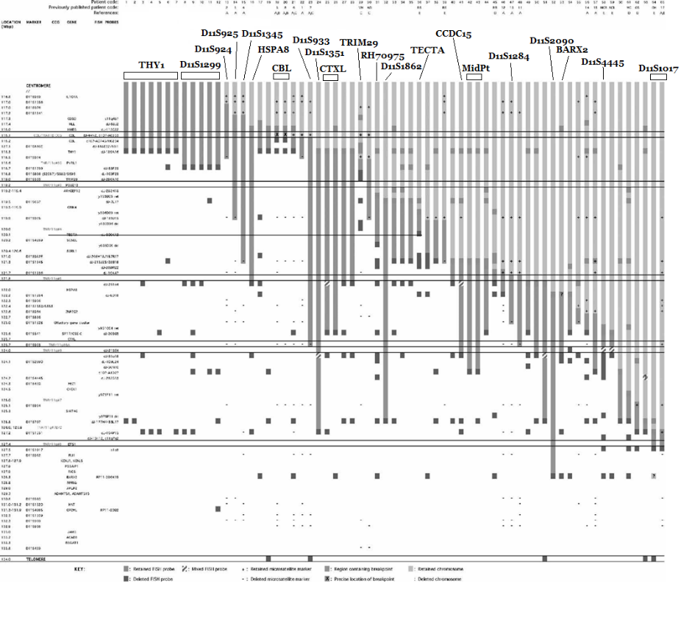

*UCSC Genome Browser View of Reported CNVs, DECIPHER CNVs, and Phenotype Groups from Grossman 2004:*

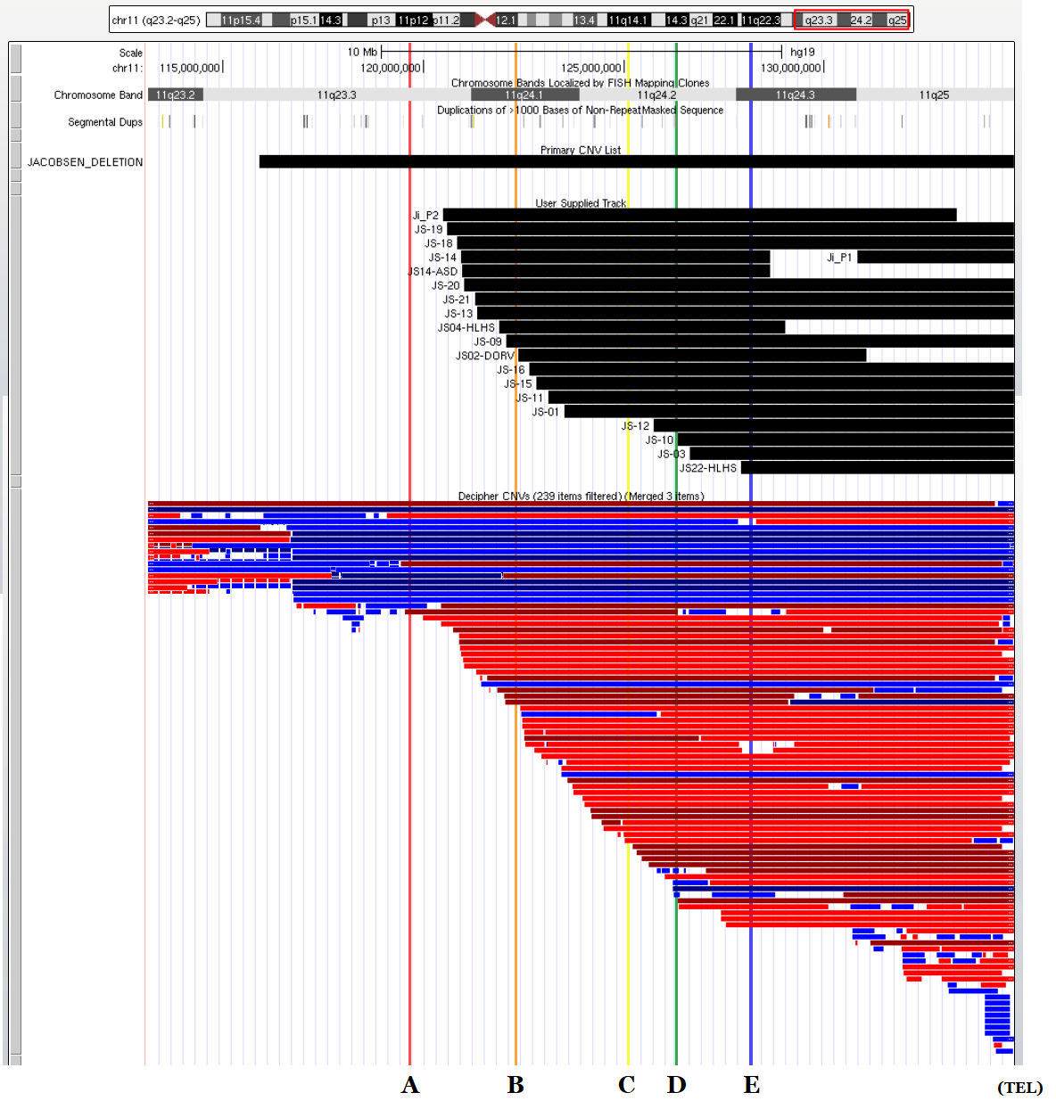

*A-E refer to the critical regions for 11q- syndrome phenotypes identified by Grossman et al.*

|  |  |  |  |
| --- | --- | --- | --- |
| **Group** | **STS Marker** | **STS Marker Coordinates (hg19)** | **Phenotype Group Coordinates (hg19)** |
| **A** | D11S1299 | chr11:119634290-119634837 | chr11:119634290-135006516 |
| **B** | D11S1345 | chr11:122297785-122298119 | chr11:122297785-135006516 |
| **C** | D11S2090 | chr11:125086881-125086982 | chr11:125086881-135006516 |
| **D** | D11S707 (SIAT4C/ST3GAL4) | chr11:126225789-126284536 | chr11:126225789-135006516 |
| **E** | D11S1351 | chr11:128142005-128142355 | chr11:128142005-135006516 |

# Primary CNV 74: 12p13.33

*UCSC Genome Browser View of Reported CNVs: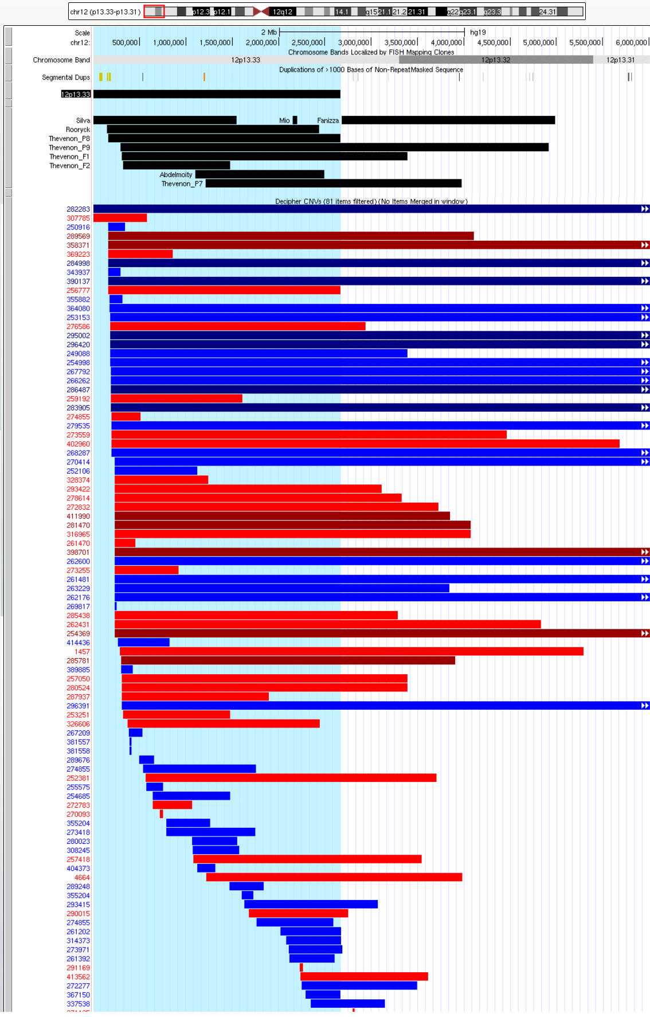*

**Whole Region (START to Thevanon P8):** chr12:0-2537524 (hg18)

# Primary CNV 75: 12q14

*Figure 2 of Lynch 2011[64]:*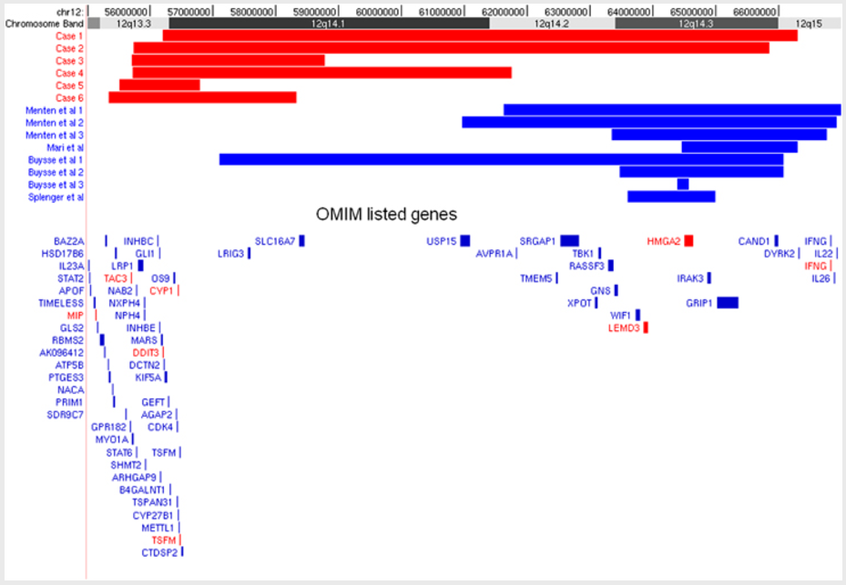

*UCSC Genome Browser View of Reported CNVs:*

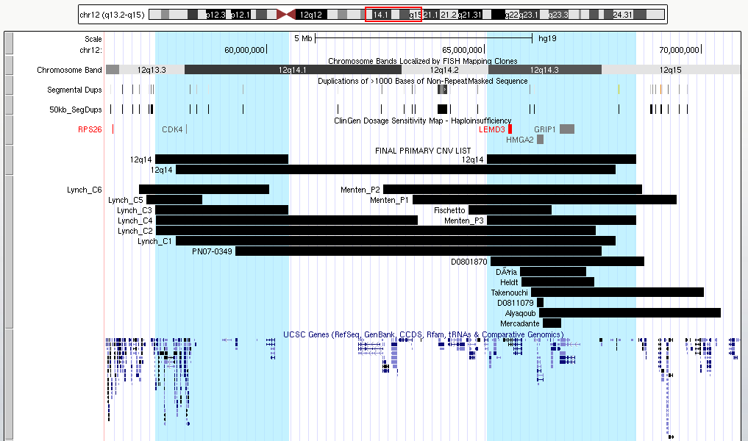

**Whole Region: Lynch (2011) Case 1:** chr12:56192860-66309484 (hg18)

**Left: Lynch (2011) Case 3:** chr12:55704299-58779521 (hg18)

**Right: Menten (2007) Case 3:** chr12:63342399-66780345 (hg18)

# Primary CNV 76: 12q21.33

*UCSC Genome Browser View of Reported CNVs:*

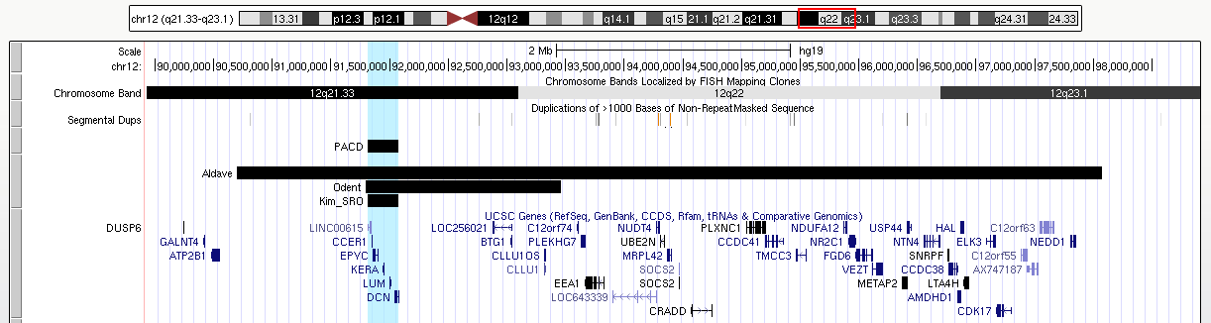

*Figure 3 of Kim 2014[65]:*

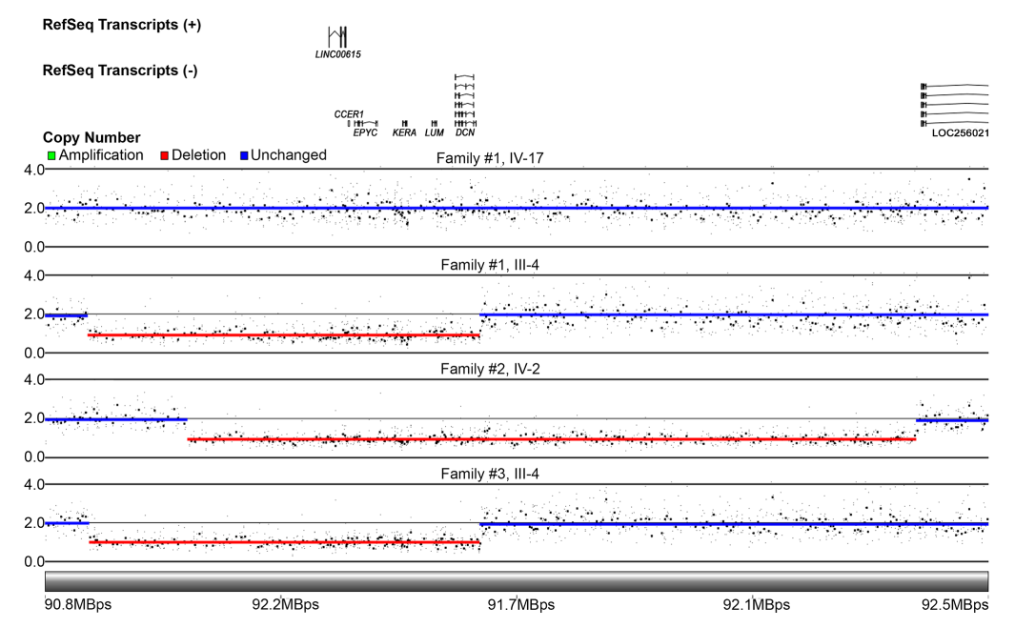

**Region (LINC00615 to DCN):** chr12:91,311,800-91,573,359 (hg19)

* **LINC00615:** chr12:91,311,800-91,342,446 (hg19)
* **DCN:** chr12:91,539,035-91,573,359 (hg19)

# Primary CNV 77: 12q24.3

*Figure 1G from Labonne 2016[66]: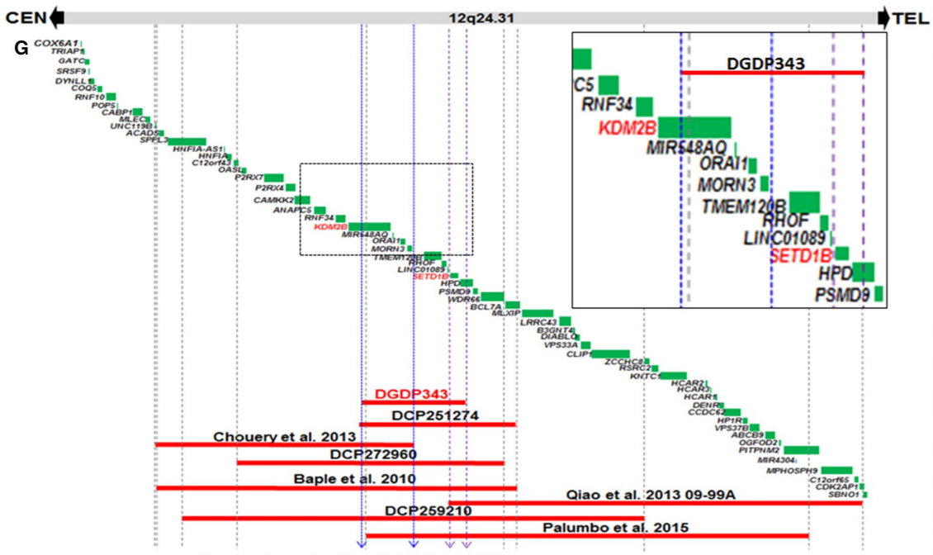*

**Whole Region (Midpoint of Chouery – Midpoint of Qiao):** chr12:121639241-123000639 (hg19)

# Primary CNV 78: 13q12.11-q12.13

*Figure 5 of Pavone 2014[67]:***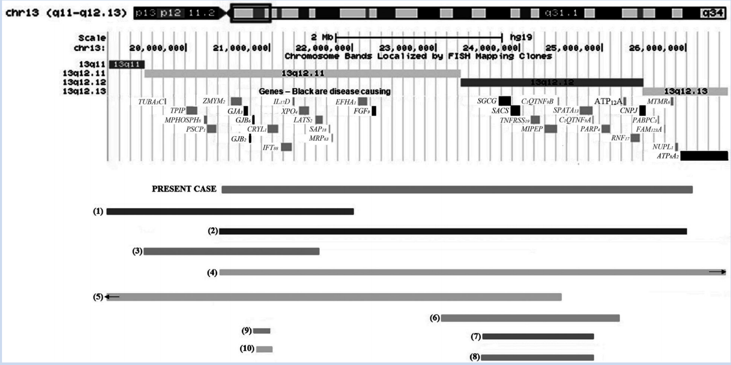**

**Whole Region = “Present Case” ::** chr13:20427493-26037670 (hg19)

**Left Region = “3” (Der Kaloustian) ::** chr13:19498791-21439928 (hg18)

**Right Region = “7” (DECIPHER Case #248569) ::** chr13:23566962-24890143 (hg19)

# Primary CNV 79: 13q12.3

*Figure 3 of Bartholdi 2013[68]:*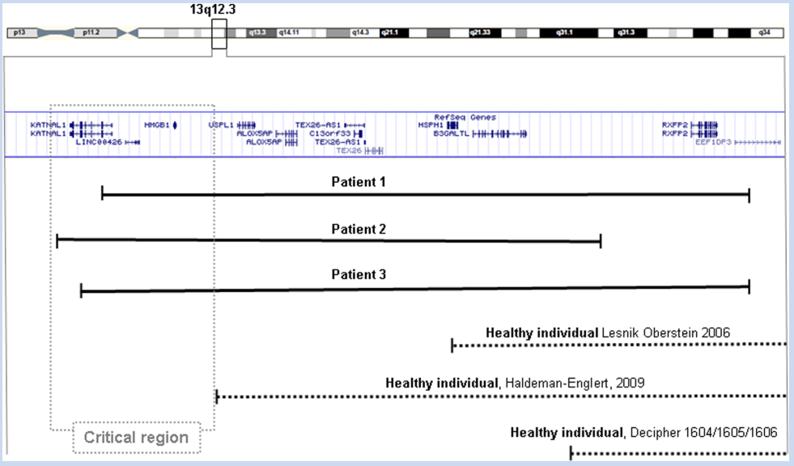

**Whole Region = Patient 2:** chr13:30768420-32166016 (hg19)

**Critical Region (KATNAL1 TO HMGB1):** chr13:30,776,767-31,191,510

* **KATNAL1:** chr13:30,776,767-30,881,624 (hg19)
* **HMGB1:** chr13:31,032,879-31,191,510 (hg19)

# Primary CNV 80: 13q14

*UCSC Genome Browser View of Reported CNVs:*

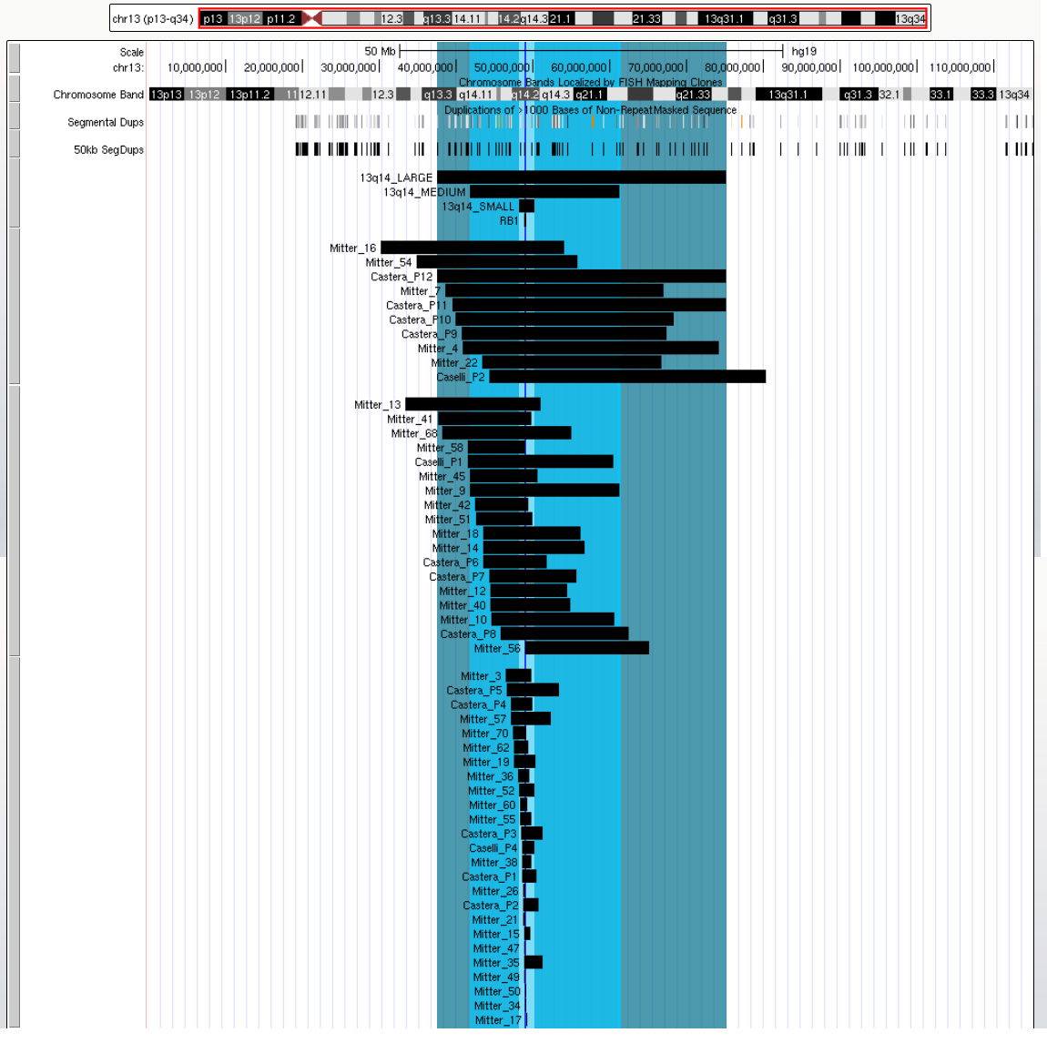

**Large = Castera P12:** chr13:36383200-74000000 (hg18)

**Medium = Mitter P9 =** chr13:40733729-60193507 (hg18)

**Small = Mitter Patient 52:**  chr13:47072184-49032229 (hg18)

**SRO = RB1 =** chr13:48877883-49056026 (hg19)

# Primary CNV 81: 13q31.3 (Feingold Syndrome 2)

*Figure 3 of Muriello 2019[69]:*

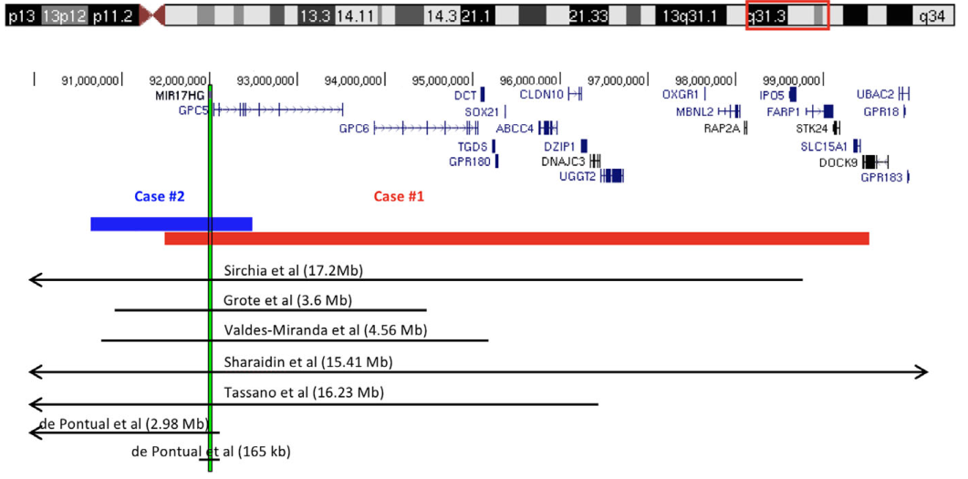

**Region = Muriello P2:** chr13:90653738-92490593 (hg19)

# Primary CNV 82: 13q32.1

*Figure 3 of Angee 2021[70]:*

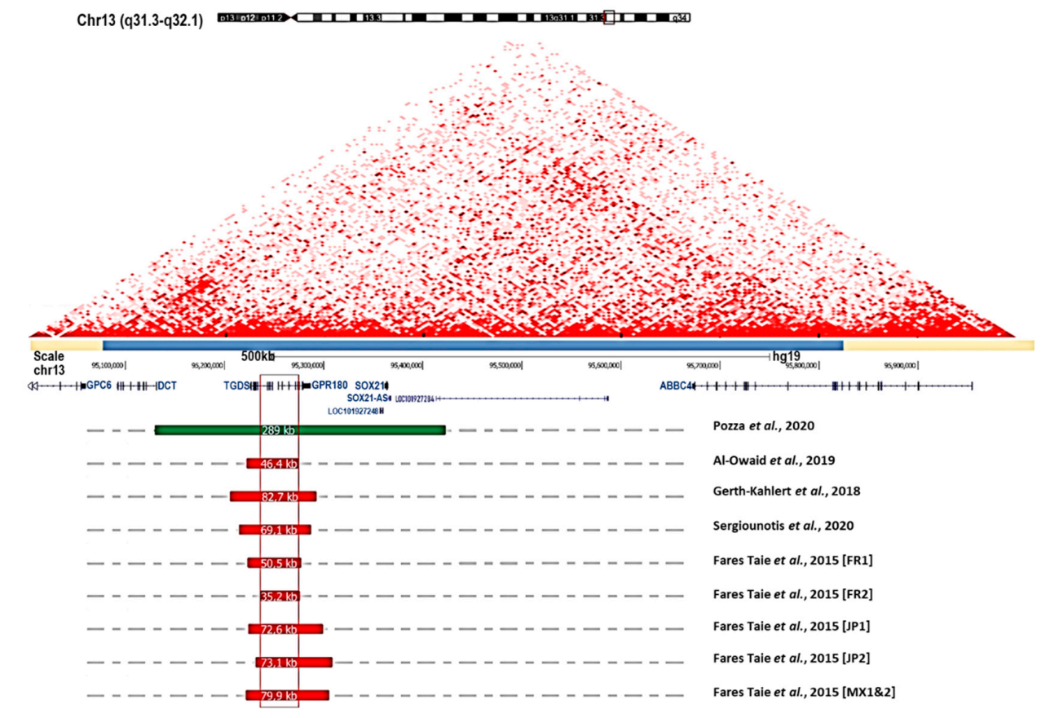

**Duplication SRO:** chr13:95119866-95438104 (hg19)

**Deletion SRO:** chr13:95241606-95273292 (hg19)

# Primary CNV 83: 13q33-q34

*UCSC Genome Browser View of Reported CNVs:*

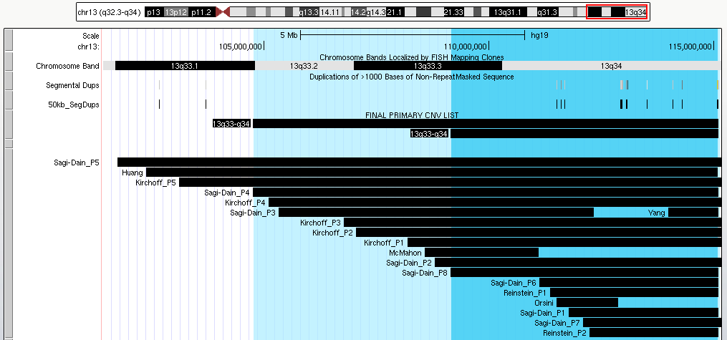

**Dark Blue Region = Sagi-Dain P8 ::** chr13:109149281-115107733 (hg19)

**Light Blue Region = Sagi-Dain P4 ::** chr13:104753418-115107733 (hg19)

# Primary CNV 84: 14q11-q22

*UCSC Genome Browser View of Reported CNVs:*

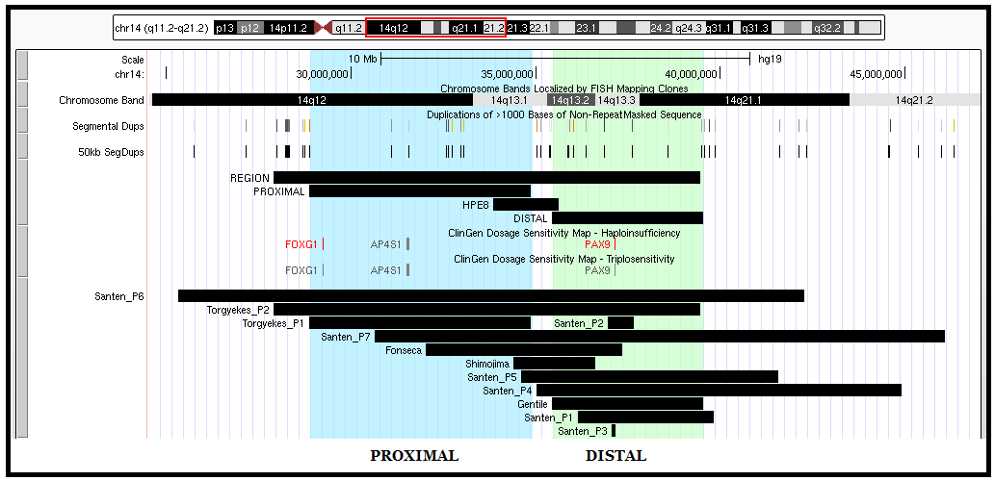

**Whole Region = Torgyekes P2 =** chr14:26972703-38533633 (hg18)

**Proximal = Torgyekes P1** = chr14:27932292-33935994 (hg18)

**Distal = Gentile =** chr14:35443407-39527387 (hg19)

# Primary CNV 85: 14q22-q23 (Frias Syndrome)

*UCSC Genome Browser View of Reported CNVs:*

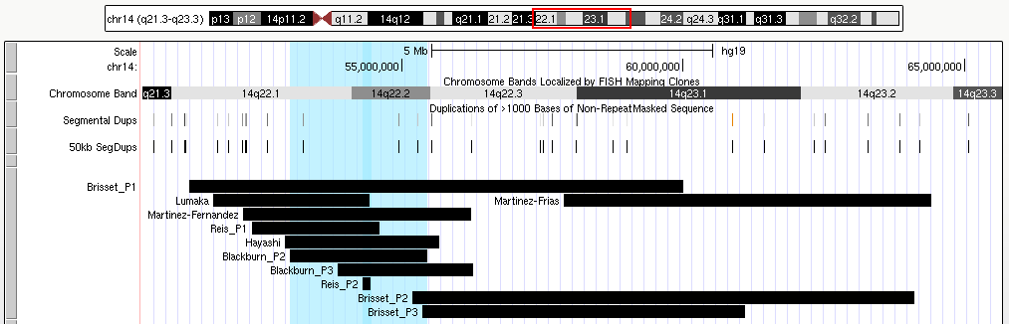

**Whole Region = Blackburn P2 =** chr14:53001803-55443425 (hg19)

**SRO = BMP4** = chr14:54416455-54421270 (hg19)

# Primary CNV 86: 15q11-q13 (Temple/ Kagami-Ogata)

*Figure 3 of Kagami 2017[71]:*

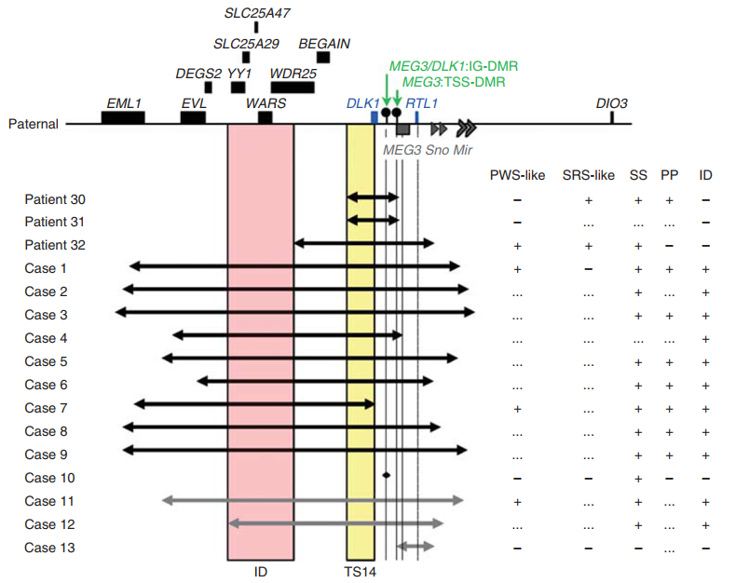

*UCSC Genome Browser View of Reported CNVs:*

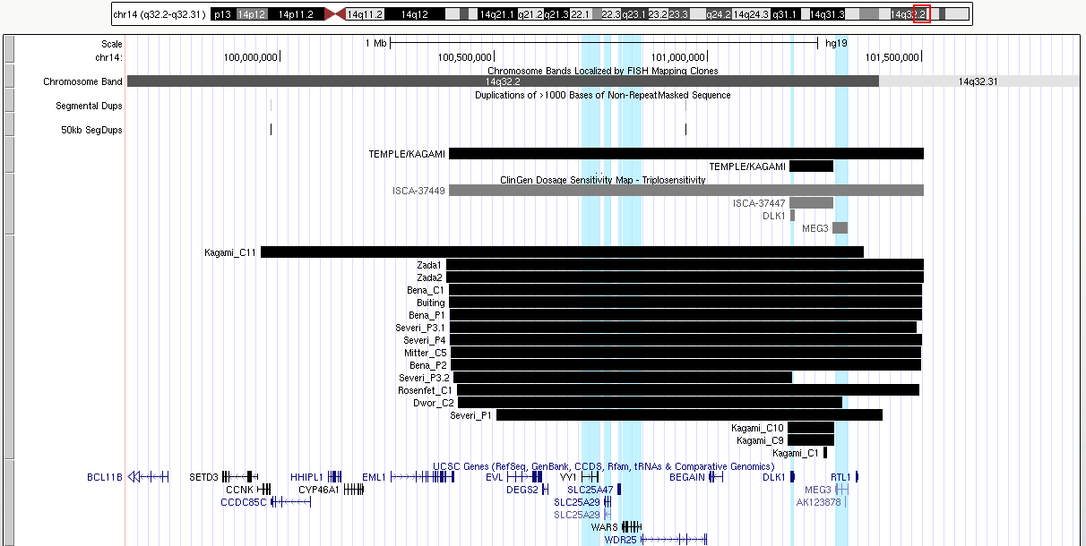

**Temple/Kagami-Ogata Large (ClinGen):** chr14:100394594-101504529 (hg19)

**Temple/Kagami-Ogata Small (ClinGen):** chr14:101191391-101294616 (hg19)

# Primary CNV 87: 15q11-q13 (Angleman/Prader-Willi)

**Prader Willi**: 15q11-q13 deletion *paternal allele* **Angelman Syndrome**: 15q11-q13 deletion *maternal allele*

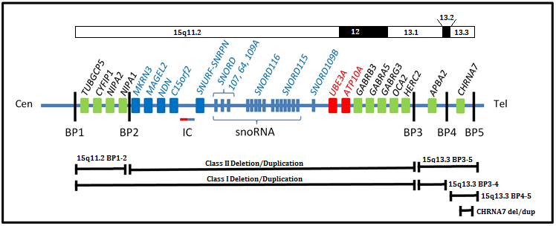

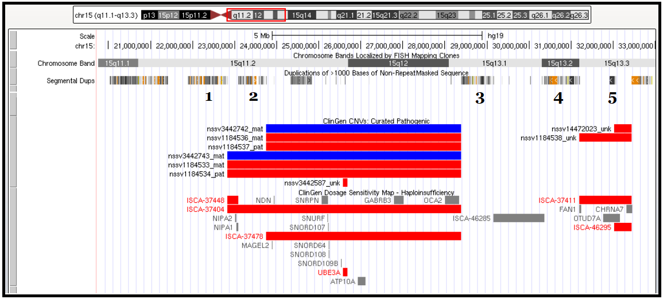

|  |  |
| --- | --- |
|  | **hg19** |
| **BP1** | 22832519 |
| **BP2** | 23747996 |
| **BP3** | 28379874 |
| **BP4** | 31192889 |
| **BP5** | 32445405 |

**Angelman/Prader Willi Type I (BP 1-3)**: chr15:22832519-28379874 (ClinGen; hg19)

**Angelman/Prader Willi Type II (BP 2-3)**: chr15:23747996-28379874 (ClinGen; hg19)

**15q13.2-13.3 BP4-5**: chr15:31192889-32445405 (ClinGen; hg19)

**CHRNA7:** chr15:32019621-32445405 (ClinGen; hg19)

# Primary CNV 88: 15q14 (MEIS2)

*UCSC Genome Browser View of Reported CNVs:*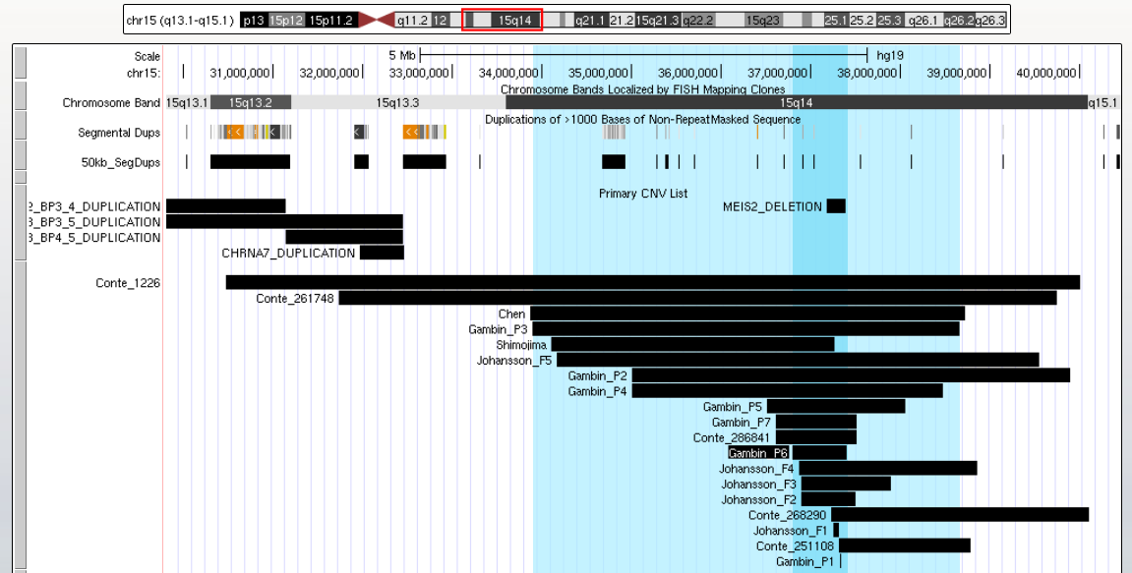

**Whole Region = Gambin P3:** chr15:33894032-38659166 (hg19)

**Smaller Region = Gambin P6:** chr15:36790702-37404359 (hg19)

# Primary CNV 89: 15q15.3

*UCSC Genome Browser View of Reported CNVs:*

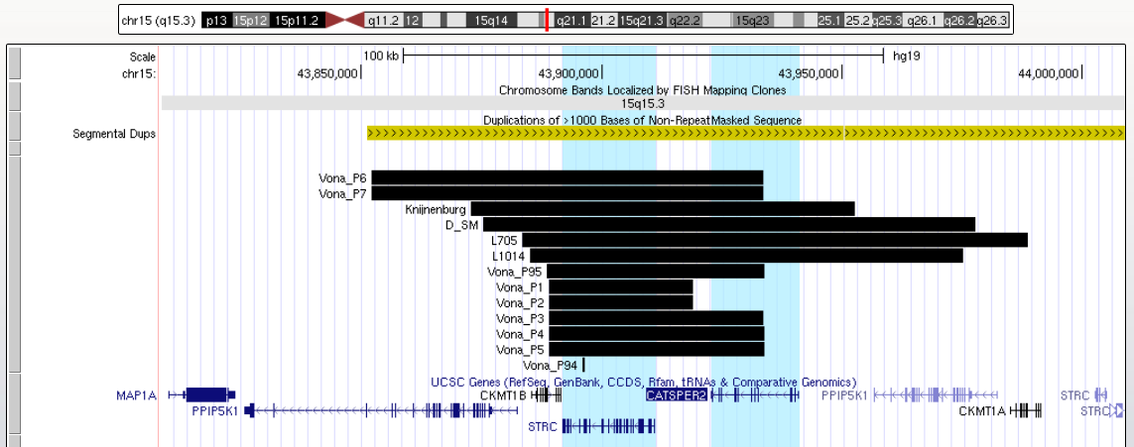

**Region (STRC to CATSPER2):** chr15:43891761-43941039 (hg19)

* **STRC:** chr15:43,891,761-43,910,998 (hg19)
* **CATSPER2:** chr15:43,922,772-43,941,039 (hg19)

# Primary CNV 90: 15q21.1 (FBN1)

*Figure 3 of Hilhorst-Hofstee 2011[72]:*

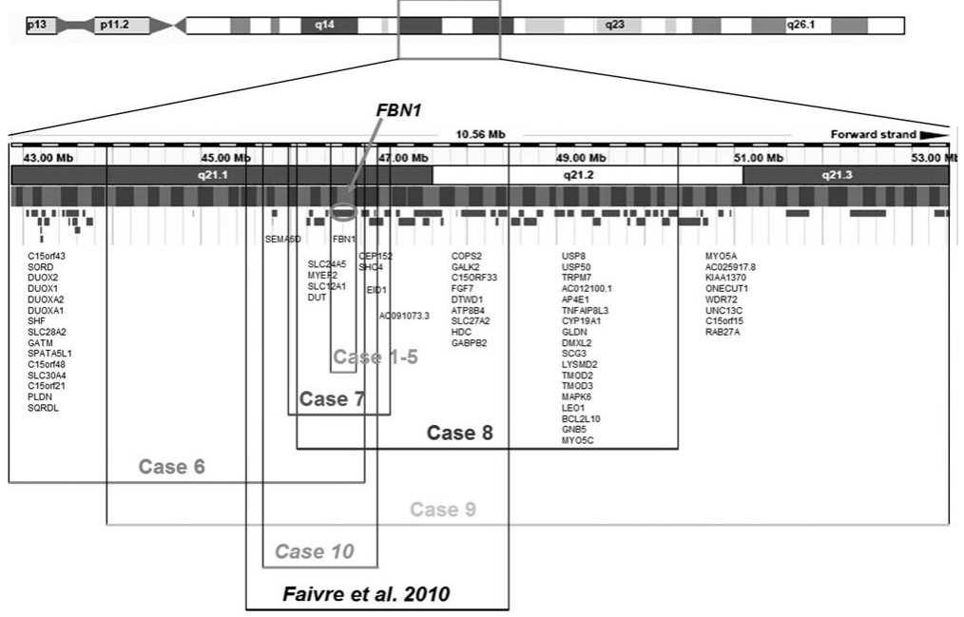

**Whole Region = Hilhorst-Hofstee P7 =** chr15:46098636-47145902 (hg18)

**FBN1:** chr15:48700503-48937985 (hg19)

# Primary CNV 91: 15q24 (Witteveen-Kolk)

*Figure 4 of El-Hattab 2009[73]:*

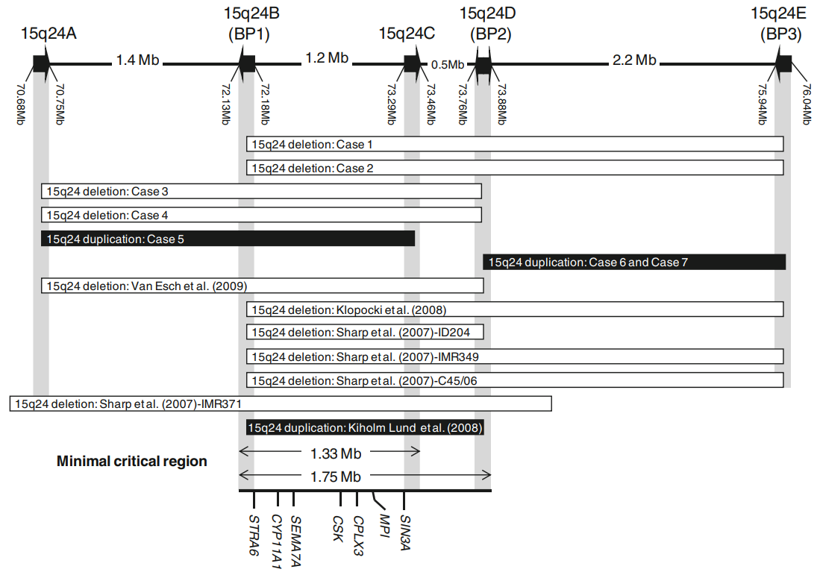

*Figure 1 of Liu 2020[74]:*

*UCSC Genome Browser View of Reported Patients:*

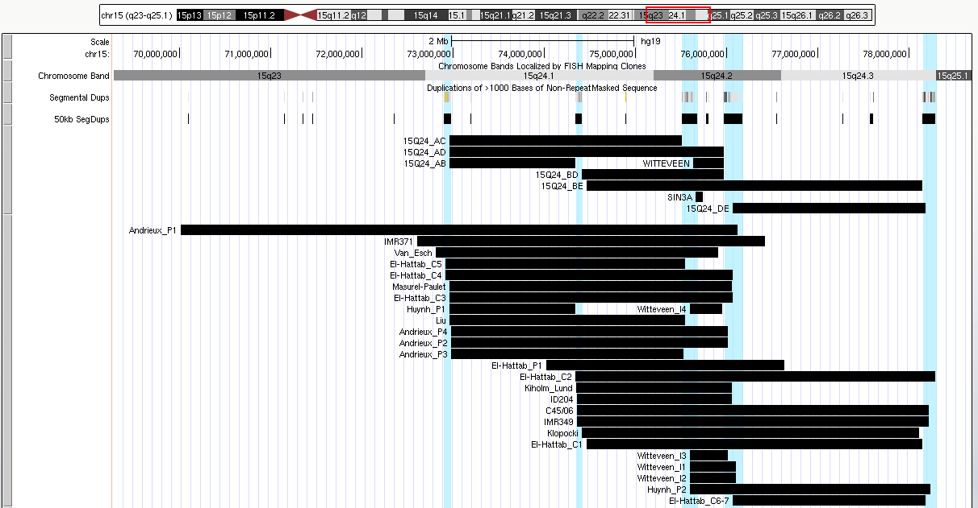

**ClinGen Regions:**

**15q24 AC:** chr15:72963715-75508312 (hg19)

**15q24 AD:** chr15:72963715-75972909 (hg19)

**15q24 CD:** chr15:75631787-75972909 (hg19)

**DECIPHER Regions:**

**15q24 BD:** chr15:74120302-75680570 (GRCh38)

**El-Hattab Regions:**

**15q24 BE = Patients 1,2:** chr15:72252000-75937000 (hg18)

**15q24 DE = Patients 6,7:** chr15:73858160-75969880 (hg18)

**15q24 AB:** chr15:72963971-74343898 (hg19)

**SIN3A:** chr15:75661720-75744087 (hg19)

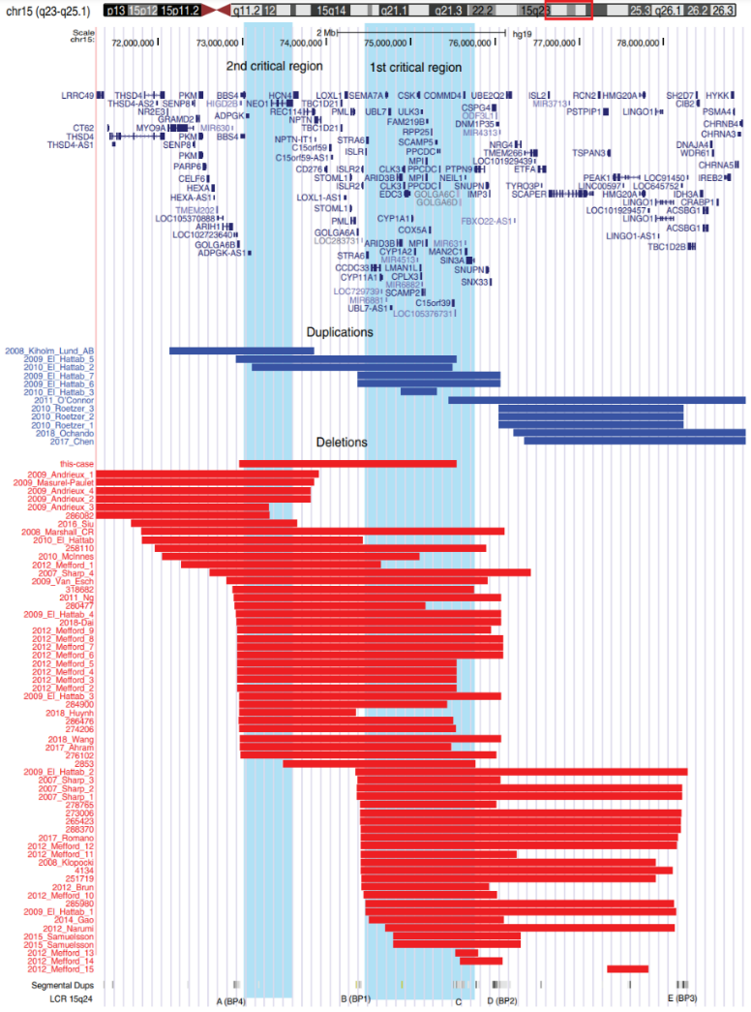

# Primary CNV 92: 15q25

*Figure 1F of Doelken 2013[75]*

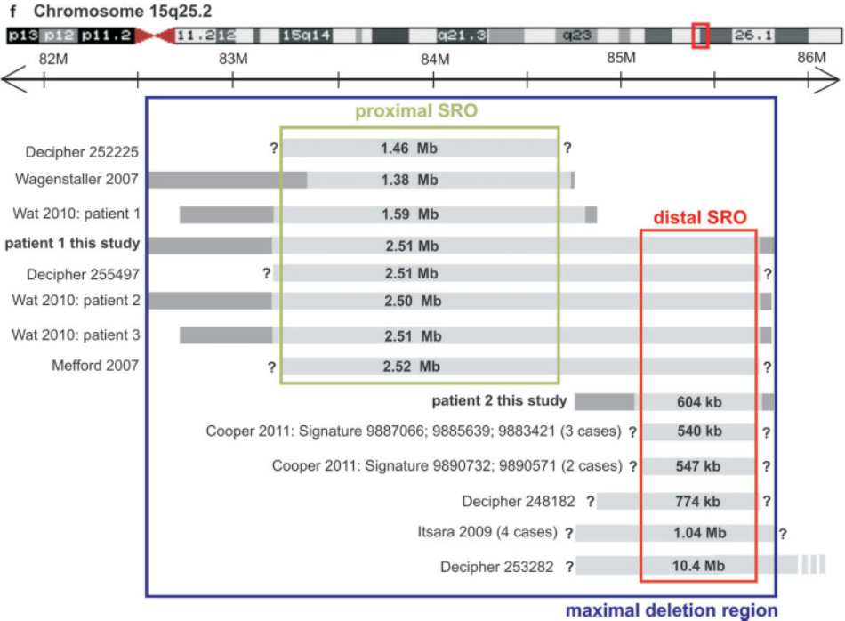

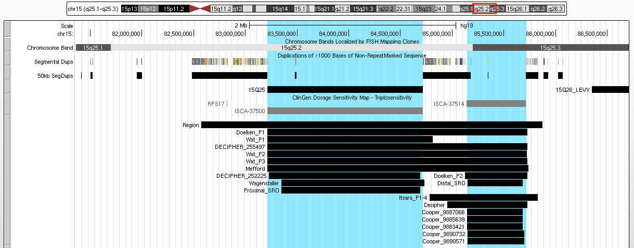

**Whole Region = ClinGen Distal + Proximal:** chr15:83213988-85713001 (hg19)

**Proximal SRO (ClinGen):** chr15:83213988-84714733 (hg19)

**Distal SRO (ClinGen):** chr15:85139652-85713001 (hg19)

# Primary CNV 93: 15q26

*UCSC Genome Browser View of Reported CNVs:*

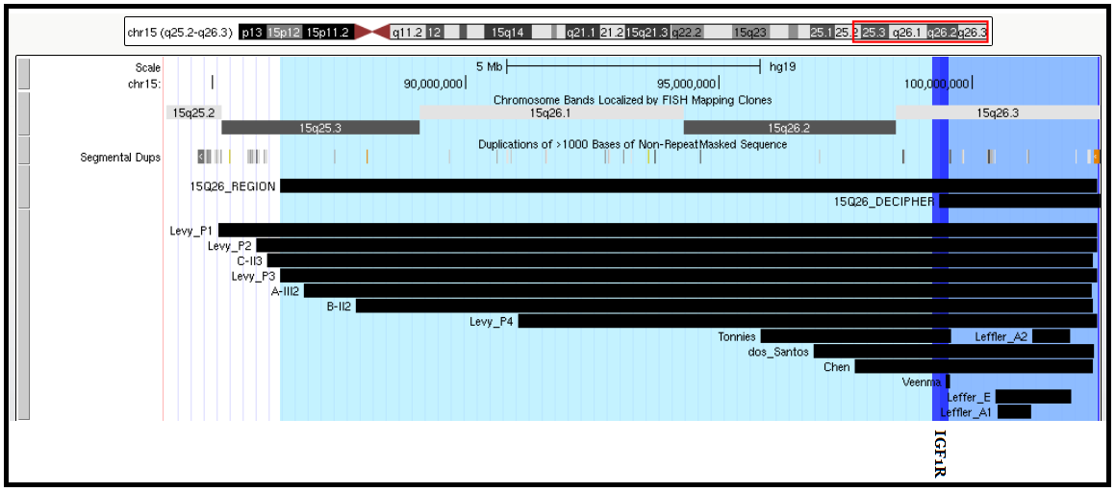

**Whole Region:** chr15:84151101-100276767 (hg18)

**DECIPHER Coordinates:** chr15:98814741-101981189 (GRCh38)

# Primary CNV 94: 16p13.3

*Figure 2 of Oyazato 2011[76]:*

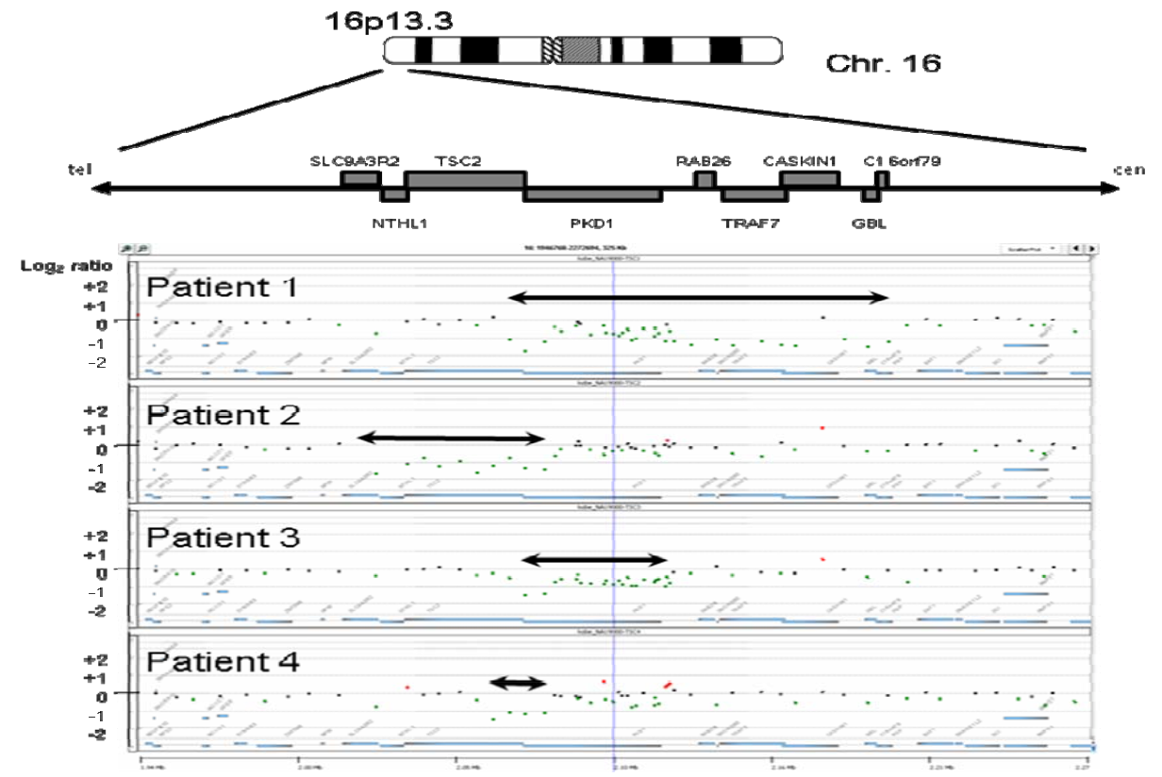

*Figure 2A of Osumi 2020[77]:*

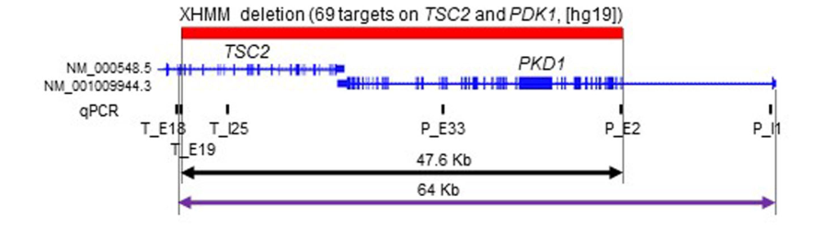

**Whole Region (TSC2 to PKD1):** chr16:2097990-2185899 (hg19)

* TSC2: chr16:2,097,990-2,138,713 (hg19)
* PKD1: chr16:2,138,711-2,185,899 (hg19)

# Primary CNV 95: 16p13.2 (Hao-Fountain Syndrome)

*Figure 2A of Fountain 2019[78]:*

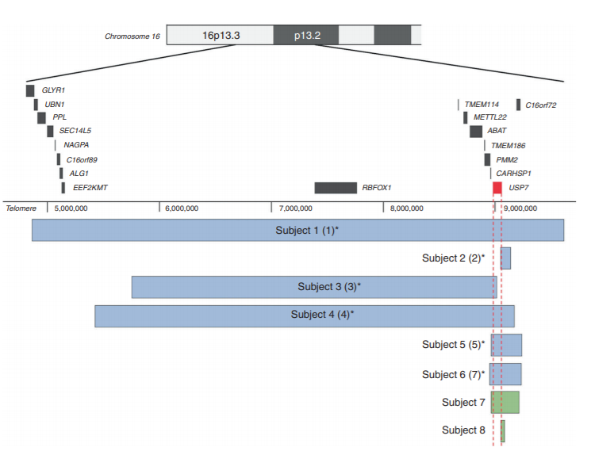

**Whole Region = Subject 4 =** chr16:5486454-9203355 (hg19)

**Subset Region = Subject 7 =** chr16:8969780-9211161 (hg19)

**USP7:** chr16:8,985,951-9,030,543 (hg19)

# Primary CNV 96: 16p13.11

*Figure 1 of Ingason 2011[79]:*

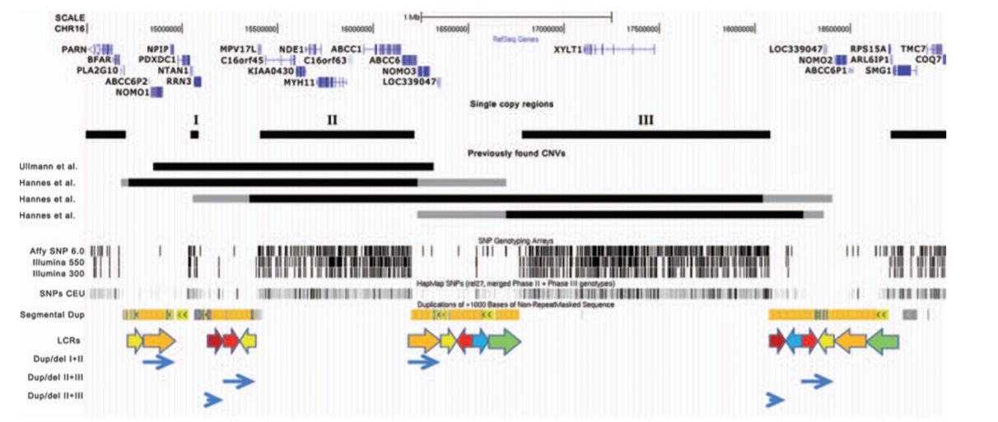

*UCSC Genome Browser View of Reported CNVs:*

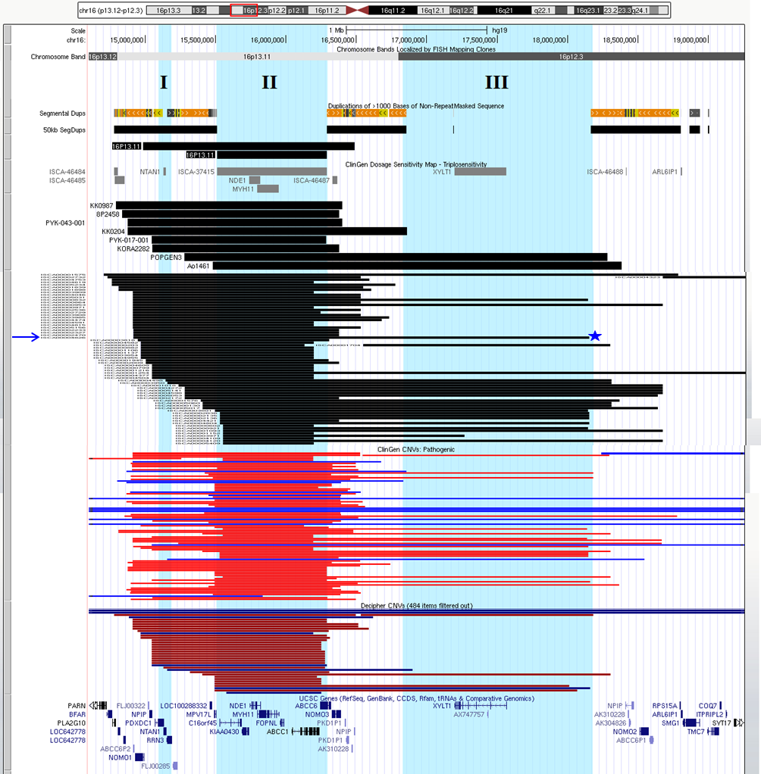

**16p13.11:**

* **BP I-II (DECIPHER):** chr16:14892827-16392827 (GRCh38)
* **BP I-III (4826; Kaminsky 2011):** chr16:14825307-18057186 (hg18)
* **BP II (ClinGen):** chr16:15511711-16292265 (hg19)
* **BP II-III (Ao1461; de Kovel 2010):** chr16:15386338-18291982 (hg18)

# Primary CNV 97: 16p12.2-p11.2

*Figure 3 of Tabet 2012[80]:*

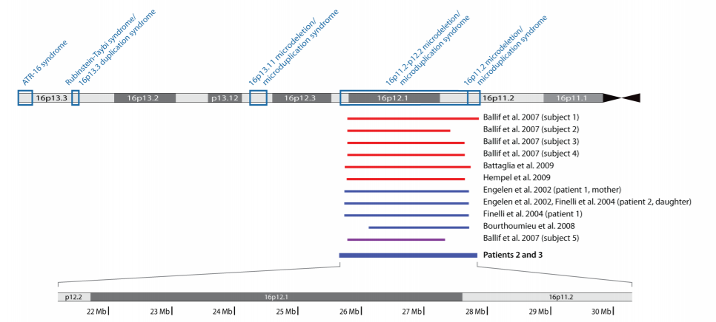

*UCSC Genome Browser View of Reported CNVs:*

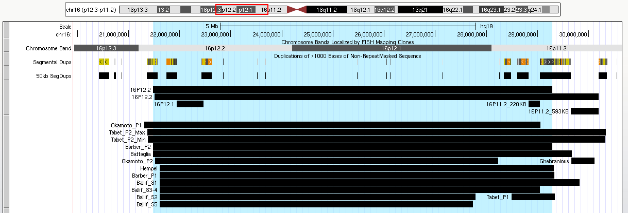

**DECIPHER Coordinates:**

chr16:21463739-29272756 (GRCh38)

chr16:21500741-30188533 (GRCh38)

# Primary CNV 98: 16p11.2 (220kb; 593kb)

*Figure 2 of Bachmann-Gagescu 2010[81]:*

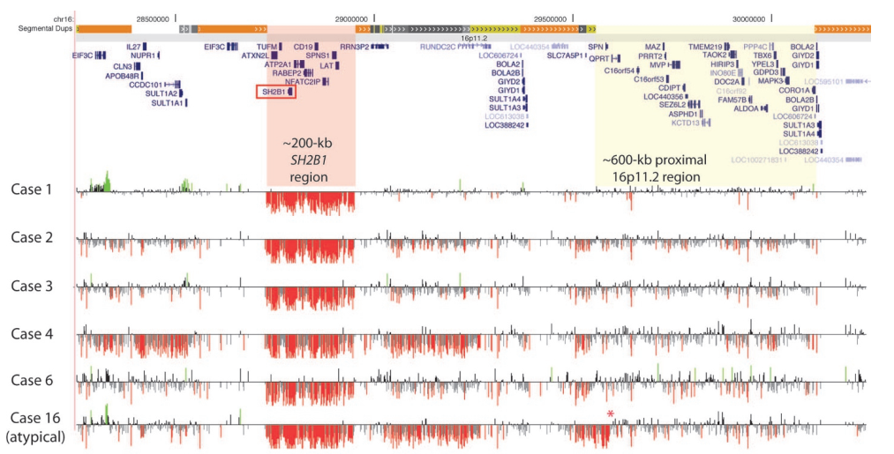

*UCSC Genome Browser View of Reported CNVs:*

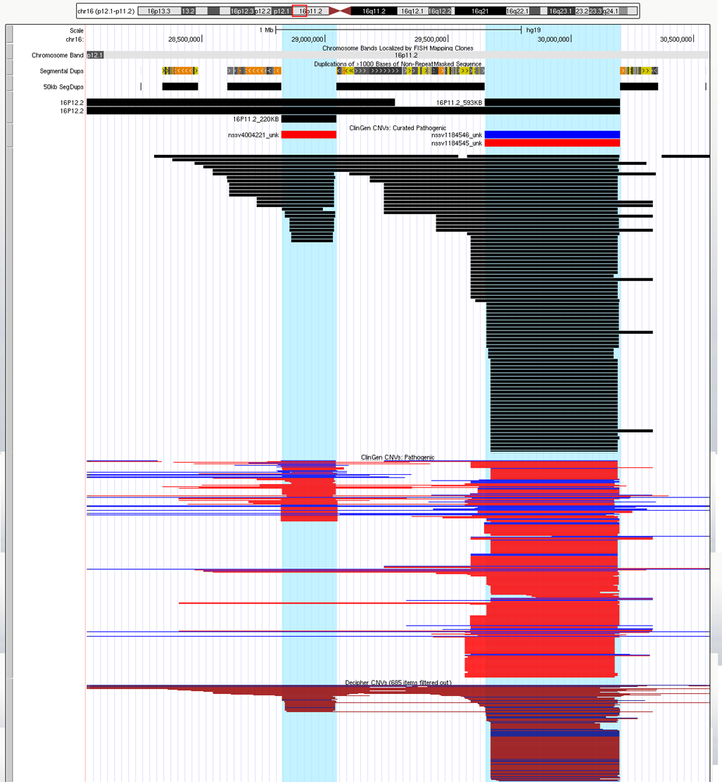

**220KB Region (ClinGen):** chr16:28822635-29046499 (hg19)

**593kb Region (ClinGen):** chr16:29649997-30199852 (hg19)

# Primary CNV 99: 16q22

*Figure 2 of Abdullah 2019[82]:*

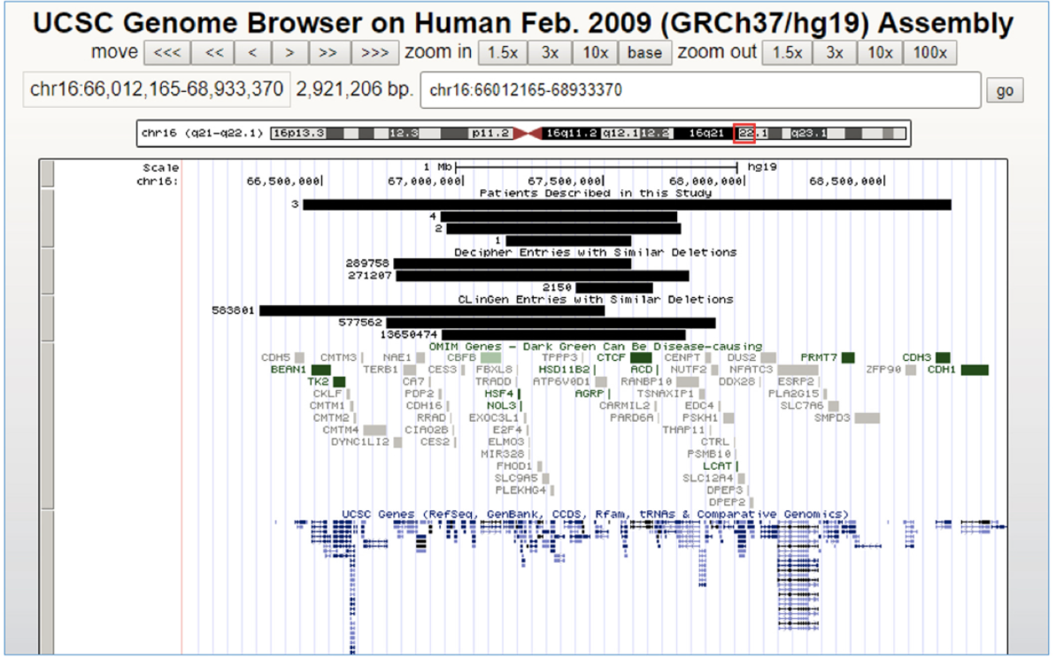

**Abdullah Patient 4:** chr16:66923587-67761965 (hg19)

# Primary CNV 100: 16q24.1

*UCSC Genome Browser View of Reported CNVs:*

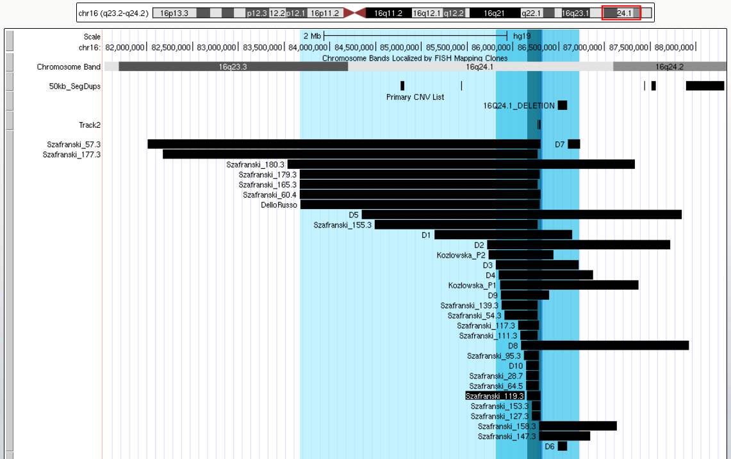

**Whole Region = Szafranski Patient 179.3:** chr16:83671523-86296478 (hg19)

**Intermediate Size = Stankiewicz Patient D3:** chr16:84374208-85277007 (hg18)

**SRO = Szafranski Patient 119.3:** chr16:86148250-86301591 (hg19)

# Primary CNV 101: 17p13.3 (Miller-Dieker Syndrome)

*UCSC Genome Browser View of Reported CNVs:*

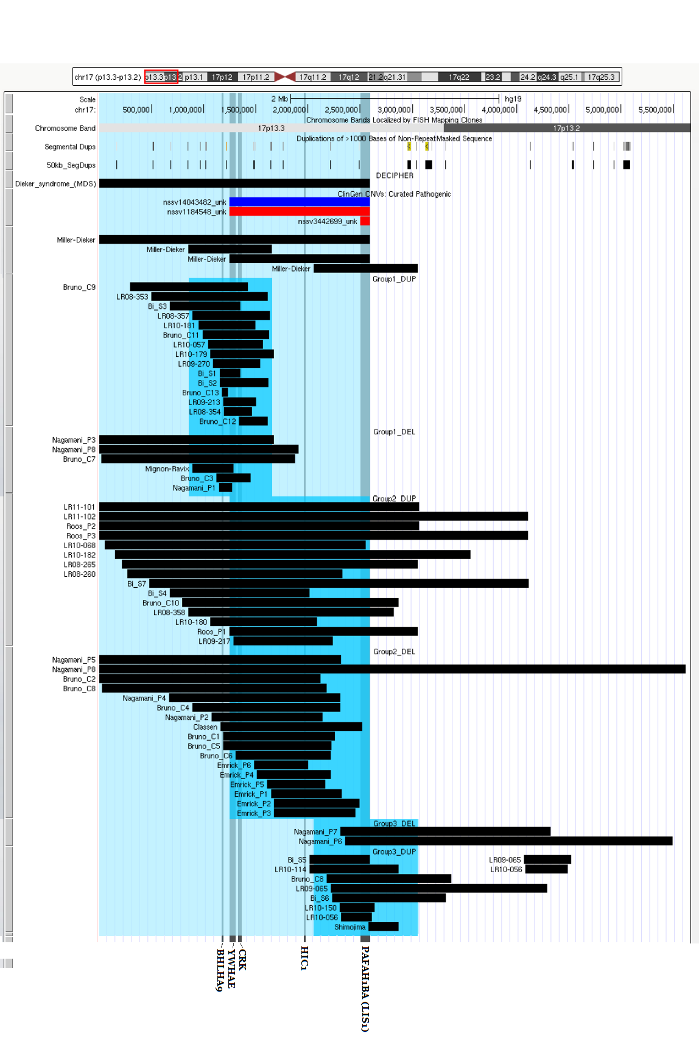

**Whole Region = DECIPHER =** chr17:150208-2685615 (GRCh38)

**Curry Group 1**: chr17:800,000–1,600,000 (hg18)

**Critical Region = ClinGen Coordinates =** chr17:1247833-2588909 (hg19)

**Curry Group 3**: chr17:2,000,000–3,000,000 (hg18)

# Primary CNV 102: 17p13.3 (SHFLD3)

*Figure 3-II of Armour 2011[83]:*

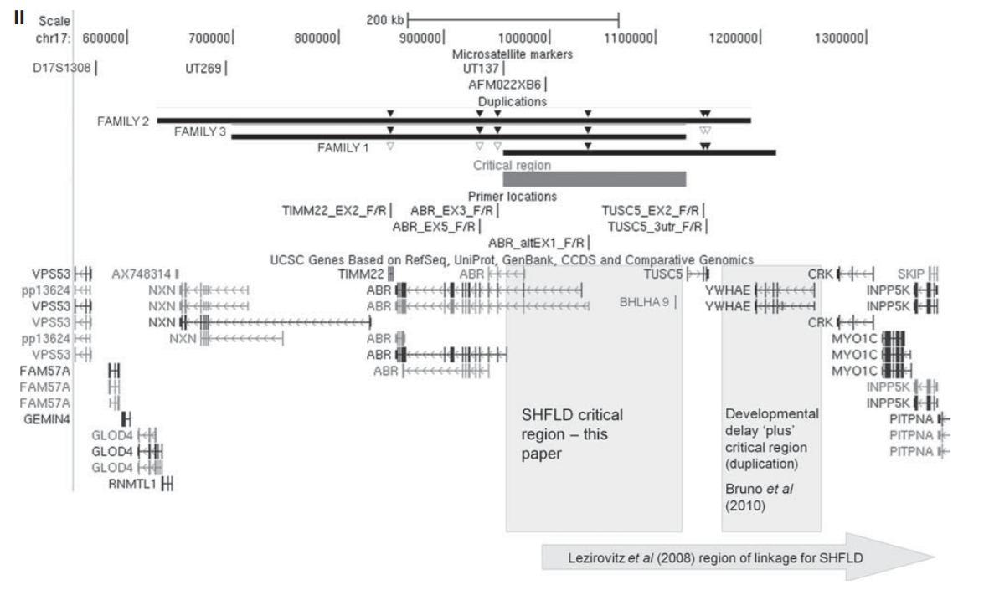

*Figure 2 of Luk 2014[84]:*

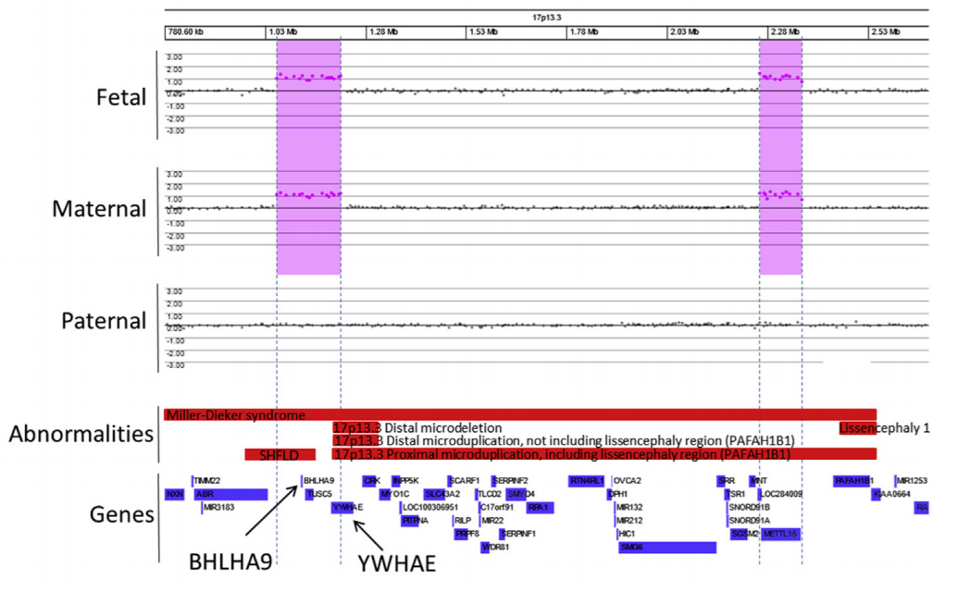

**Region = Armour SHFLD CR** = chr17:950721-1145540 (hg18)

# Primary CNV 103: 17p13.1

*UCSC Genome Browser View of Reported CNVs:*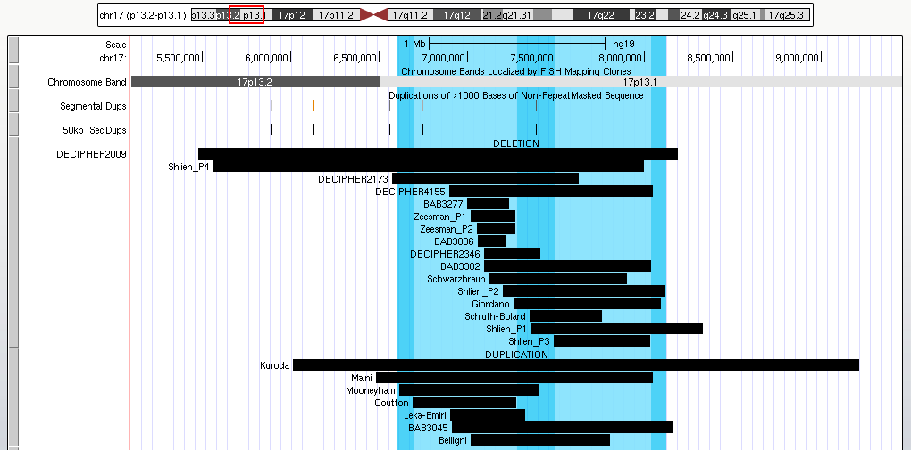

**Whole Region (Mooneyham to Shlien P2):** chr17:6610939-8121046 (hg19)

* **Mooneyham:** chr17:6610939-7399323 (hg19)
* **Shlien P2:** chr17:7140464-8061771 (hg18) // chr17:7199741-8121046 (hg19)

**Distal Region (Shlien P3):** chr17:7429371-7972019 (hg18)

**Proximal Region (Coutton):** chr17:6690620-7276764 (hg19)

# Primary CNV 104: 17p11.2 (CMT1A/HNPP)

*Schematic View of Figure 1 of Zhang 2010[85]:*

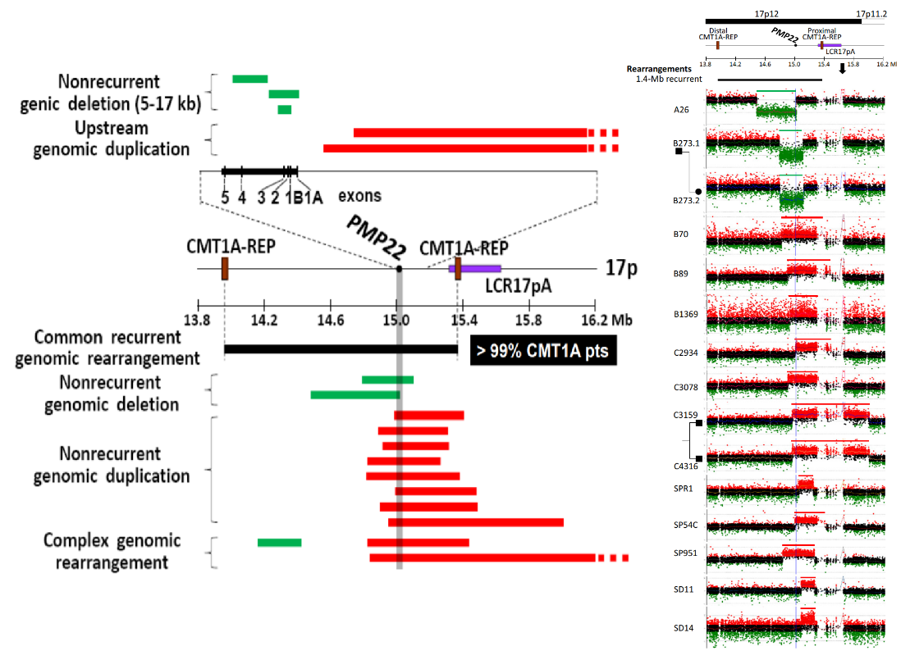

**Common Recurrent Region (ClinGen):**

chr17:14097915-15422952 (hg19)

**Nonrecurrent:** chr17:15133094-15422954

* **PMP22:** chr17:15133094-15168690 (hg19)
* **CMT1A-REP:** chr17:15422954-15796452 (hg19)

# Primary CNV 105: 17p11.2 (PTLS/SMS)

*Figure 2 of Potocki 2007[86]:*

**ClinGen**: chr17:16810028-20213202 (hg19)

**PTLS/SMS Critical**: chr17:16796512-18088067

* **RP11-48J14:** chr17:16796512-16796743 (hg19)
* **RP11-258F1:** chr17:18079879-18088067 (hg19)

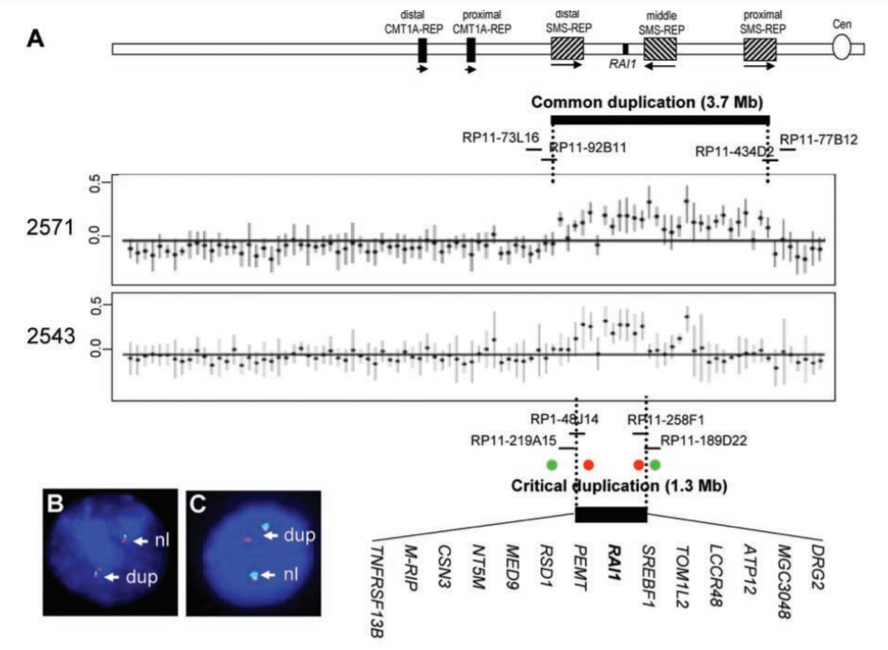

*Figure 1 of Shaw 2004[87]:*

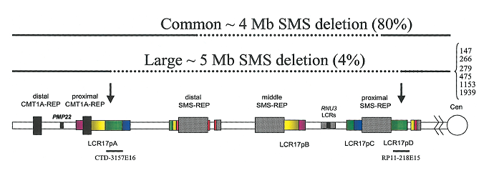

**Large PTLS/SMS:** chr17:15691101-20635656

* **CTD-3157E16:** chr17:15691101-15691519 (hg19)
* **RP11-218E15:** chr17:20440061-20635656 (hg19)

*UCSC Genome Browser View of Reported CNVs: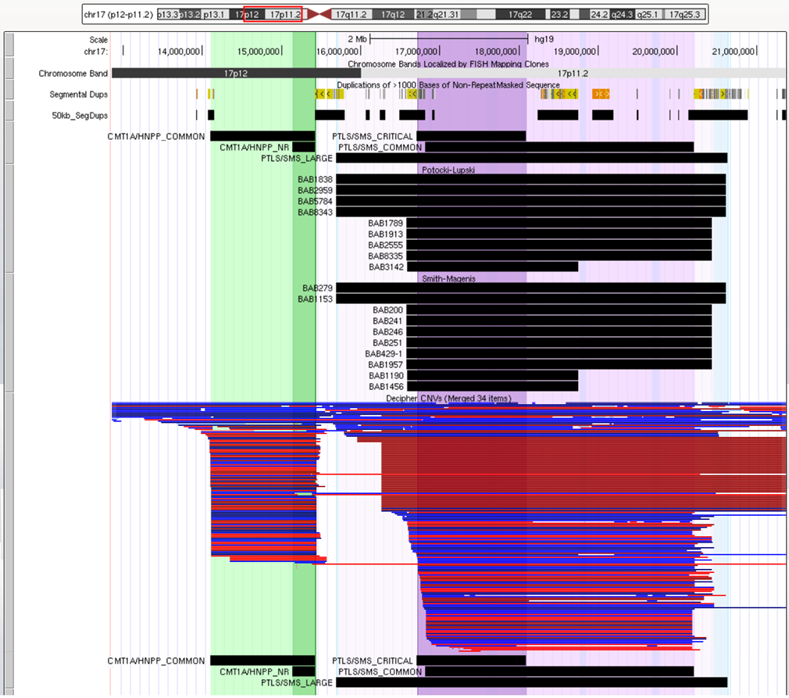*

# Primary CNV 106: 17p11.2 (Yuan-Harel-Lupski)

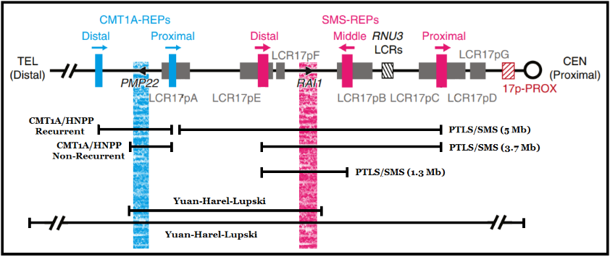

*Figure 2 of Yuan 2015[88]:*

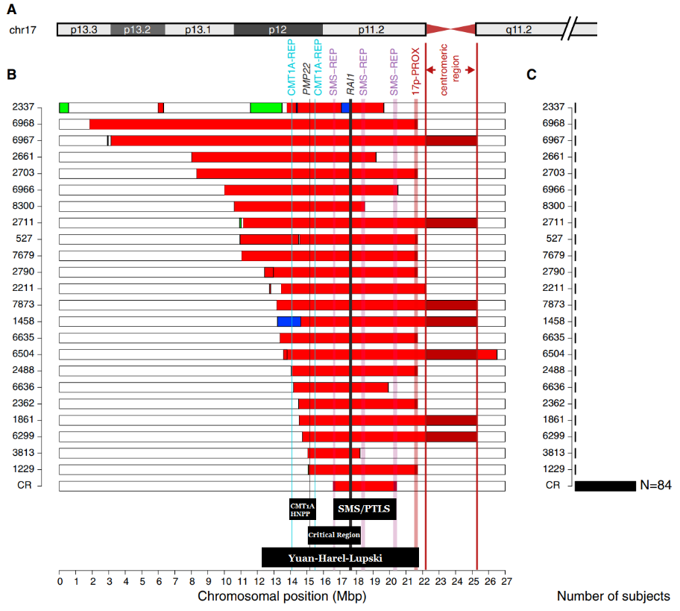

*UCSC Genome Browser View of Reported CNVs:*

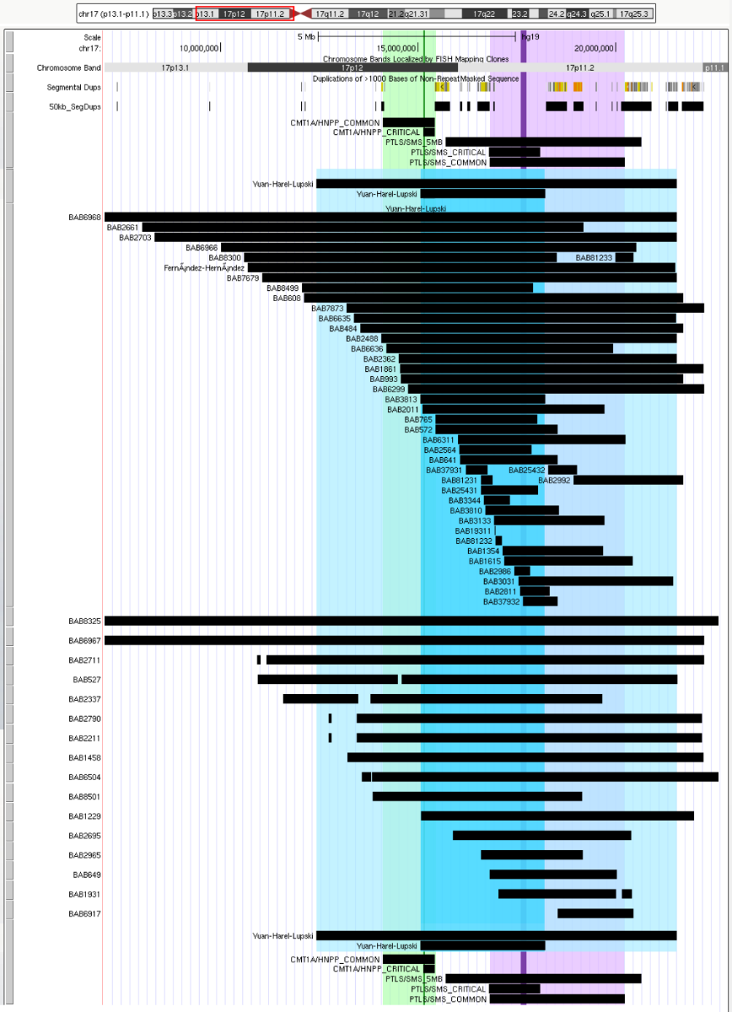

**Whole Region = Patient 2790:** chr17:12434684-21531363 (hg19)

**Smaller Region = Patient 3813:** chr17:15060682-18212609 (hg19)

# Primary CNV 107: 17q11.2 (NF1)

*Figure 1 of Moles 2012[89]:*

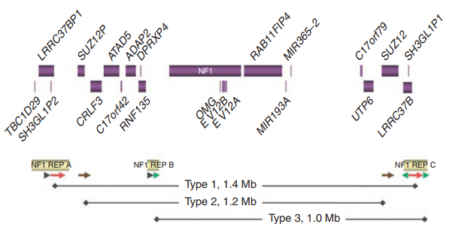

**Type 1 (Midpoint REP-A to Midpoint REP-C):** chr17:28961884-30370955 (hg19)

* REP-A: chr17:28816673-29107096 (hg19)
* REP-C: chr17:30263321-30478590 (hg19)

**Type II (End REP-A to Start REP-C; ClinGen Coordinates):** chr17:29097069-30264027 (hg19)

**Type III (Start REP-B to End of REP-C):** chr17:29465301-30478590 (hg19)

* REP-B: chr17:29465301-29595301 (hg19)
* REP-C: chr17:30263321-30478590 (hg19)

# Primary CNV 108: 17q23.1-q23.2

*Figure 1 of Schönewolf-Greulich 2011[90]:*

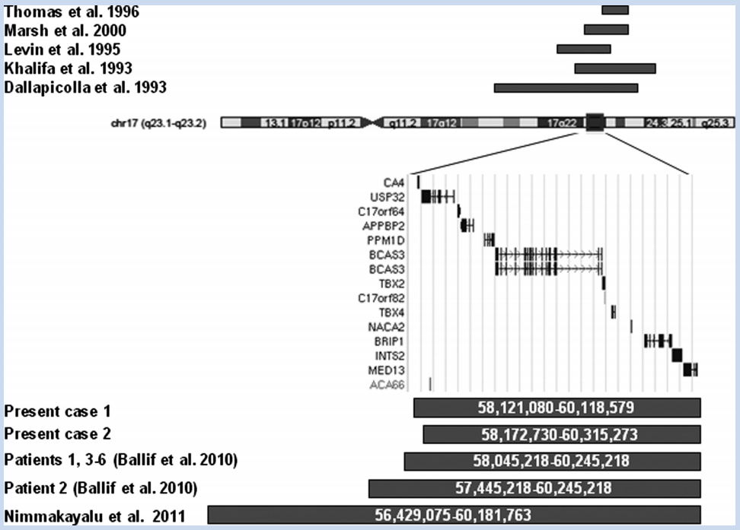

*UCSC Genome Browser View of Reported CNVs:*

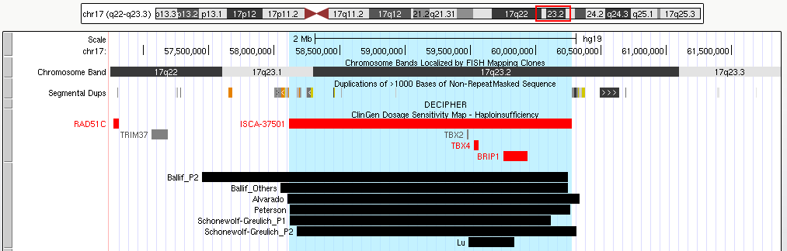

**Whole Region (ClinGen Coordinates):** chr17:58113002-60275809 (hg19)

# Primary CNV 109: 17q24.2-q24.3

*UCSC Genome Browser View of Reported CNVs:*

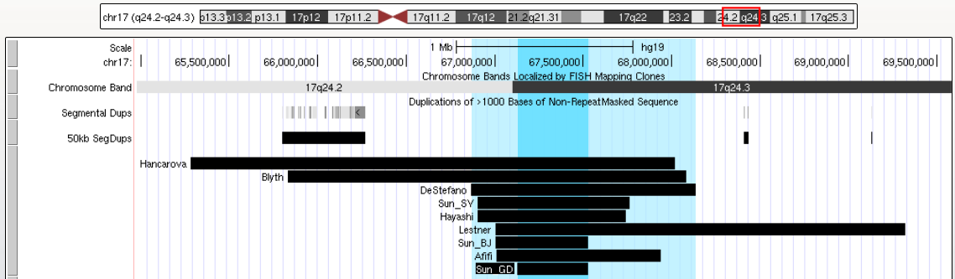

**Whole Region = DeStefano:** chr17:66865466-68134760 (hg19)

**SRO = Sun Patient “GD”:** chr17:64641291-65042219 (hg18)

# Primary CNV 110: 17q24.3 (SRXY10; SRXX2)

*Figure 1 of Kim 2015[91]:*

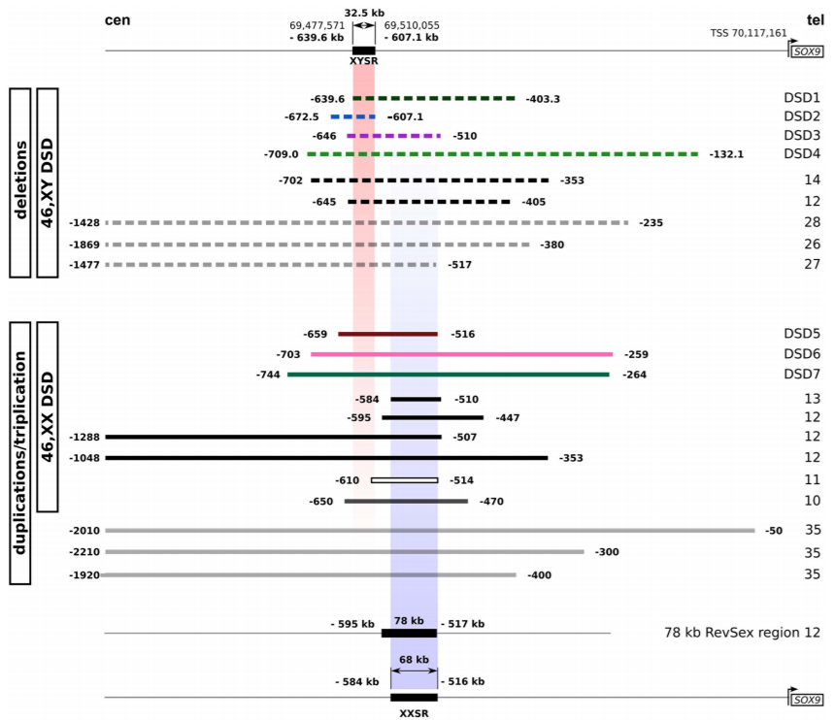

*UCSC Genome Browser View of Reported CNVs:*

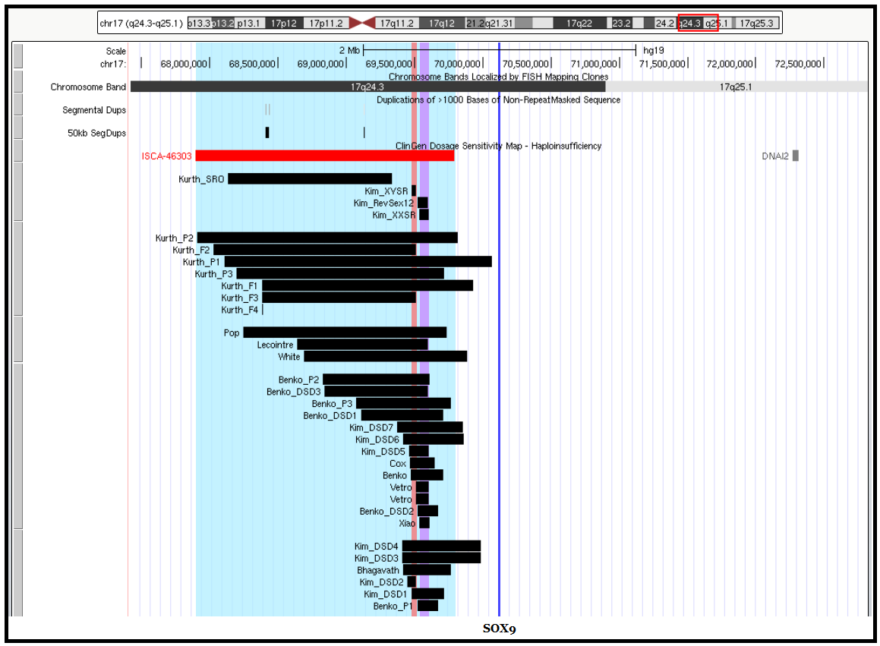

**Blue (SOX9 Enhancer Region) ::** chr17:67892996-69792434 (hg19)

**Red (46,XY; SRXY10) ::**  chr17:69477571-69510055 (hg19)

**Purple (46,XX; SRXX2) ::**  chr17:69533161-69601161 (hg19)

# Primary CNV 111: 18p

*Figure 1 of Wester 2006[92]:*

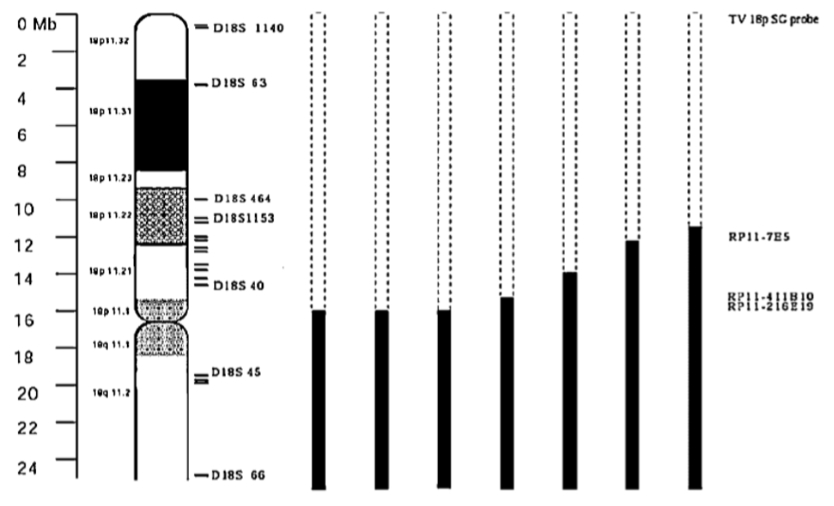

**Whole 18p arm:** chr18:1-15,400,000 (hg19)

# Primary CNV 112: 18q Proximal

*UCSC Genome Browser View of Reported CNVs:*

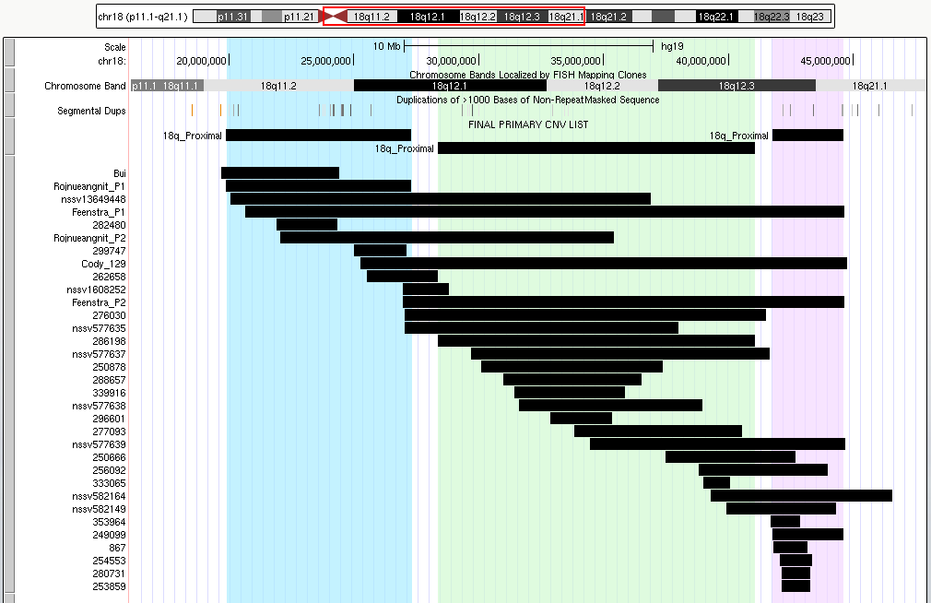

**Proximal (Blue) = Rojnueangnit P1:** chr18:19886814-27306978 (hg19)

**Intermediate (Green) = DECIPHER #286198 (Rojnueangnit):** chr18:28354894-41068920 (hg19)

**Distal (Purple) = DECIPHER #249015q99 (Rojnueangnit):** chr18:41756428-44600418 (hg19)

# Primary CNV 113: 18q Terminal

*Figure 1 of Cody 2015[93]:*

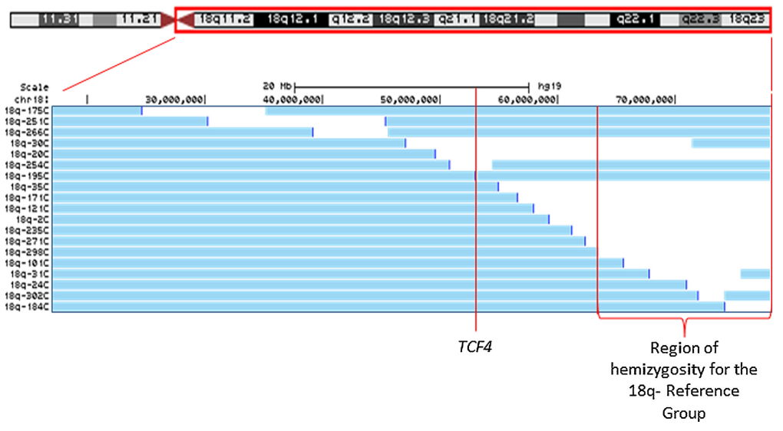

**Region 1 (TCF4 to qter):** chr18:52889429-78077248 (hg19)

**Region 2 (18q- Reference Group):** chr18:61637263-78077248 (hg19)

# Primary CNV 114: 19p13.3

*Figure 2 of Nevado 2015[94]:*

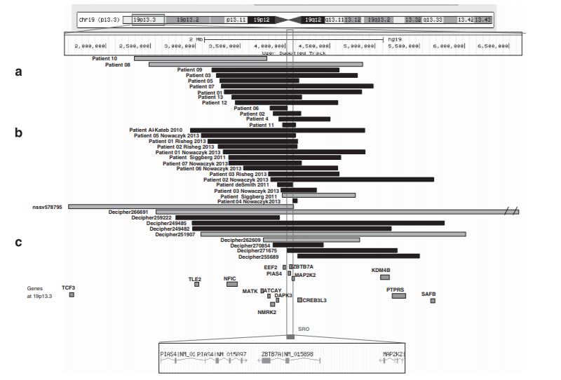

**Whole Region (Orellana P1-3) =** chr19:1952590-6908729 (hg19)

**Nevado SRO =** chr19:3979568-4093035 (hg19)

# Primary CNV 115: 19p13.2

# Primary CNV 116: 19p13.12

*UCSC Genome Browser View of Reported CNVs:*

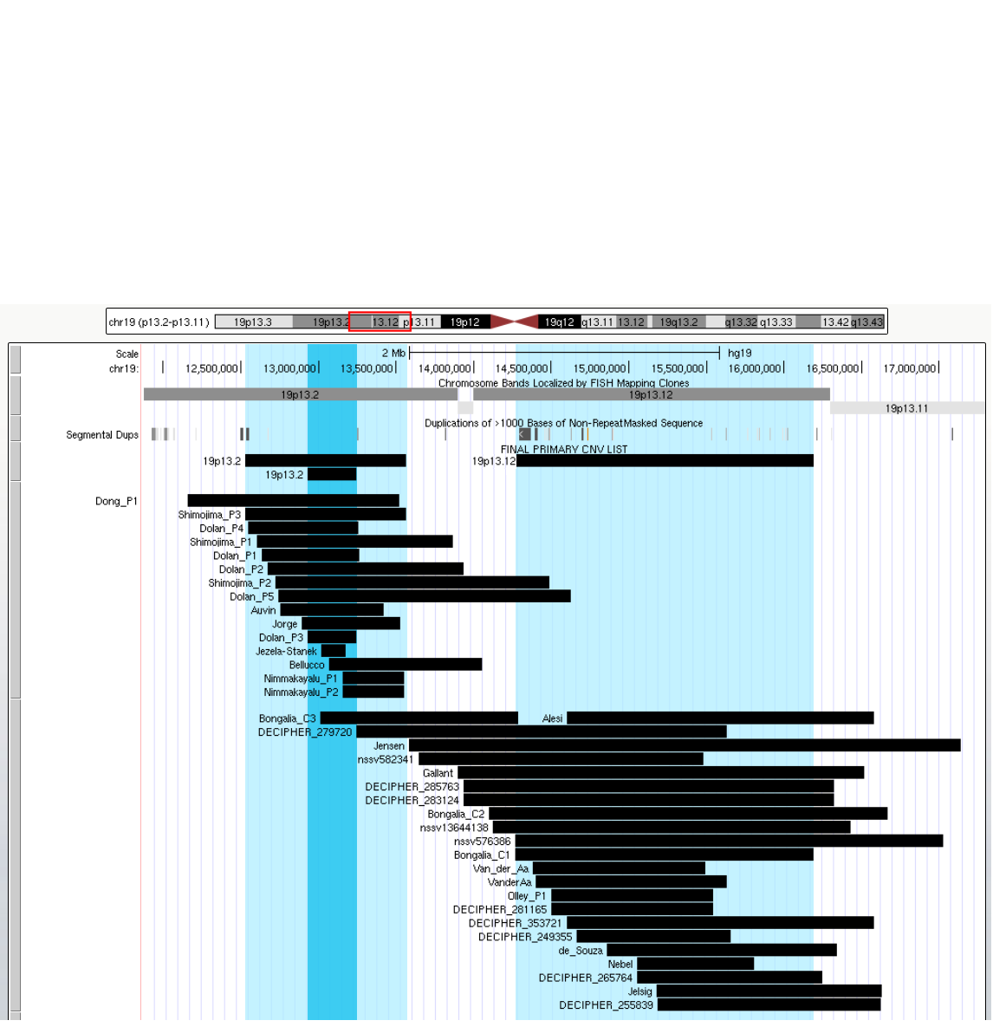

**19q13.2:**

**Whole Region = Shimojima P3:** chr19:12527157-13563832(hg19)

**SRO = Dolan P3 =** chr19:12793474-13104643 (hg18)

**19q13.12:**

**Whole Region = Bonaglia C1:** chr19:14130000-16050000 (hg18)

# Primary CNV 117: 19q13.11 Proximal, Distal

Proximal:

Figure 1A of Caubit 2016[95]:

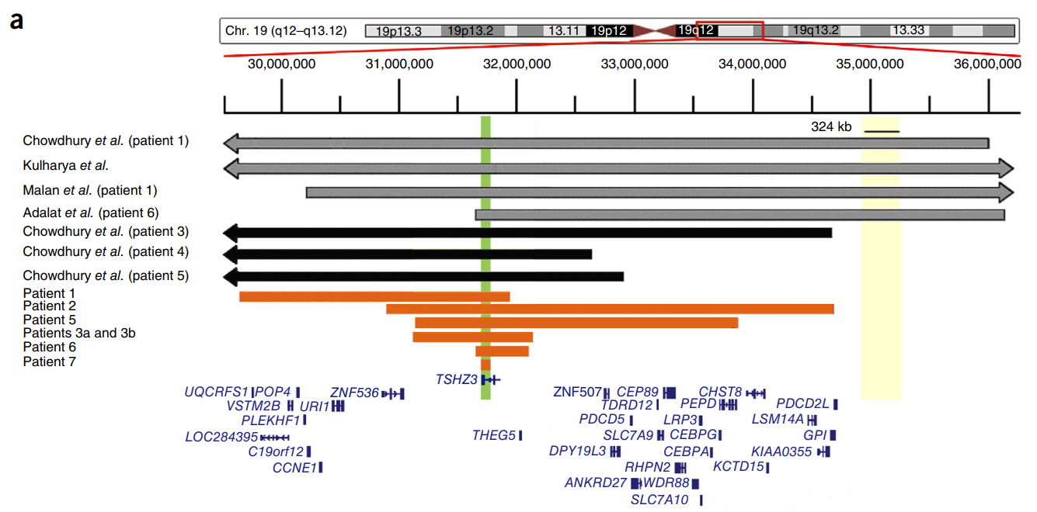

**Whole Region = Chowdhury P4 =** chr19:33509029-37420026 (hg18)

**SRO = TSHZ3 =** chr19:31765851-31840190 (hg19)

Distal:

*Figure 3 of Gana 2012[96]:*

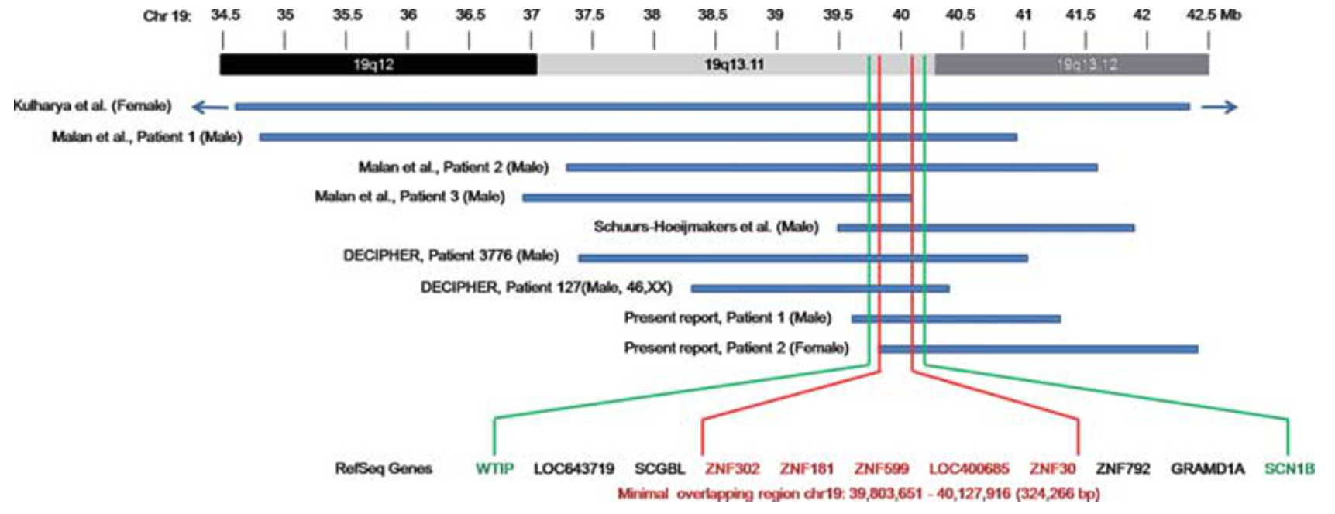

**Whole Region = 3 = Malan P2:** chr19:37301826-41577180 (hg18)

**Gana SRO = ZNF302 to SNF30 =** chr19:39803651-40127916 (hg18)

***UCSC Genome Browser View of Reported CNVs:***

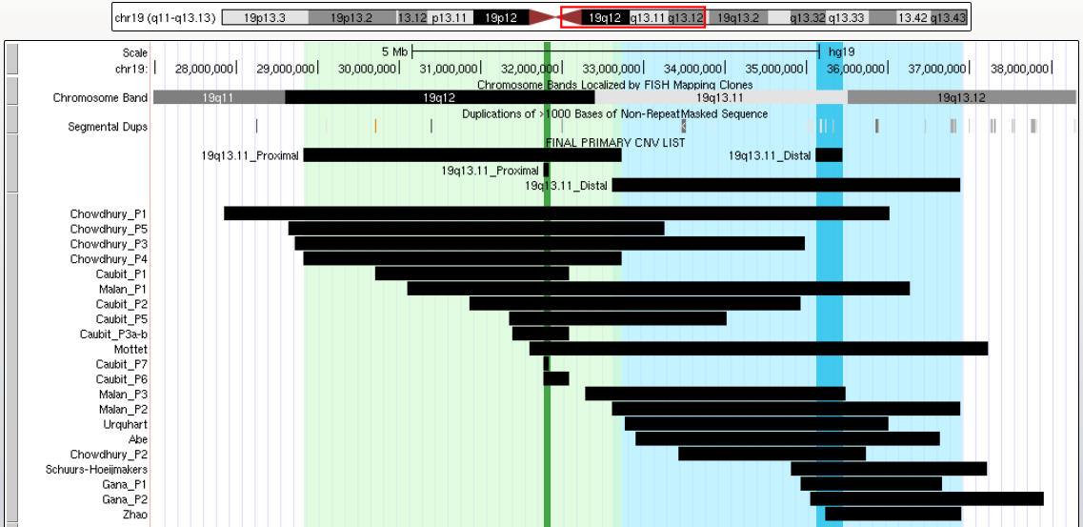

# Primary CNV 118: 19q13.2

*UCSC Genome Browser View of Reported CNVs:*

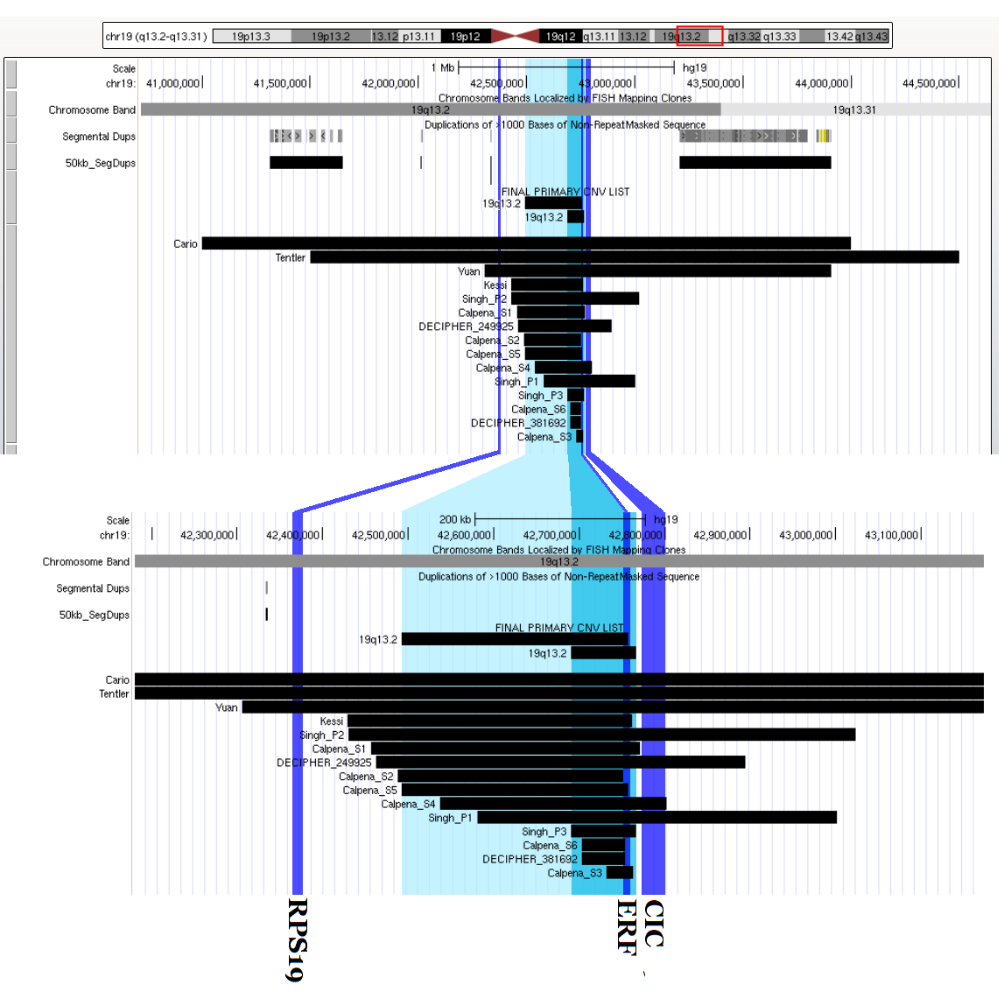

**Whole Region = Calpena S5 =** chr19:42492136-42756726 (hg19)

**SRO = Singh P3 =** chr19:42690571-42766082 (hg19)

# Primary CNV 119: 20p13

*UCSC Genome Browser View of Reported CNVs:*

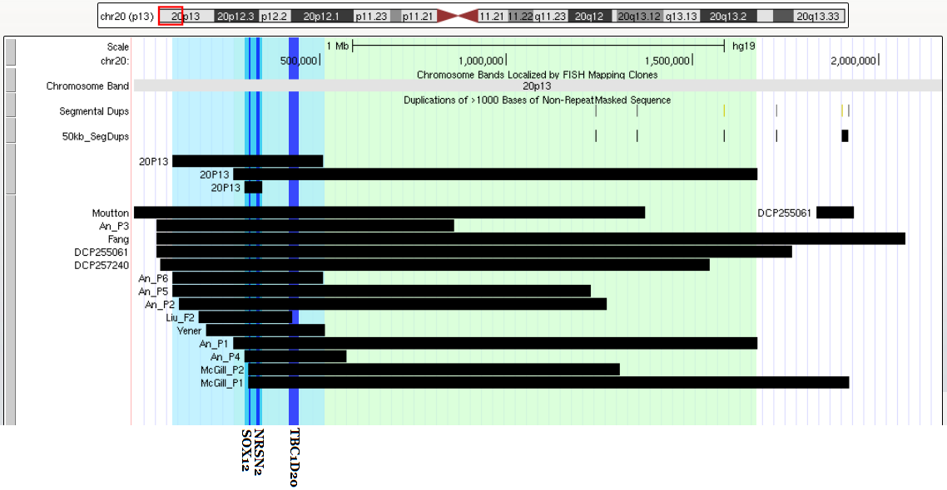

**Blue Region = An P6 =** chr20:102422-508612 (hg19)

**Blue Region SRO = An SRO =** chr20:297444-344879 (hg19)

**Green Region = An P1 =** chr20:266000-1676018 (hg19)

# Primary CNV 120: 20p12.3

*UCSC Genome Browser View of Reported CNVs:*

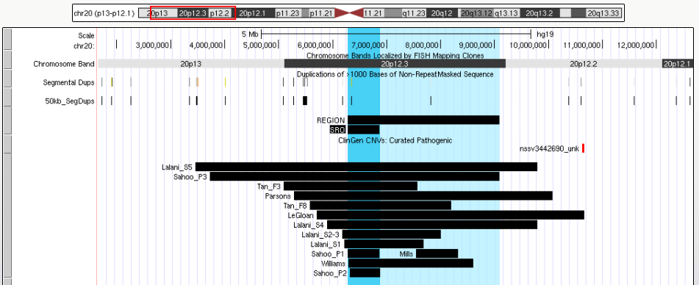

**Region = Sahoo P1 to Sahoo P3 =** chr20:6222266-9042183 (hg18)

**SRO = Sahoo P1 =** chr20:6222266-6814990 (hg18)

# Primary CNV 121: 20q13.33

*Figure 1G of Traylor 2010[97]:*

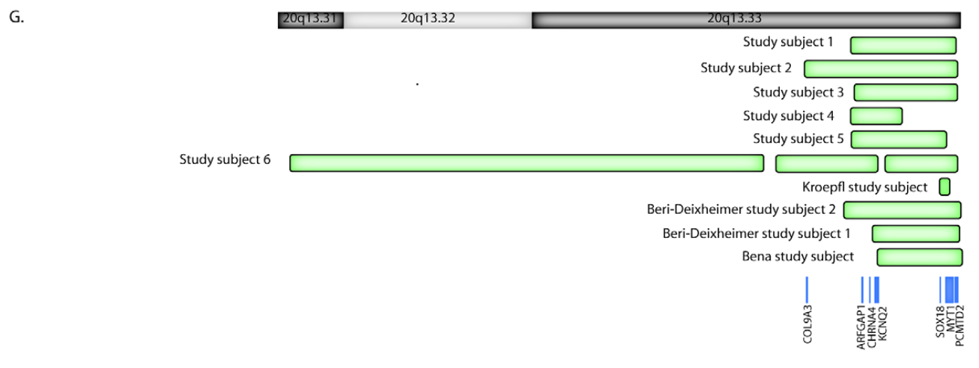

**Traylor Subject 2** = chr20:60760865-62379119 (hg18)

# Primary CNV 122: 21q22

*Figure 3 of Ji 2015[98]: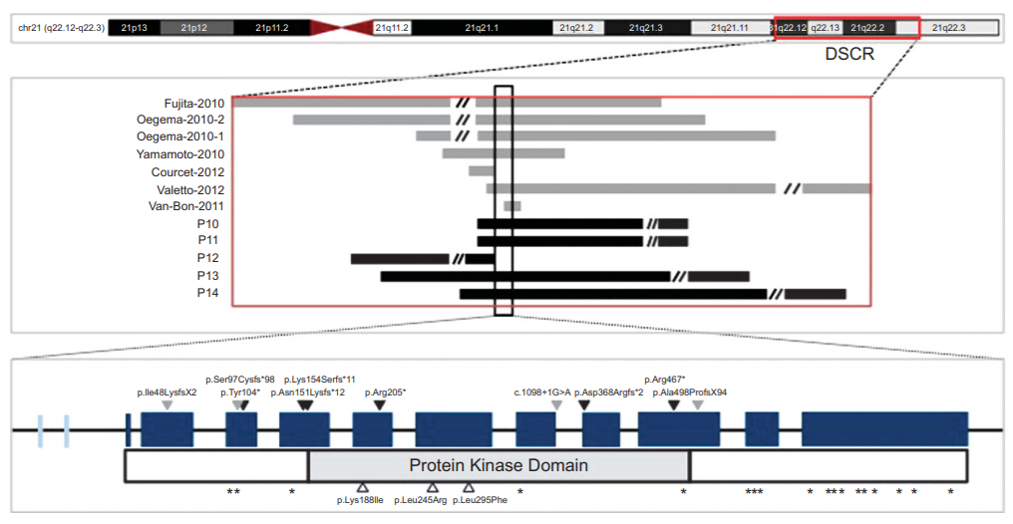*

**Whole Region = Oegema P2 to Oegema P1 =** chr21:35337577-41102161 (hg18)

**SRO = Yamanmoto P5 =** chr21:37450000-37931000 (hg18)

# Primary CNV 123: 22q11 (Cat-eye syndrome)

*Figure 2 of McDermid 2002[99]:*

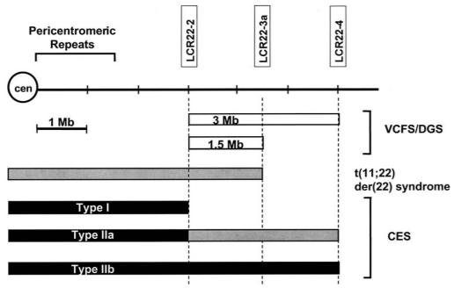

*UCSC Genome Browser View of Reported Patients in ClinGen:*

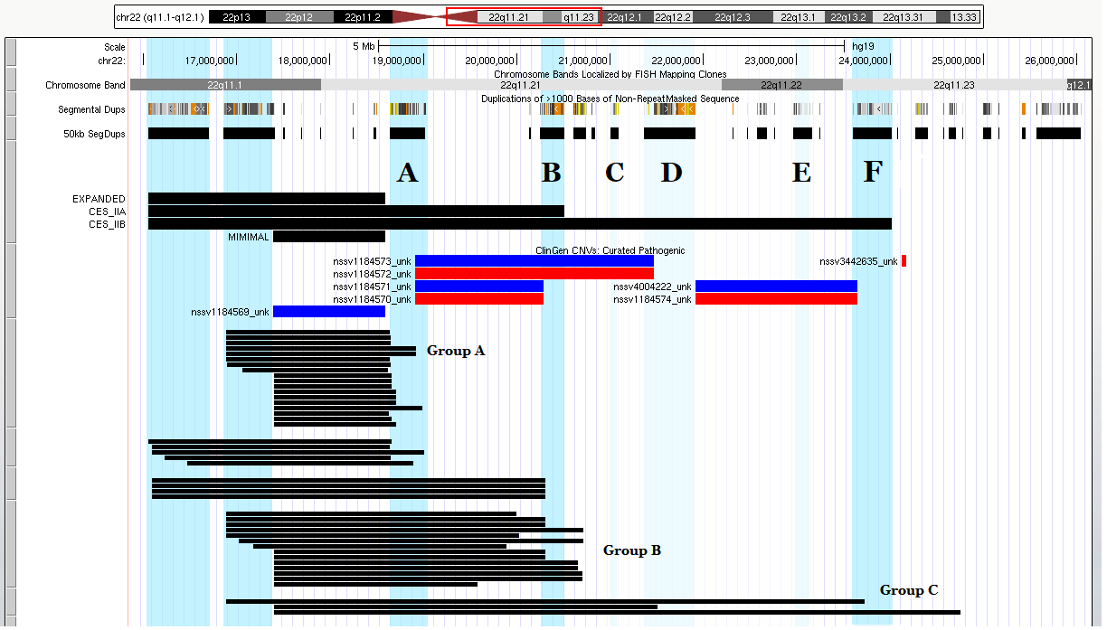**Cat-Eye Syndrome:**

* **Group A (ClinGen):** chr22:17392953-18591860 (hg19)
* **Group B (CES to “B”):** chr22:17392953-20509428 (hg19)
* **Group C (CES to “F”):** chr22:17392953-24021303 (hg19)

# Primary CNV 124: 22q11.2 (DGS/VCFS)

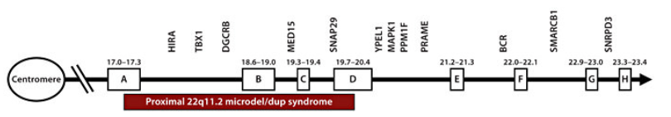

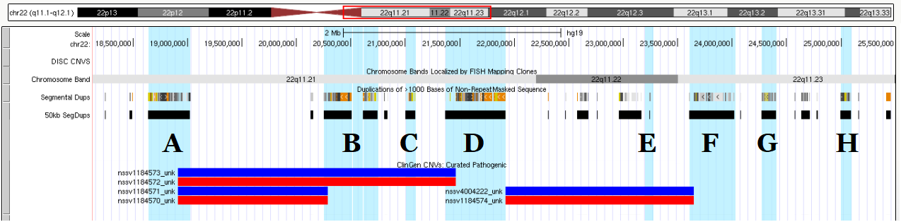

|  |  |  |  |
| --- | --- | --- | --- |
|  | **Breakpoint Region (hg19)** | **Midpoint** | **ClinGen (hg19)** |
| **A** | chr22:18642491-19023012 | 18832752 | 18912231 |
| **B** | chr22:20249559-20744436 | 20496997 | 20287208 |
| **C** | chr22:21002235-21092337 | 21047287 |  |
| **D** | chr22:21364655-21917116 | 21640885 | 21465672 |
| **E** | chr22:22963079-23249072 | 23106076 |  |
| **F** | chr22:23606141-24021303 | 23813722 | 23649111 |
| **G** | chr22:24271707-24404807 | 24338258 |  |
| **H** | chr22:24994435-25089103 | 25041769 |  |

*All coordinates from hg19 assembly*

**ClinGen Coordinates (hg19):**

**22q11.2 DGS/VCFS (A-B):** chr22:18912231-20287208

**22q11.2 DGS/VCFS (A-D):** chr22:18912231-21465672

**22q11.2 DGS/VCFS Distal (D-F):** chr22:21917117-23649111

**22q11.2 DGS/VCFS (B-D):** chr22:20287208-21465672

**Breakpoint Region Based Coordinates (hg19):**

**22q11.2 DGS/VCFS (A-C):** chr22:18832752-21047287

**22q11.2 DGS/VCFS (C-D):** chr22:21047287-21640885

**22q11.2 DGS/VCFS Distal (D-H):** chr22:21640885-25041769

# Primary CNV 125: 22q13.33 (Phelan-McDermid)

**Blue Region = Upadia =** chr22:41673833-42839139 (hg19)

**Green Regions:**

* **Light = Disciglio P8:** chr22:43709818-50692268 (hg19)
* **Middle = Dhar P5:** chr22:46458243-49499770 (hg18)
* **Dark = Dhar P4:** chr22:48554059-49565875 (hg18)

**DECIPHER** **= SHANK3 =** chr22:50607088-50749416 (GRCh38)

*UCSC Genome Browser View of Reported CNVs:*

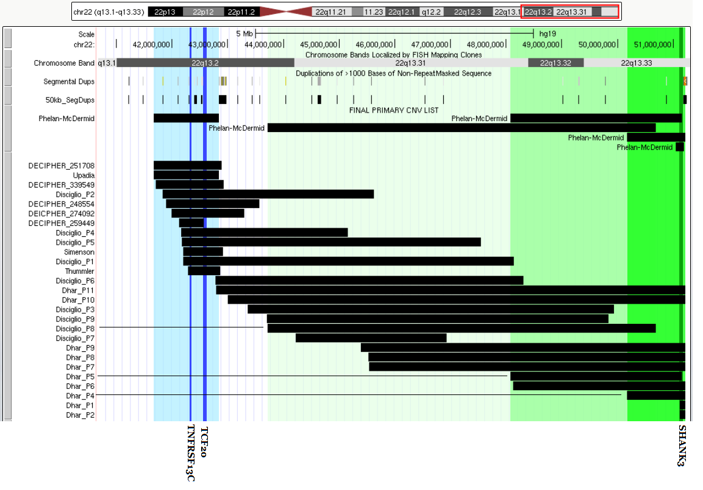

# Primary CNV 126: Xp22.31 (STS)

*Figure 1A of Hand 2014[100]:*

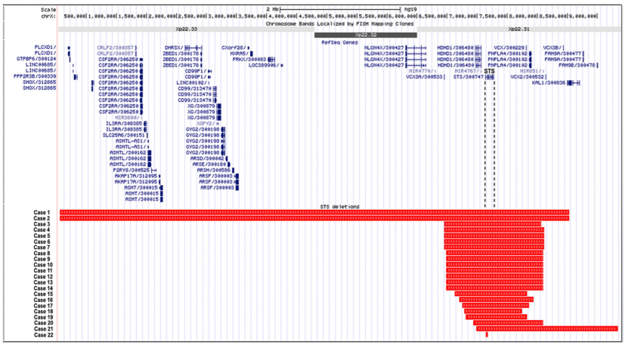

*UCSC Genome Browser View of Reported CNVs:*

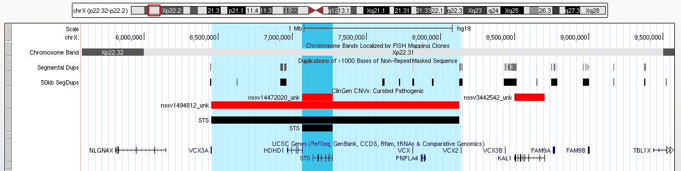

**Whole Region (ClinGen; VCX3A to VCX2):** chrX:6455812-8124954 (hg19)

**STS** **(ClinGen)**: chrX:7065293-7272684 (hg19)

# Primary CNV 127: Xp21

*UCSC Genome View of Reported CNVs:*

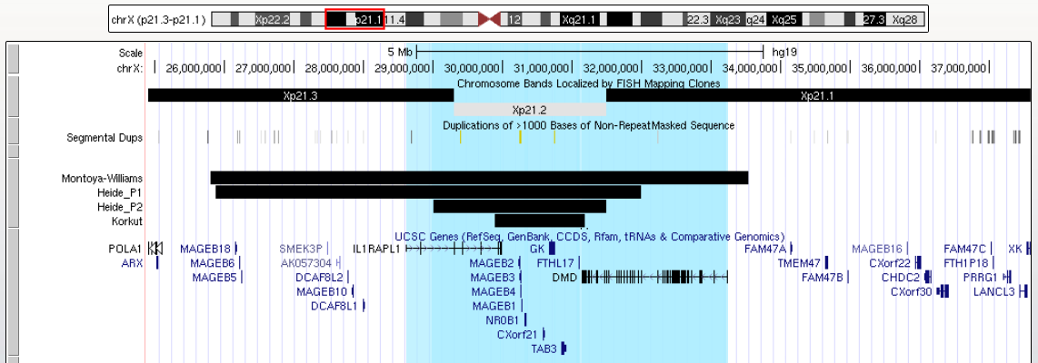

**Region (IL1RAPL1 to DMD):** chrX:28605681-33229673 (hg19)

* **IL1RAP1**: chrX:28,605,681-29,974,017 (hg19)
* **DMD**: chrX:31,137,345-33,229,673 (hg19)

# Primary CNV 128: Xp11.3

*UCSC Genome Browser View of Reported CNVs:*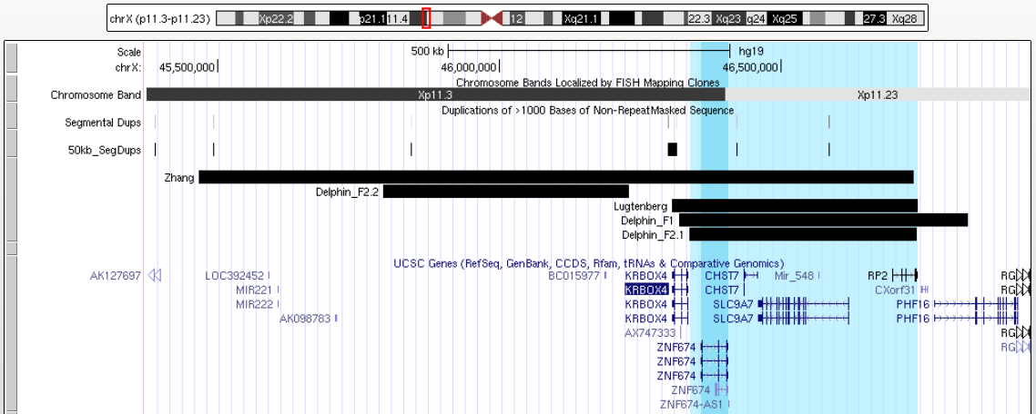

**Whole Region = Delphin F2.1 =** chrX:46336830-46740394 (hg19)

# Primary CNV 129: Xp11.23-p11.22

# Primary CNV 130: Xp11.22

*Figure 2 of Grams 2016[101]:*

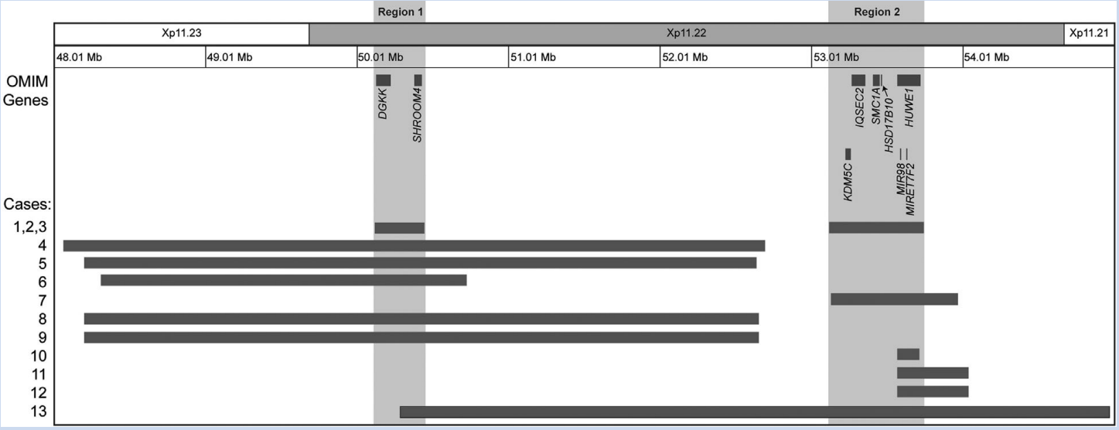

*UCSC Genome Browser View of Reported CNVs:*

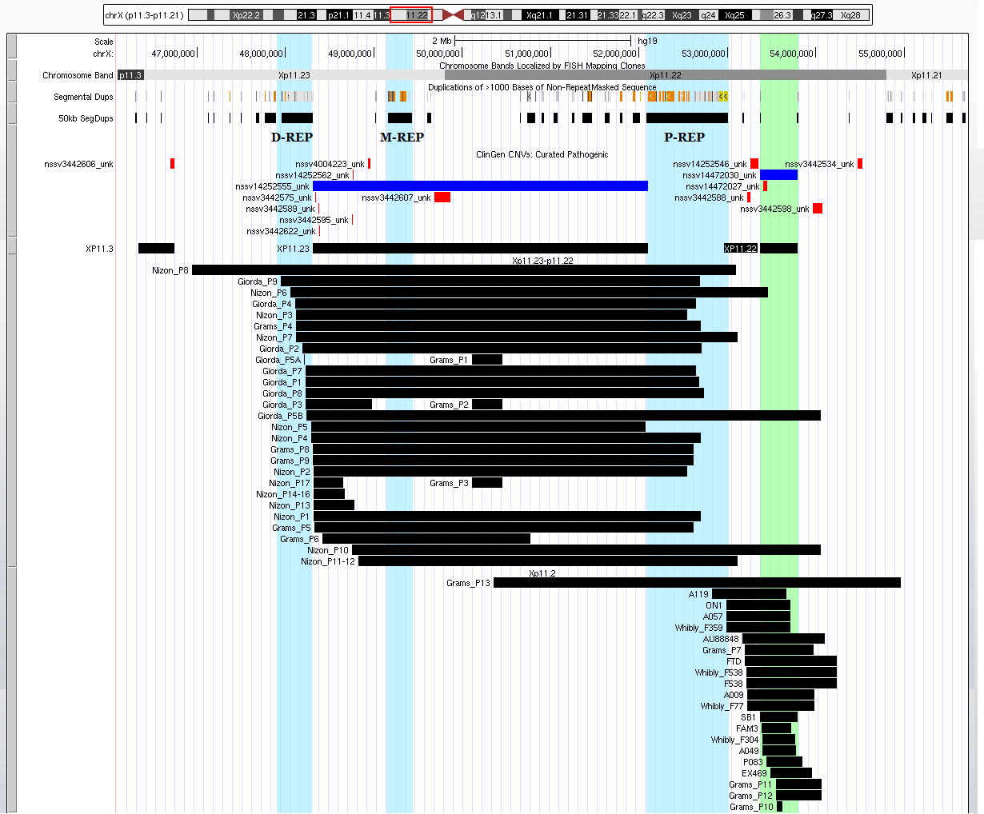

**Xp11.23-p11.22 = ClinGen (D-REP to P-REP):** chrX:48306152-52103258 (hg19)

**Xp11.22 = ClinGen (Green):** chrX:53363456-53793054 (hg19)

# Primary CNV 131: Xq21

*UCSC Genome Browser View of Reported CNVs: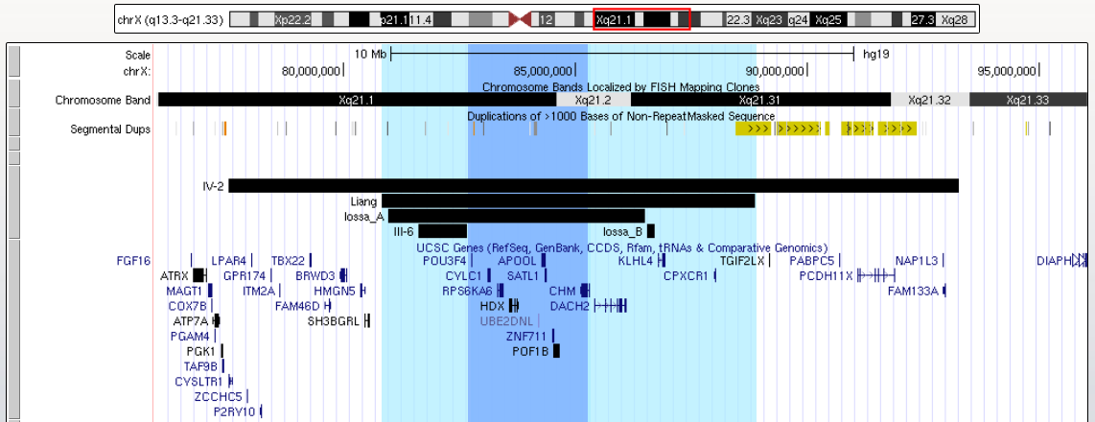*

**Whole Region (Liang):** chrX:80817978-88868979 (hg19)

**SRO (POU3F4 to CHM):** chrX:82763269-85302566 (hg19)

* **POU3F4:** chrX:82,763,269-82,764,775 (hg19)
* **CHM:** chrX:85,116,185-85,302,566 (hg19)

# Primary CNV 132: Xq22 (DL-ATS, DL-MR)

*Figure 3 of Meloni 2002[102]:*

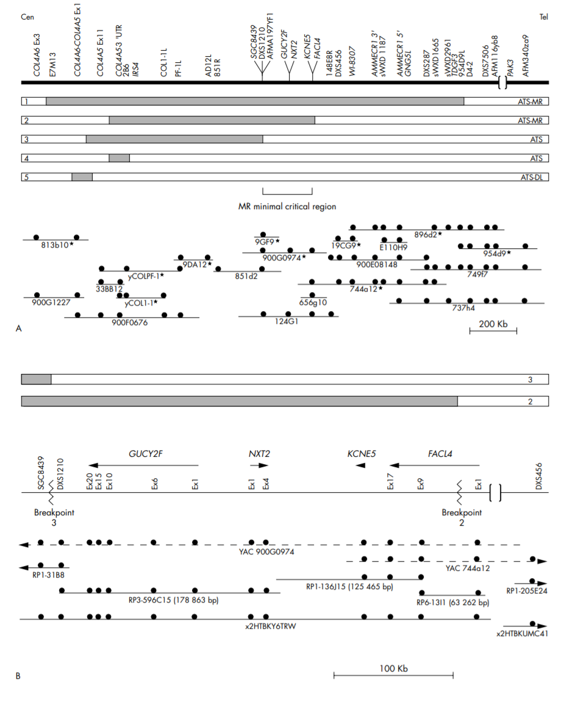

**DL-ATS (COL4A6 to COL4A5):** chrX:107398837-107940775 (hg19)

**DL-MR (COL4A5 to FACL/ASCL4):** chrX:107683074-108976621 (hg19)

* **COL4A6**: chrX:107,398,837-107,682,704 (hg19)
* **COL4A5**: chrX:107,683,074-107,940,775 (hg19)
* **FACL (ACSL4)** = chrX:108,884,564-108,976,621 (hg19)

# Primary CNV 133: Xq25

*UCSC Genome Browser View of Reported CNVs:*

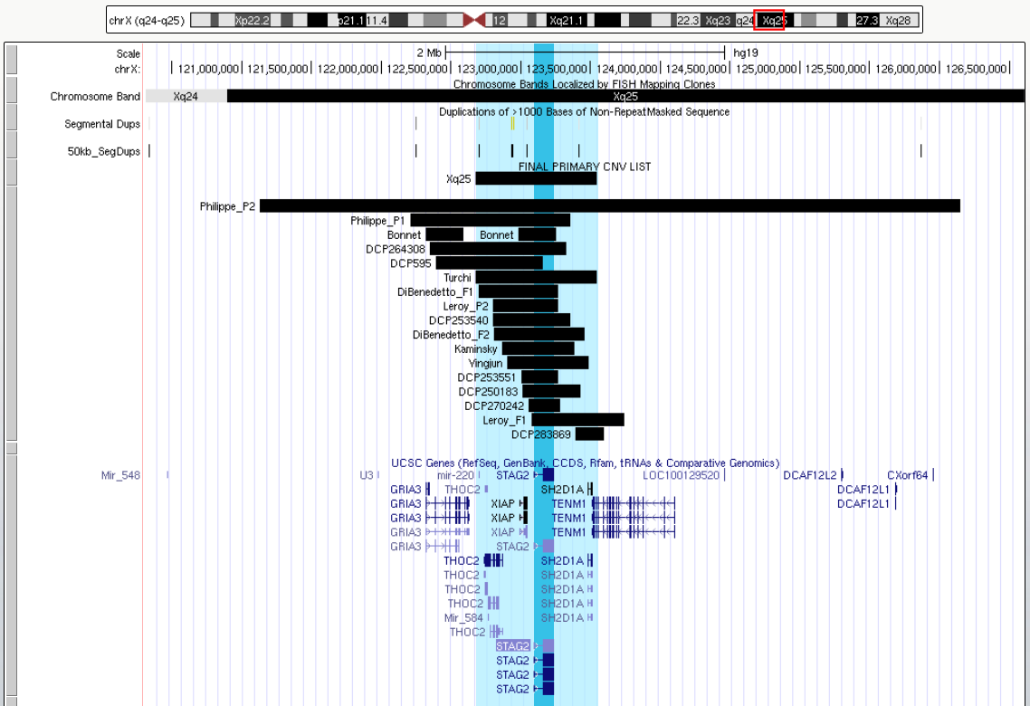

**Whole Region = Turchi =** chrX:122673975-123546561 (hg19)

# Primary CNV 134: Xq26.3 (XLAG)

*Figure 2 of Trivellin 2014[103]:*

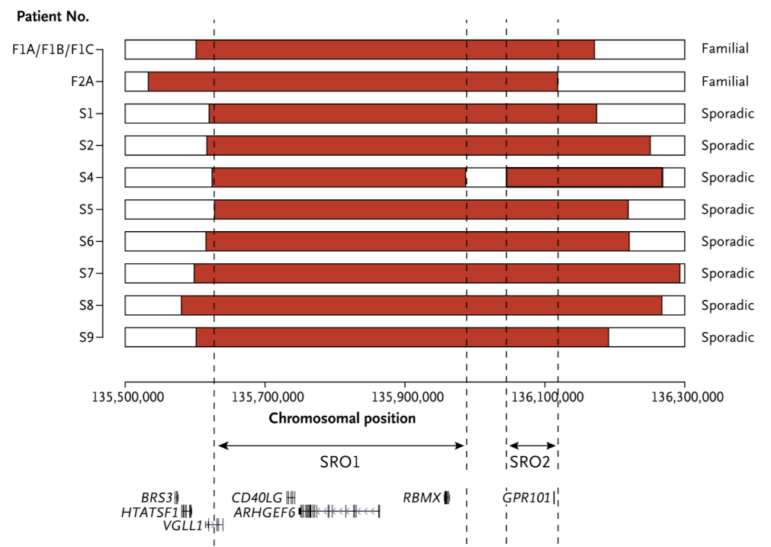

*UCSC Genome Browser View of Reported CNVs:*

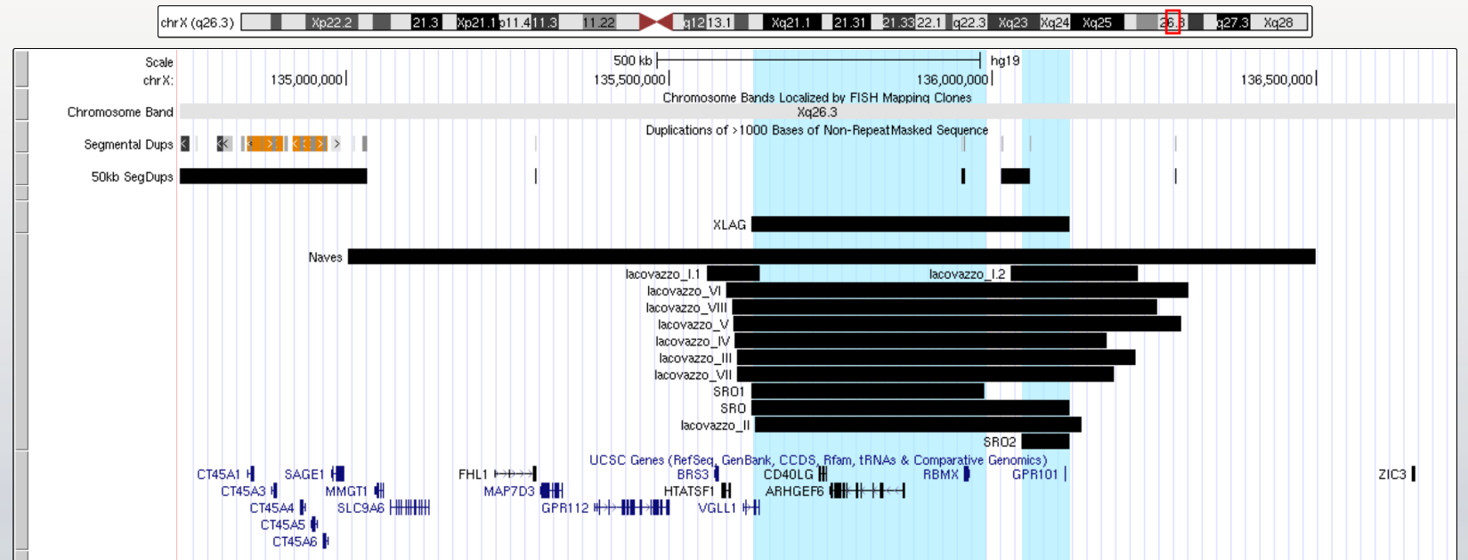

**Whole Region:** chrX:135627637-136118269 (hg19)

* **SRO1 (****Trivellin_2014):** chrX:135627637-135986830 (hg19)
* **SRO2 (Trivellin_2014):** chrX:136045310-136118269 (hg19)

# Primary CNV 135: Xq27.1

*UCSC Genome Browser View of Reported CNVs:*

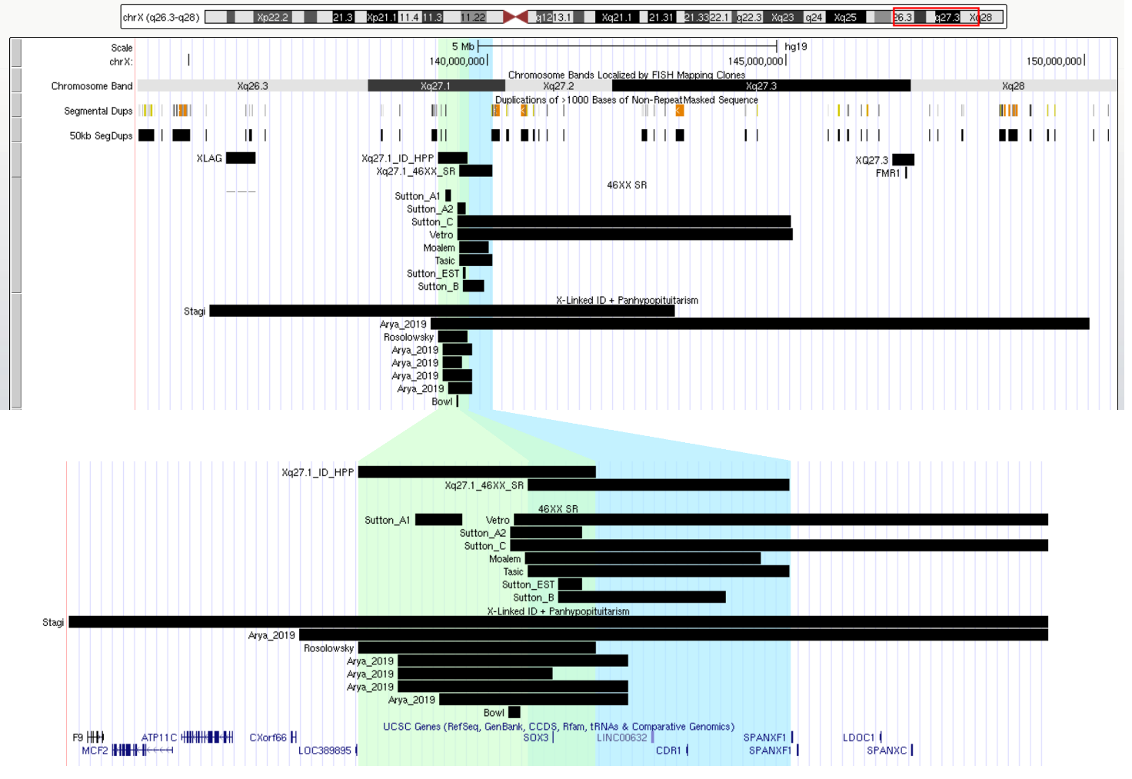

*NOTE: SOX3 duplications have been associated with 46XX sex reversal (OMIM 300833) and X-linked panhypopituitarism with (OMIM 300123) and without ID (OMIM 312000).*

**46XX SR = Tasic:** chrX:139532854-140080654 (hg19)

**X-linked = Rosolowsky_2020:** chrX:139178566-139675085 (hg19)

# Primary CNV 136: Xq27.3-q28

*UCSC Genome Browser View of Reported CNVs:*

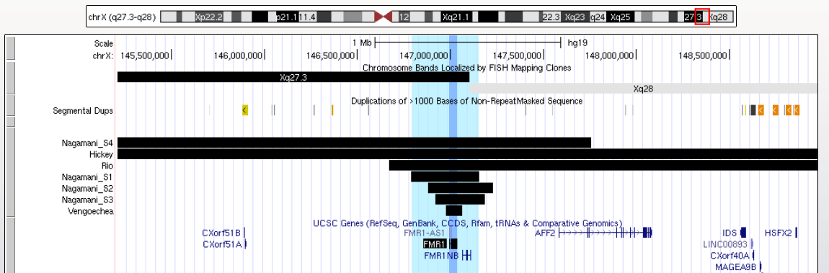

**Whole Region (Nagamani P1):** chrX:146789031-147152262 (hg19)

**FMR1 Coordinates:** chrX:146993469-147032647 (hg19)

# Primary CNV 137: Xq28 (MECP2)

# Primary CNV 138: Xq28 (GD1)

# Primary CNV 139: Xq28 (RAB39B)

# Primary CNV 140: Xq28 (BRCC3)

*UCSC Genome Browser View of Reported CNVs:*

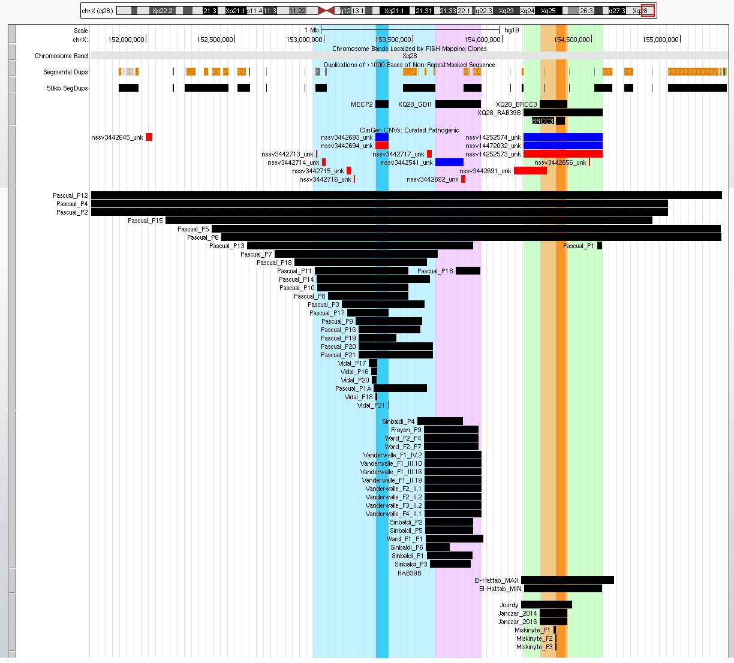

**Blue = MECP2:**

* **Whole Region = Patient 14 (**Pascual-Alonso 2020**):** chrX:152957295-153594098 (hg19)
* **SRO = MECP2 (ClinGen):** chrX:153287264-153363188 (hg19)

**Purple = GDI1:**

* **DECIPHER:** chrX:154396222-154653579 (GRCh38)

**Green = RAB39B**

* **ClinGen:** chrX:154118603-154564401 (hg19)

**Orange = BRCC3**

* **Whole Region = Janczar (2016):** chrX:154210613-154364362 (hg19)
* **SRO = BRCC3**: chrX:154299695-154351349 (hg19)

Literature Cited

1. Gunning AC, Strucinska K, Muñoz Oreja M, Parrish A, Caswell R, Stals KL, Durigon R, Durlacher-Betzer K, Cunningham MH, Grochowski CM *et al*: **Recurrent De Novo NAHR Reciprocal Duplications in the ATAD3 Gene Cluster Cause a Neurogenetic Trait with Perturbed Cholesterol and Mitochondrial Metabolism**. *American journal of human genetics* 2020, **106**(2):272-279.

2. Desai R, Frazier AE, Durigon R, Patel H, Jones AW, Dalla Rosa I, Lake NJ, Compton AG, Mountford HS, Tucker EJ *et al*: **ATAD3 gene cluster deletions cause cerebellar dysfunction associated with altered mitochondrial DNA and cholesterol metabolism**. *Brain* 2017, **140**(6):1595-1610.

3. Gennarino VA, Palmer EE, McDonell LM, Wang L, Adamski CJ, Koire A, See L, Chen C-A, Schaaf CP, Rosenfeld JA *et al*: **A Mild PUM1 Mutation Is Associated with Adult-Onset Ataxia, whereas Haploinsufficiency Causes Developmental Delay and Seizures**. *Cell* 2018, **172**(5):924-936.e911.

4. Labonne JD, Shen Y, Kong IK, Diamond MP, Layman LC, Kim HG: **Comparative deletion mapping at 1p31.3-p32.2 implies NFIA responsible for intellectual disability coupled with macrocephaly and the presence of several other genes for syndromic intellectual disability**. *Molecular cytogenetics* 2016, **9**:24.

5. Willemsen MH, Vallès A, Kirkels LA, Mastebroek M, Olde Loohuis N, Kos A, Wissink-Lindhout WM, de Brouwer AP, Nillesen WM, Pfundt R *et al*: **Chromosome 1p21.3 microdeletions comprising DPYD and MIR137 are associated with intellectual disability**. *Journal of medical genetics* 2011, **48**(12):810-818.

6. Klopocki E, Schulze H, Strauss G, Ott C-E, Hall J, Trotier F, Fleischhauer S, Greenhalgh L, Newbury-Ecob RA, Neumann LM *et al*: **Complex inheritance pattern resembling autosomal recessive inheritance involving a microdeletion in thrombocytopenia-absent radius syndrome**. *American journal of human genetics* 2007, **80**(2):232-240.

7. Mefford HC, Sharp AJ, Baker C, Itsara A, Jiang Z, Buysse K, Huang S, Maloney VK, Crolla JA, Baralle D *et al*: **Recurrent Rearrangements of Chromosome 1q21.1 and Variable Pediatric Phenotypes**. *New England Journal of Medicine* 2008, **359**(16):1685-1699.

8. Brunetti-Pierri N, Berg JS, Scaglia F, Belmont J, Bacino CA, Sahoo T, Lalani SR, Graham B, Lee B, Shinawi M *et al*: **Recurrent reciprocal 1q21.1 deletions and duplications associated with microcephaly or macrocephaly and developmental and behavioral abnormalities**. *Nature genetics* 2008, **40**(12):1466-1471.

9. Rosenfeld JA, Traylor RN, Schaefer GB, McPherson EW, Ballif BC, Klopocki E, Mundlos S, Shaffer LG, Aylsworth AS, q21.1 Study G: **Proximal microdeletions and microduplications of 1q21.1 contribute to variable abnormal phenotypes**. *Eur J Hum Genet* 2012, **20**(7):754-761.

10. Pang H, Yu X, Kim YM, Wang X, Jinkins JK, Yin J, Li S, Gu H: **Disorders Associated With Diverse, Recurrent Deletions and Duplications at 1q21.1**. *Frontiers in Genetics* 2020, **11**(577).

11. Rosenfeld JA, Lacassie Y, El-Khechen D, Escobar LF, Reggin J, Heuer C, Chen E, Jenkins LS, Collins AT, Zinner S *et al*: **New cases and refinement of the critical region in the 1q41q42 microdeletion syndrome**. *European journal of medical genetics* 2011, **54**(1):42-49.

12. Ballif BC, Rosenfeld JA, Traylor R, Theisen A, Bader PI, Ladda RL, Sell SL, Steinraths M, Surti U, McGuire M *et al*: **High-resolution array CGH defines critical regions and candidate genes for microcephaly, abnormalities of the corpus callosum, and seizure phenotypes in patients with microdeletions of 1q43q44**. *Human genetics* 2012, **131**(1):145-156.

13. De Rocker N, Vergult S, Koolen D, Jacobs E, Hoischen A, Zeesman S, Bang B, Béna F, Bockaert N, Bongers EM *et al*: **Refinement of the critical 2p25.3 deletion region: the role of MYT1L in intellectual disability and obesity**. *Genet Med* 2015, **17**(6):460-466.

14. Lowther C, Speevak M, Armour CM, Goh ES, Graham GE, Li C, Zeesman S, Nowaczyk MJM, Schultz L-A, Morra A *et al*: **Molecular characterization of NRXN1 deletions from 19,263 clinical microarray cases identifies exons important for neurodevelopmental disease expression**. *Genetics in Medicine* 2017, **19**(1):53-61.

15. Hancarova M, Vejvalkova S, Trkova M, Drabova J, Dleskova A, Vlckova M, Sedlacek Z: **Identification of a patient with intellectual disability and de novo 3.7Mb deletion supports the existence of a novel microdeletion syndrome in 2p14–p15**. *Gene* 2013, **516**(1):158-161.

16. Writzl K, Lovrecić L, Peterlin B: **Interstitial deletion 2p11.2-p12: further delineation**. *American journal of medical genetics Part A* 2009, **149a**(10):2324-2326.

17. Barber JC, Thomas NS, Collinson MN, Dennis NR, Liehr T, Weise A, Belitz B, Pfeiffer L, Kirchhoff M, Krag-Olsen B *et al*: **Segmental haplosufficiency: transmitted deletions of 2p12 include a pancreatic regeneration gene cluster and have no apparent phenotypic consequences**. *Eur J Hum Genet* 2005, **13**(3):283-291.

18. Riley KN, Catalano LM, Bernat JA, Adams SD, Martin DM, Lalani SR, Patel A, Burnside RD, Innis JW, Rudd MK: **Recurrent deletions and duplications of chromosome 2q11.2 and 2q13 are associated with variable outcomes**. *American journal of medical genetics Part A* 2015, **167a**(11):2664-2673.

19. Wolfe K, McQuillin A, Alesi V, Boudry Labis E, Cutajar P, Dallapiccola B, Dentici ML, Dieux-Coeslier A, Duban-Bedu B, Duelund Hjortshøj T *et al*: **Delineating the psychiatric and behavioral phenotype of recurrent 2q13 deletions and duplications**. *American Journal of Medical Genetics Part B: Neuropsychiatric Genetics* 2018, **177**(4):397-405.

20. Ishihara N, Yamada K, Yamada Y, Miura K, Kato J, Kuwabara N, Hara Y, Kobayashi Y, Hoshino K, Nomura Y *et al*: **Clinical and molecular analysis of Mowat-Wilson syndrome associated with ZFHX1B mutations and deletions at 2q22-q24.1**. *Journal of medical genetics* 2004, **41**(5):387-393.

21. Ivanovski I, Djuric O, Caraffi SG, Santodirocco D, Pollazzon M, Rosato S, Cordelli DM, Abdalla E, Accorsi P, Adam MP *et al*: **Phenotype and genotype of 87 patients with Mowat-Wilson syndrome and recommendations for care**. *Genet Med* 2018, **20**(9):965-975.

22. Talkowski ME, Mullegama SV, Rosenfeld JA, van Bon BWM, Shen Y, Repnikova EA, Gastier-Foster J, Thrush DL, Kathiresan S, Ruderfer DM *et al*: **Assessment of 2q23.1 microdeletion syndrome implicates MBD5 as a single causal locus of intellectual disability, epilepsy, and autism spectrum disorder**. *American journal of human genetics* 2011, **89**(4):551-563.

23. Theisen A, Rosenfeld JA, Shane K, McBride KL, Atkin JF, Gaba C, Hoo J, Kurczynski TW, Schnur RE, Coffey LB *et al*: **Refinement of the Region for Split Hand/Foot Malformation 5 on 2q31.1**. *Molecular Syndromology* 2010, **1**(5):262-271.

24. Ferreira SI, Matoso E, Venâncio M, Saraiva J, Melo JB, Carreira IM: **Critical region in 2q31.2q32.3 deletion syndrome: Report of two phenotypically distinct patients, one with an additional deletion in Alagille syndrome region**. *Molecular cytogenetics* 2012, **5**(1):25-25.

25. Zarate YA, Fish JL: **SATB2-associated syndrome: Mechanisms, phenotype, and practical recommendations**. *American Journal of Medical Genetics Part A* 2017, **173**(2):327-337.

26. Barroso E, Berges-Soria J, Benito-Sanz S, Rivera-Pedroza CI, Ballesta-Martínez MJ, López-González V, Guillen-Navarro E, Heath KE: **Identification of the fourth duplication of upstream IHH regulatory elements, in a family with craniosynostosis Philadelphia type, helps to define the phenotypic characterization of these regulatory elements**. *American journal of medical genetics Part A* 2015, **167a**(4):902-906.

27. Le TN, Williams SR, Alaimo JT, Elsea SH: **Genotype and phenotype correlation in 103 individuals with 2q37 deletion syndrome reveals incomplete penetrance and supports HDAC4 as the primary genetic contributor**. *American Journal of Medical Genetics Part A* 2019, **179**(5):782-791.

28. Eto K, Sakai N, Shimada S, Shioda M, Ishigaki K, Hamada Y, Shinpo M, Azuma J, Tominaga K, Shimojima K *et al*: **Microdeletions of 3p21.31 characterized by developmental delay, distinctive features, elevated serum creatine kinase levels, and white matter involvement**. *American journal of medical genetics Part A* 2013, **161a**(12):3049-3056.

29. Lovrecic L, Bertok S, Žerjav Tanšek M: **A New Case of an Extremely Rare 3p21.31 Interstitial Deletion**. *Molecular syndromology* 2016, **7**(2):93-98.

30. Hervé B, Fauvert D, Dard R, Roume J, Cognard S, Goidin D, Lozach F, Molina-Gomes D, Vialard F: **The emerging microduplication 3q13.31: Expanding the genotype-phenotype correlations of the reciprocal microdeletion 3q13.31 syndrome**. *European journal of medical genetics* 2016, **59**(9):463-469.

31. Ponzi E, Asaro A, Orteschi D, Genuardi M, Zollino M, Gurrieri F: **Variable expressivity of a familial 1.9 Mb microdeletion in 3q28 leading to haploinsufficiency of TP63: Refinement of the critical region for a new microdeletion phenotype**. *European journal of medical genetics* 2015, **58**(8):400-405.

32. Harada N, Nagai T, Shimokawa O, Niikawa N, Matsumoto N: **A 4q21-q22 deletion in a girl with severe growth retardation**. *Clin Genet* 2002, **61**(3):226-228.

33. Hu X, Chen X, Wu B, Soler IM, Chen S, Shen Y: **Further defining the critical genes for the 4q21 microdeletion disorder**. *American Journal of Medical Genetics Part A* 2017, **173**(1):120-125.

34. Snijders Blok C, Corsten-Janssen N, FitzPatrick DR, Romano C, Fichera M, Vitello GA, Willemsen MH, Schoots J, Pfundt R, van Ravenswaaij-Arts CM *et al*: **Definition of 5q11.2 microdeletion syndrome reveals overlap with CHARGE syndrome and 22q11 deletion syndrome phenotypes**. *American journal of medical genetics Part A* 2014, **164a**(11):2843-2848.

35. Cellamare A, Coccaro N, Nuzzi MC, Casieri P, Tampoia M, Maggiolini FA, Gentile M, Ficarella R, Ponzi E, Conserva MR *et al*: **Cytogenetic and Array-CGH Characterization of a Simple Case of Reciprocal t(3;10) Translocation Reveals a Hidden Deletion at 5q12**. *Genes* 2021, **12**(6).

36. Hotz A, Hellenbroich Y, Sperner J, Linder-Lucht M, Tacke U, Walter C, Caliebe A, Nagel I, Saunders DE, Wolff G *et al*: **Microdeletion 5q14.3 and anomalies of brain development**. *American journal of medical genetics Part A* 2013, **161a**(9):2124-2133.

37. Brown N, Burgess T, Forbes R, McGillivray G, Kornberg A, Mandelstam S, Stark Z: **5q31.3 Microdeletion syndrome: clinical and molecular characterization of two further cases**. *American journal of medical genetics Part A* 2013, **161a**(10):2604-2608.

38. Linhares ND, Svartman M, Rodrigues TC, Rosenberg C, Valadares ER: **Subtelomeric 6p25 deletion/duplication: Report of a patient with new clinical findings and genotype–phenotype correlations**. *European journal of medical genetics* 2015, **58**(5):310-318.

39. Kent OA, Saha M, Coyaud E, Burston HE, Law N, Dadson K, Chen S, Laurent EM, St-Germain J, Sun RX *et al*: **Haploinsufficiency of RREB1 causes a Noonan-like RASopathy via epigenetic reprogramming of RAS-MAPK pathway genes**. *Nature communications* 2020, **11**(1):4673.

40. Engwerda A, Frentz B, den Ouden AL, Flapper BCT, Swertz MA, Gerkes EH, Plantinga M, Dijkhuizen T, van Ravenswaaij-Arts CMA: **The phenotypic spectrum of proximal 6q deletions based on a large cohort derived from social media and literature reports**. *European Journal of Human Genetics* 2018, **26**(10):1478-1489.

41. Thienpont B, Zhang L, Postma AV, Breckpot J, Tranchevent L-C, Van Loo P, Møllgård K, Tommerup N, Bache I, Tümer Z *et al*: **Haploinsufficiency of TAB2 causes congenital heart defects in humans**. *American journal of human genetics* 2010, **86**(6):839-849.

42. Santen GW, Clayton-Smith J: **The ARID1B phenotype: what we have learned so far**. *American journal of medical genetics Part C, Seminars in medical genetics* 2014, **166c**(3):276-289.

43. Caselli R, Ballarati L, Vignoli A, Peron A, Recalcati MP, Catusi I, Larizza L, Giardino D: **7p22.1 microduplication syndrome: Clinical and molecular characterization of an adult case and review of the literature**. *European journal of medical genetics* 2015, **58**(11):578-583.

44. Shimojima K, Narai S, Togawa M, Doumoto T, Sangu N, Vanakker OM, de Paepe A, Edwards M, Whitehall J, Brescianini S *et al*: **7p22.1 microdeletions involving ACTB associated with developmental delay, short stature, and microcephaly**. *European journal of medical genetics* 2016, **59**(10):502-506.

45. Ramocki MB, Bartnik M, Szafranski P, Kołodziejska KE, Xia Z, Bravo J, Miller GS, Rodriguez DL, Williams CA, Bader PI *et al*: **Recurrent distal 7q11.23 deletion including HIP1 and YWHAG identified in patients with intellectual disabilities, epilepsy, and neurobehavioral problems**. *American journal of human genetics* 2010, **87**(6):857-865.

46. Porter MA, Dobson-Stone C, Kwok JBJ, Schofield PR, Beckett W, Tassabehji M: **A Role for Transcription Factor GTF2IRD2 in Executive Function in Williams-Beuren Syndrome**. *PLOS ONE* 2012, **7**(10):e47457.

47. Rasmussen MB, Kreiborg S, Jensen P, Bak M, Mang Y, Lodahl M, Budtz-Jørgensen E, Tommerup N, Tranebjærg L, Rendtorff ND: **Phenotypic subregions within the split-hand/foot malformation 1 locus**. *Human genetics* 2016, **135**(3):345-357.

48. Luo H, Xie L, Wang SZ, Chen JL, Huang C, Wang J, Yang JF, Zhang WZ, Yang YF, Tan ZP: **Duplication of 8q12 encompassing CHD7 is associated with a distinct phenotype but without duane anomaly**. *European journal of medical genetics* 2012, **55**(11):646-649.

49. Overhoff J, Rabideau MM, Bird LM, Schweitzer DN, Haynes K, Schultz RA, Shaffer LG, Rosenfeld JA, Ellison JW: **Refinement of the 8q22.1 microdeletion critical region associated with Nablus mask-like facial syndrome**. *American Journal of Medical Genetics Part A* 2014, **164**(1):259-263.

50. Sinajon P, Gofine T, Ingram J, So J: **Microdeletion 8q22.2-q22.3 in a 40-year-old male**. *European journal of medical genetics* 2015, **58**(11):569-572.

51. Wells C, Spaggiari E, Malan V, Stirnemann JJ, Attie-Bitach T, Ville Y, Vekemans M, Bessieres B, Romana S: **First fetal case of the 8q24.3 contiguous genes syndrome**. *American Journal of Medical Genetics Part A* 2016, **170**(1):239-242.

52. Ferreira SI, Cinnirella G, Ramos L, Suppa A, Pires LM, Nardone AM, Camerota L, Lanciotti S, Galasso C, De Maio F *et al*: **Tremor is a major feature of 9p13 deletion syndrome**. *American Journal of Medical Genetics Part A* 2020, **182**(11):2694-2698.

53. Mucciolo M, Magini P, Marozza A, Mongelli P, Mencarelli MA, Hayek G, Tavalazzi F, Mari F, Seri M, Renieri A *et al*: **9q31.1q31.3 deletion in two patients with similar clinical features: a newly recognized microdeletion syndrome?** *American journal of medical genetics Part A* 2014, **164a**(3):685-690.

54. Nevado J, Mergener R, Palomares-Bralo M, Souza KR, Vallespín E, Mena R, Martínez-Glez V, Mori M, Santos F, García-Miñaur S *et al*: **New microdeletion and microduplication syndromes: A comprehensive review**. *Genetics and molecular biology* 2014, **37**(1 Suppl):210-219.

55. Lichtner P, König R, Hasegawa T, Van Esch H, Meitinger T, Schuffenhauer S: **An HDR (hypoparathyroidism, deafness, renal dysplasia) syndrome locus maps distal to the DiGeorge syndrome region on 10p13/14**. *Journal of medical genetics* 2000, **37**(1):33-37.

56. van Bon BW, Balciuniene J, Fruhman G, Nagamani SC, Broome DL, Cameron E, Martinet D, Roulet E, Jacquemont S, Beckmann JS *et al*: **The phenotype of recurrent 10q22q23 deletions and duplications**. *Eur J Hum Genet* 2011, **19**(4):400-408.

57. Choucair N, Abou Ghoch J, Fawaz A, Mégarbané A, Chouery E: **10q26.1 Microdeletion: Redefining the critical regions for microcephaly and genital anomalies**. *American journal of medical genetics Part A* 2015, **167a**(11):2707-2713.

58. Lin S, Zhou Y, Fang Q, Wu J, Zhang Z, Ji Y, Luo Y: **Chromosome 10q26 deletion syndrome: Two new cases and a review of the literature**. *Molecular medicine reports* 2016, **14**(6):5134-5140.

59. Chiesa N, De Crescenzo A, Mishra K, Perone L, Carella M, Palumbo O, Mussa A, Sparago A, Cerrato F, Russo S *et al*: **The KCNQ1OT1 imprinting control region and non-coding RNA: new properties derived from the study of Beckwith-Wiedemann syndrome and Silver-Russell syndrome cases**. *Hum Mol Genet* 2012, **21**(1):10-25.

60. Addis L, Ahn JW, Dobson R, Dixit A, Ogilvie CM, Pinto D, Vaags AK, Coon H, Chaste P, Wilson S *et al*: **Microdeletions of ELP4 Are Associated with Language Impairment, Autism Spectrum Disorder, and Mental Retardation**. *Human mutation* 2015, **36**(9):842-850.

61. Han JC, Liu Q-R, Jones M, Levinn RL, Menzie CM, Jefferson-George KS, Adler-Wailes DC, Sanford EL, Lacbawan FL, Uhl GR *et al*: **Brain-Derived Neurotrophic Factor and Obesity in the WAGR Syndrome**. *New England Journal of Medicine* 2008, **359**(9):918-927.

62. Trajkova S, Di Gregorio E, Ferrero GB, Carli D, Pavinato L, Delplancq G, Kuentz P, Brusco A: **New Insights into Potocki-Shaffer Syndrome: Report of Two Novel Cases and Literature Review**. *Brain sciences* 2020, **10**(11).

63. Grossfeld PD, Mattina T, Lai Z, Favier R, Jones KL, Cotter F, Jones C, the 11q C: **The 11q terminal deletion disorder: A prospective study of 110 cases**. *American Journal of Medical Genetics Part A* 2004, **129A**(1):51-61.

64. Lynch SA, Foulds N, Thuresson AC, Collins AL, Annerén G, Hedberg BO, Delaney CA, Iremonger J, Murray CM, Crolla JA *et al*: **The 12q14 microdeletion syndrome: six new cases confirming the role of HMGA2 in growth**. *Eur J Hum Genet* 2011, **19**(5):534-539.

65. Kim MJ, Frausto RF, Rosenwasser GO, Bui T, Le DJ, Stone EM, Aldave AJ: **Posterior amorphous corneal dystrophy is associated with a deletion of small leucine-rich proteoglycans on chromosome 12**. *PLoS One* 2014, **9**(4):e95037.

66. Labonne JDJ, Lee K-H, Iwase S, Kong I-K, Diamond MP, Layman LC, Kim C-H, Kim H-G: **An atypical 12q24.31 microdeletion implicates six genes including a histone demethylase KDM2B and a histone methyltransferase SETD1B in syndromic intellectual disability**. *Human genetics* 2016, **135**(7):757-771.

67. Pavone P, Briuglia S, Falsaperla R, Warm A, Pavone V, Bernardini L, Novelli A, Praticò AD, Salpietro V, Ruggieri M: **Wide spectrum of congenital anomalies including choanal atresia, malformed extremities, and brain and spinal malformations in a girl with a de novo 5.6-Mb deletion of 13q12.11-13q12.13**. *American journal of medical genetics Part A* 2014, **164a**(7):1734-1743.

68. Bartholdi D, Stray-Pedersen A, Azzarello-Burri S, Kibaek M, Kirchhoff M, Oneda B, Rødningen O, Schmitt-Mechelke T, Rauch A, Kjaergaard S: **A newly recognized 13q12.3 microdeletion syndrome characterized by intellectual disability, microcephaly, and eczema/atopic dermatitis encompassing the HMGB1 and KATNAL1 genes**. *American journal of medical genetics Part A* 2014, **164a**(5):1277-1283.

69. Muriello M, Kim AY, Sondergaard Schatz K, Beck N, Gunay-Aygun M, Hoover-Fong JE: **Growth hormone deficiency, aortic dilation, and neurocognitive issues in Feingold syndrome 2**. *American journal of medical genetics Part A* 2019, **179**(3):410-416.

70. Angée C, Nedelec B, Erjavec E, Rozet J-M, Fares Taie L: **Congenital Microcoria: Clinical Features and Molecular Genetics**. *Genes* 2021, **12**(5):624.

71. Kagami M, Nagasaki K, Kosaki R, Horikawa R, Naiki Y, Saitoh S, Tajima T, Yorifuji T, Numakura C, Mizuno S *et al*: **Temple syndrome: comprehensive molecular and clinical findings in 32 Japanese patients**. *Genetics in Medicine* 2017, **19**(12):1356-1366.

72. Hilhorst-Hofstee Y, Hamel BC, Verheij JB, Rijlaarsdam ME, Mancini GM, Cobben JM, Giroth C, Ruivenkamp CA, Hansson KB, Timmermans J *et al*: **The clinical spectrum of complete FBN1 allele deletions**. *Eur J Hum Genet* 2011, **19**(3):247-252.

73. El-Hattab AW, Smolarek TA, Walker ME, Schorry EK, Immken LL, Patel G, Abbott M-A, Lanpher BC, Ou Z, Kang S-HL *et al*: **Redefined genomic architecture in 15q24 directed by patient deletion/duplication breakpoint mapping**. *Human genetics* 2009, **126**(4):589-602.

74. Liu Y, Zhang Y, Zarrei M, Dong R, Yang X, Zhao D, Scherer SW, Gai Z: **Refining critical regions in 15q24 microdeletion syndrome pertaining to autism**. *American Journal of Medical Genetics Part B: Neuropsychiatric Genetics* 2020, **183**(4):217-226.

75. Doelken SC, Seeger K, Hundsdoerfer P, Weber-Ferro W, Klopocki E, Graul-Neumann L: **Proximal and distal 15q25.2 microdeletions-genotype-phenotype delineation of two neurodevelopmental susceptibility loci**. *American journal of medical genetics Part A* 2013, **161a**(1):218-224.

76. Oyazato Y, Iijima K, Emi M, Sekine T, Kamei K, Takanashi J, Nakao H, Namai Y, Nozu K, Matsuo M: **Molecular analysis of TSC2/PKD1 contiguous gene deletion syndrome**. *The Kobe journal of medical sciences* 2011, **57**(1):E1-10.

77. Osumi K, Suga K, Ono A, Goji A, Mori T, Kinoshita Y, Sugano M, Toda Y, Urushihara M, Nakagawa R *et al*: **Molecular diagnosis of an infant with TSC2/PKD1 contiguous gene syndrome**. *Human Genome Variation* 2020, **7**(1):21.

78. Fountain MD, Oleson DS, Rech ME, Segebrecht L, Hunter JV, McCarthy JM, Lupo PJ, Holtgrewe M, Moran R, Rosenfeld JA *et al*: **Pathogenic variants in USP7 cause a neurodevelopmental disorder with speech delays, altered behavior, and neurologic anomalies**. *Genet Med* 2019, **21**(8):1797-1807.

79. Ingason A, Rujescu D, Cichon S, Sigurdsson E, Sigmundsson T, Pietiläinen OPH, Buizer-Voskamp JE, Strengman E, Francks C, Muglia P *et al*: **Copy number variations of chromosome 16p13.1 region associated with schizophrenia**. *Molecular Psychiatry* 2011, **16**(1):17-25.

80. Tabet A-C, Pilorge M, Delorme R, Amsellem F, Pinard J-M, Leboyer M, Verloes A, Benzacken B, Betancur C: **Autism multiplex family with 16p11.2p12.2 microduplication syndrome in monozygotic twins and distal 16p11.2 deletion in their brother**. *European Journal of Human Genetics* 2012, **20**(5):540-546.

81. Bachmann-Gagescu R, Mefford HC, Cowan C, Glew GM, Hing AV, Wallace S, Bader PI, Hamati A, Reitnauer PJ, Smith R *et al*: **Recurrent 200-kb deletions of 16p11.2 that include the SH2B1 gene are associated with developmental delay and obesity**. *Genet Med* 2010, **12**(10):641-647.

82. Abdullah S, Helal M, Dupuis L, Stavropoulos DJ, Louro P, Ramos L, Mendoza-Londono R: **16q22.1 microdeletion and anticipatory guidance**. *American Journal of Medical Genetics Part A* 2019, **179**(7):1287-1292.

83. Armour CM, Bulman DE, Jarinova O, Rogers RC, Clarkson KB, DuPont BR, Dwivedi A, Bartel FO, McDonell L, Schwartz CE *et al*: **17p13.3 microduplications are associated with split-hand/foot malformation and long-bone deficiency (SHFLD)**. *Eur J Hum Genet* 2011, **19**(11):1144-1151.

84. Luk HM, Wong VC, Lo IF, Chan KY, Lau ET, Kan AS, Tang MH, Tang WF, She WM, Chu YW *et al*: **A prenatal case of split-hand malformation associated with 17p13.3 triplication - a dilemma in genetic counseling**. *European journal of medical genetics* 2014, **57**(2-3):81-84.

85. Zhang F, Seeman P, Liu P, Weterman MAJ, Gonzaga-Jauregui C, Towne CF, Batish SD, De Vriendt E, De Jonghe P, Rautenstrauss B *et al*: **Mechanisms for Nonrecurrent Genomic Rearrangements Associated with CMT1A or HNPP: Rare CNVs as a Cause for Missing Heritability**. *The American Journal of Human Genetics* 2010, **86**(6):892-903.

86. Potocki L, Bi W, Treadwell-Deering D, Carvalho CM, Eifert A, Friedman EM, Glaze D, Krull K, Lee JA, Lewis RA *et al*: **Characterization of Potocki-Lupski syndrome (dup(17)(p11.2p11.2)) and delineation of a dosage-sensitive critical interval that can convey an autism phenotype**. *American journal of human genetics* 2007, **80**(4):633-649.

87. Shaw CJ, Withers MA, Lupski JR: **Uncommon Deletions of the Smith-Magenis Syndrome Region Can Be Recurrent When Alternate Low-Copy Repeats Act as Homologous Recombination Substrates**. *The American Journal of Human Genetics* 2004, **75**(1):75-81.

88. Yuan B, Harel T, Gu S, Liu P, Burglen L, Chantot-Bastaraud S, Gelowani V, Beck CR, Carvalho CM, Cheung SW *et al*: **Nonrecurrent 17p11.2p12 Rearrangement Events that Result in Two Concomitant Genomic Disorders: The PMP22-RAI1 Contiguous Gene Duplication Syndrome**. *American journal of human genetics* 2015, **97**(5):691-707.

89. Moles KJ, Gowans GC, Gedela S, Beversdorf D, Yu A, Seaver LH, Schultz RA, Rosenfeld JA, Torchia BS, Shaffer LG: **NF1 microduplications: identification of seven nonrelated individuals provides further characterization of the phenotype**. *Genetics in Medicine* 2012, **14**(5):508-514.

90. Schönewolf-Greulich B, Ronan A, Ravn K, Baekgaard P, Lodahl M, Nielsen K, Rendtorff ND, Tranebjaerg L, Brøndum-Nielsen K, Tümer Z: **Two new cases with microdeletion of 17q23.2 suggest presence of a candidate gene for sensorineural hearing loss within this region**. *American journal of medical genetics Part A* 2011, **155a**(12):2964-2969.

91. Kim GJ, Sock E, Buchberger A, Just W, Denzer F, Hoepffner W, German J, Cole T, Mann J, Seguin JH *et al*: **Copy number variation of two separate regulatory regions upstream of SOX9 causes isolated 46,XY or 46,XX disorder of sex development**. *Journal of medical genetics* 2015, **52**(4):240-247.

92. Wester U, Bondeson ML, Edeby C, Annerén G: **Clinical and molecular characterization of individuals with 18p deletion: a genotype-phenotype correlation**. *American journal of medical genetics Part A* 2006, **140**(11):1164-1171.

93. Cody JD, Sebold C, Heard P, Carter E, Soileau B, Hasi-Zogaj M, Hill A, Rupert D, Perry B, O'Donnell L *et al*: **Consequences of chromsome18q deletions**. *American Journal of Medical Genetics Part C: Seminars in Medical Genetics* 2015, **169**(3):265-280.

94. Nevado J, Rosenfeld JA, Mena R, Palomares-Bralo M, Vallespín E, Ángeles Mori M, Tenorio JA, Gripp KW, Denenberg E, Del Campo M *et al*: **PIAS4 is associated with macro/microcephaly in the novel interstitial 19p13.3 microdeletion/microduplication syndrome**. *Eur J Hum Genet* 2015, **23**(12):1615-1626.

95. Caubit X, Gubellini P, Andrieux J, Roubertoux PL, Metwaly M, Jacq B, Fatmi A, Had-Aissouni L, Kwan KY, Salin P *et al*: **TSHZ3 deletion causes an autism syndrome and defects in cortical projection neurons**. *Nature genetics* 2016, **48**(11):1359-1369.

96. Gana S, Veggiotti P, Sciacca G, Fedeli C, Bersano A, Micieli G, Maghnie M, Ciccone R, Rossi E, Plunkett K *et al*: **19q13.11 cryptic deletion: description of two new cases and indication for a role of WTIP haploinsufficiency in hypospadias**. *European Journal of Human Genetics* 2012, **20**(8):852-856.

97. Traylor RN, Bruno DL, Burgess T, Wildin R, Spencer A, Ganesamoorthy D, Amor DJ, Hunter M, Caplan M, Rosenfeld JA *et al*: **A genotype-first approach for the molecular and clinical characterization of uncommon de novo microdeletion of 20q13.33**. *PLoS One* 2010, **5**(8):e12462.

98. Ji J, Lee H, Argiropoulos B, Dorrani N, Mann J, Martinez-Agosto JA, Gomez-Ospina N, Gallant N, Bernstein JA, Hudgins L *et al*: **DYRK1A haploinsufficiency causes a new recognizable syndrome with microcephaly, intellectual disability, speech impairment, and distinct facies**. *European Journal of Human Genetics* 2015, **23**(11):1473-1481.

99. McDermid HE, Morrow BE: **Genomic Disorders on 22q11**. *The American Journal of Human Genetics* 2002, **70**(5):1077-1088.

100. Hand JL, Runke CK, Hodge JC: **The phenotype spectrum of X-linked ichthyosis identified by chromosomal microarray**. *Journal of the American Academy of Dermatology* 2015, **72**(4):617-627.

101. Grams SE, Argiropoulos B, Lines M, Chakraborty P, McGowan-Jordan J, Geraghty MT, Tsang M, Eswara M, Tezcan K, Adams KL *et al*: **Genotype-phenotype characterization in 13 individuals with chromosome Xp11.22 duplications**. *American journal of medical genetics Part A* 2016, **170a**(4):967-977.

102. Meloni I, Vitelli F, Pucci L, Lowry RB, Tonlorenzi R, Rossi E, Ventura M, Rizzoni G, Kashtan CE, Pober B *et al*: **Alport syndrome and mental retardation: clinical and genetic dissection of the contiguous gene deletion syndrome in Xq22.3 (ATS-MR)**. *Journal of medical genetics* 2002, **39**(5):359-365.

103. Trivellin G, Daly AF, Faucz FR, Yuan B, Rostomyan L, Larco DO, Schernthaner-Reiter MH, Szarek E, Leal LF, Caberg JH *et al*: **Gigantism and acromegaly due to Xq26 microduplications and GPR101 mutation**. *The New England journal of medicine* 2014, **371**(25):2363-2374.